The Impact of Integration of Solar farms on the Power Losses, Voltage Profile and Short Circuit Level in the Distribution system

¹Abdallah R.Alzyoud, ¹Ali S. Khrewish, ¹Anwar ALMofleh, ¹Ahmad S.Allabadi

¹Electrical Engineering Department, Faculty Of Engineering Technology, Al-Balqa’ Applied University, Amman 11134,Jordan

Article Info |  | ABSTRACT
Article history:  Received November 17, 2019  Revised , , 2019  Accepted , 2019 |  | This paper introduces a study of utilizing solar energy farm, integrated with the national grid, according to an intensive data availability of solar energy in Jordan. This study discusses the impact and the ability of integrating solar farms into the Jordanian national grid, considering different cases and, various power system studies for connection points of solar farms to medium voltage networks. Among these studies are short circuit level, voltage profile and power losses. The major objective of the study is to analyze the impacts of integration of solar farms on distribution systems in the chosen areas. Photovoltaic (PV) system with varying penetration levels are integrated at different locations (connection points) into the distribution network. Calculations are performed and models are built using real data obtained from the Jordanian power system with PV interconnection. The effects of the short circuit level, voltage profile and power losses in the distribution system are also analyzed. Finally, the most suitable method of connecting the solar farm to the national power network is recommended
Keywords:
Renewable energy
Solar system
Distribution network
Short circuit level
Voltage profile
Power losses.

Copyright © 2019Institute of Advanced Engineering and Science.
All rights reserved.
Corresponding Author:
Anwar ALMofleh,
Electrical Engineering Department, Faculty Of Engineering Technology,
Al-Balqa’ Applied University,
Amman 11134,Jordan
Email: anwaralmofleh@yahoo.com, almofleh@bau.edu.jo,

- INTRODUCTION
Jordan is a key country in the Middle East region. Much of its budget is intended to import oil from several countries. The problem worsens year after year due to population growth and increasing demand for electricity. Therefore, the search for alternative sources of energy has become an imminent issue in Jordan [1, 2, and 3].
Jordan's current energy production process is highly dependent on fossil fuels. From 2014 the oil reserves of Jordan were estimated to be around 1 million barrels, while natural gas reserves were estimated to be around 200 billion cubic feet [4]. The relatively low fossil fuel resources force the country to import most of the fuel needed for electrical generation; 88% of Jordan's electricity production is supported by importing fossil fuels, while local fossil fuel production accounts for only 2% of the country's demand. The import of fossil fuels has proved to be an exhausting economic burden for Jordan, as it accounts for almost 40% of the country's budget [5]. Due to the ever-changing political situation in the Middle East, the energy security of Jordan is constantly threatened as it imports significant amounts of oil from Iraq And natural gas from Egypt through the Arab Gas Pipeline (AGP) through Sinai and Syria. In recent years, the political instability of Syria and Sinai has led to a dramatic decline in Jordan's gas import from 89 billion cubic feet to 17 billion cubic feet and effectively caused [6, 7]

In line with the global technological advances inexploiting renewable energy resources, the Ministry ofEnergy and Mineral Resources (MEMR) of Jordan is keen tofacilitate the integration of electricity generation using solarand wind energy to the national grid. This is very significantas it will contribute in reducing the reliance on externalenergy sources and creating economically feasiblealternatives to reduce the total energy bill without anyadverse effects on the energy efficiency or the localcommunity [8].
In a conventional large electric power system, the central generatorsfeed the interconnected transmission system through their step-uptransformers and the power being extracted from this high-voltage(HV) network passes through a series of transformers to thedistribution network to ultimately reach the clients demand.Inevitably, these power flows induce important losses that canreach the rate of 13%.Distributed generation (DG) integration, undoubtedly, aims tominimise power losses as it is preferably allocated near thedemand side, whereas nearby nodal voltages are improved withthe reactive power compensation. However, the sizing andallocation of DG technologies into medium and low voltage (MV/LV) grids creates a number of technical issues [9, 10].

The installation and connection of large scale renewable energy plants is not a newly emerged issue in most developed countries. According to the International Energy Agency (IEA), there are about 20 utility-scale plants of over100 MW capacities in the world mostly in China and in the United States. A considerable number of vendors are participating in renovating the technology that converts the solar radiation or the wind potential into useful electrical energy [7]. The market is full of competitors; encouraging vendors looking for a toehold in the market to continuously develop their products toward enhancing the conversion efficiency and the quality of electrical power output. In view of that, different operational performances are expected from different technology providers. Both the provider and the grid operator (transmission or distribution) have to ensure the connection suitability of the PV or Wind plant to the electrical grid. The Transmission System Operator(TSO) in Jordan, as most of the other TSOs worldwide, issues the technical requirements that shall be fulfilled by any renewable energy plants (REPs )willing to connect to the grid. These requirements are usually defined in the ‘Grid Code’ or in a separate connection agreement [8]. To avoid costly design variation after installation, the REP technical performance is simulated and tested to be compliant with the relevant technical requirements in the design or pre-design phase. The Special simulation software is capable of modeling both the REP and the electrical grid, and thus examines the performance of the plant in advance, prior to the on-site testing during the commissioning phase. [11,12,13,14].
In this paper, the impact of connecting large-scale PVPson the grid power losses, voltage profile, and short circuit current levels of the national grid of Jordan are examined. Load flow and short circuit studies have been carried using ETAP software.

- NATIONAL GRID OF JORDAN
Jordan is interconnected through 400 KV and 132kVnational grid. The 400 KV lines form a long corridor that extends from Aqaba in the South to Irbid in the far North.The 132 KV lines share the routes of the 400 KV lines but is more divergent to reach further areas of Jordan. The demand for electricity reaches more than 50% in the central area of the Kingdom, where congestion in the bulk substations there. While around 25% of the demand is located in the North, around 20% in the south and no more than 5% in the East. Figure 1 shows the Winter, Spring and Summer daily load curves in selected days in the year 2015.[15]The load reaches a minimum value before sunrise, then a morning peak around midday, and an evening peak just after the sunset.
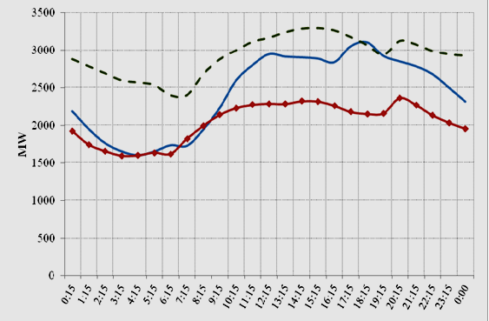
Figure 1.Daily load curves of Jordan System

- RENEWABLE ENERGY POTENTIALS
Jordan is located in the solar belt of the world, thus it has the potential to generate at least 1000Gwh annually [16]. In a recent report by the International Renewable Energy Agency [17], the cost of electricity generated by concentrating solar power (CSP) could be as low as $0.14/kWh if the storage period is less than six hours. Compare this to a cost of $0.13/kWh for a Conventional natural gas burning combustion turbine, $0.20/kWh for offshore wind turbines and, around $0.1/kWh for advanced nuclear [18]. The low cost of solar power generation paired with Jordan’s solar potential makes Jordan’s reliance on renewable energy feasible [19]. Jordan is renowned by a relatively high solar irradiation that reaches more than 2200 kWh/m2/yr in the southern area of the kingdom and more than 2000 kWh/m2/yr in the eastern area [20].Utility-scale PVPs under such climatic conditions would be able to produce electrical power with a very competitive levelized cost of energy considering system costs and costs of capital. The wind speed potential in Jordan is also of a remarkable interest. The wind speed reaches an average value between 5-7 m/s (at 100m height) in most of the areas, and has its highest values in the southern and eastern areas of the kingdom. Accordingly, the eastern and southern areas fit mostly in terms of solar radiation, wind speed and land availability. Figure 2 shows the solar radiation map of Jordan [21].

This research presents two scenarios with identical PV systems but with different connection points to the distribution network. The first connection was to 33kV Ma'an substation bus, whereas the second two 11kVbus. The different scenarios are simulated using Energy Technology Assistance Program (ETAP), and then the effects of integration the solar farms into the grid are analyzed and evaluated.

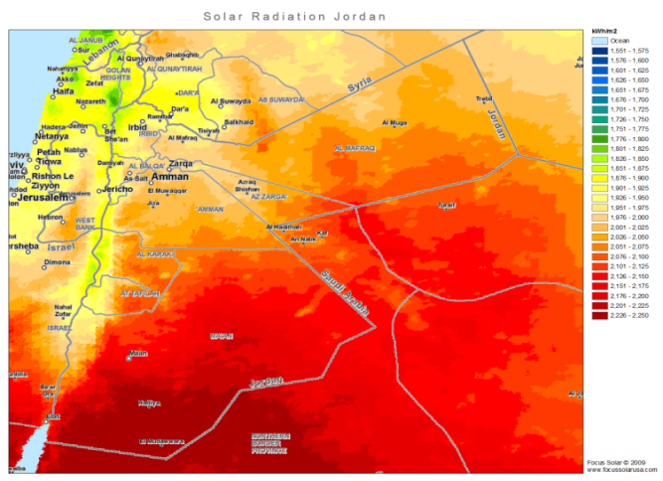

Figure 2. Solar radiation map of Jordan

- SYSTEM CONFIGURATION MODEL
The system configuration model was built using ETAP 11and it’s shown in Figure 3.
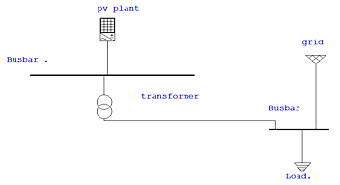
Figure 3. System Model Configuration

The system is composed of electrical grids and PV solar plant. The output of the PV panels is DC, which is then converted to AC using an inverter connected to the AC bus to which the electrical load is connected.

4.1. Solar Data for the selected site
The data obtained is shown in Table 1 and illustrated in Figure 4. The average solar radiation is about 6.2 kWh/m² per day, which is quite high value and suitable for electrical power generation.

Table 1. The monthly average of global horizontal irradiation and air temperature for the considered site in Ma'an

Month | Ghm | Ghd | Dhd | T24
Jan | 115 | 3.70 | 1.10 | 6.5
Feb | 134 | 4.77 | 1.36 | 7.9
Mar | 193 | 6.21 | 1.60 | 11.4
Apr | 213 | 7.10 | 2.10 | 16.6
May | 249 | 8.04 | 2.08 | 20.6
Jun | 263 | 8.77 | 1.73 | 23.3
jul | 264 | 8.52 | 1.65 | 24.7
Aug | 242 | 7.82 | 1.76 | 24.7
Sep | 204 | 6.80 | 1.57 | 22.5
Oct | 164 | 5.28 | 1.56 | 18.9
Nov | 122 | 4.07 | 1.18 | 13.1
Dec | 102 | 3.28 | 0.95 | 8.4
year | 2265 | 6.20 | 1.55 | 16.6

Where (long term monthly averages): Ghm:Monthly sum of global irradiation [kWh/m²] , Ghd: Daily sum of global irradiation [kWh/m²] , Dhd: Daily sum of diffuse irradiation [kWh/m²] , T24: Daily (diurnal) air temperature [°C]

Figure.4. The monthly averages of global horizontal irradiation and air temperature for the site in Ma'an

4.2 PV system Description
The Suniva solar module ART245-60-3-1PV was chosen for modeling, since it is well suited for traditional applications of photovoltaic systems [20]. The key specifications are shown in Table 2 below.

Table 2 SunivaPanel characteristics (Suniva ART245-60-3-1PV Panel data sheet)
UNIT | VALUES | The SunivaART245-60-3-1 PV DATA
W | 239.7 | Nominal power [Pnom]
V | 30.65 | Voltage at Nominal Power [Vmpp]
A | 7.82 | Current at Nominal Power[Impp]
V | 37.08 | Open-circuit Voltage[Voc]
A | 8.33 | Short-circuit Current[Isc]
% /C° | -0.332 | Voltage Temperature Coefficient
% /C° | 0.036 | Current Temperature Coefficient
% | 14.9 | Module Efficiency
Cm | 165.3 | Length
Cm | 98.2 | Width
m² | 1.62 | Area

This PV solar system consists of 18PV arrays. Each array contains 6969 solar panels, with output 239.7 watt for each panel connecting 23 solar panels in series which is called string to get 704.95 V and 303 in parallel to get 1670 kWDC and current with 2369.46 A. These data are used in the SMA central inverter with 2000 KVA and unity power factor output. Table 3shows the technical data for the inverter.

Table 3. Technical data for MV power station 2000sc
UNIT | VALUES | The SMA central inverter data
kW | 2244 | Max. DC power
V | 1000 | Max. input voltage
V | 688 | Rated input voltage
A | 3270 | Max. input current
KVA | 2000 | Output rated power
kV | 6.6-35 | Nominal AC voltage
Hz | 50 | Ac power frequency
A | 64 | Max. output current at 20 KV
% | 97.6 | Max. efficiency

The inverters connected to 33kV bus bar which is suitable to their output voltage.The PV- power plant with output 30 MVA at unity power factor is connected to the national power grid to 33 kV Ma'ansubstation.

4.3Distribution Network Description
The distribution network of Ma'an is fed from the power grid of 132kV through three 16MVA step down transformers (132 /33 kV) to supply the town's load.

- SIMULATION USING ETAP

Energy technology assistance program (ETAP) is used to simulate the PV solar system integrated with the grid [23]. ETAP is the most comprehensive analysis platform for the design, simulation, operation, and automation of generation, distribution, and industrial power systems. In this paper three cases are studied and analyzed

5.1. Case I: Electrical Distribution Network without PV Solar System

Case I considers Ma'an electric distribution network which is fed from the transmission grid operated by NEPCO [24]. Figure 5 shows the single line diagram of electric distribution network
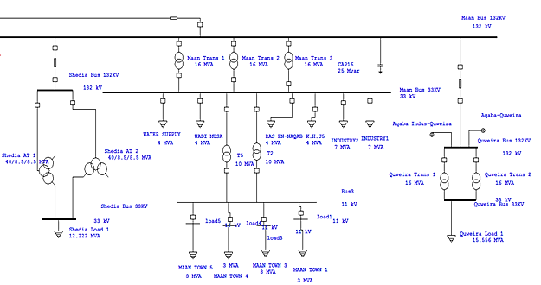
Figure 5. Single line diagram of Ma'an distribution network

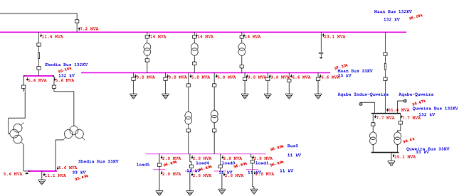
The load flow of the distribution network is shown in Figure 6:
Figure 6. Load flow of the distribution network of Ma'an

5.1.2 Case II: PV Solar System is connected to 33kV Bus Bar at Average Load.

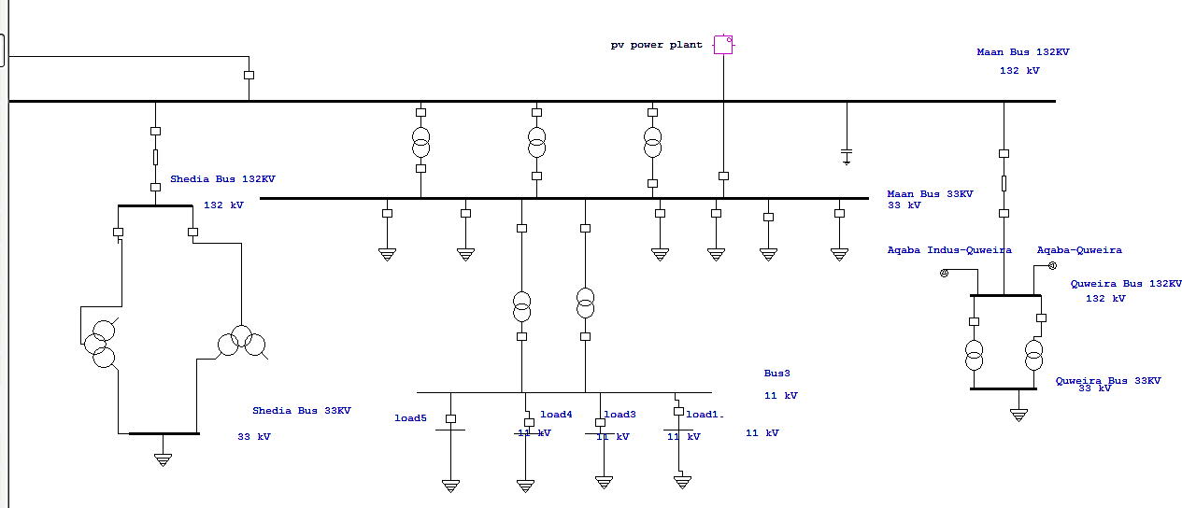
Case II consists of the distribution system with the solar plant 33 kV bus bar near the grid. Figure 7 shows the single line diagram of this case:

Figure7. ETAP single line diagram for case II.

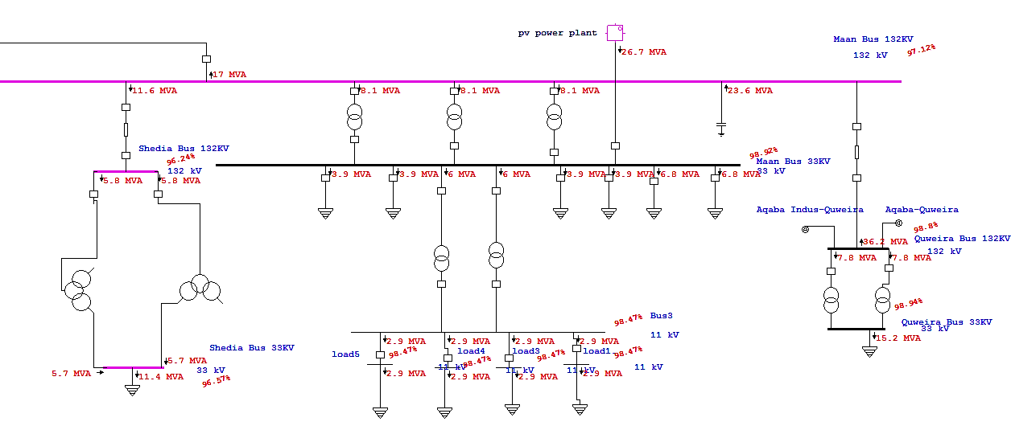
The load flow for the transformers and distribution lines is shown in Figure 8.

Figure8. ETAP load flow diagram for case II

5.1.3 Case III: PV Solar System is connected to 11kV Bus Bar at Average Load.

Case III consists of the distribution system with solar plant connected to the side of 11 kV bus bar and Figure 9 shows the single line diagram of this case.
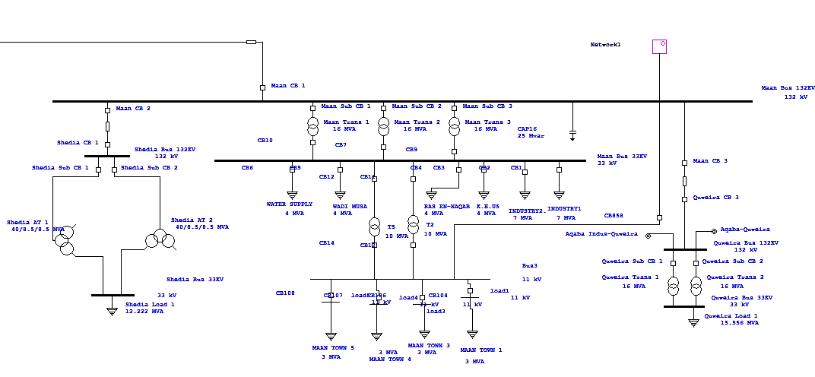
Figure 9. ETAP single line diagram for case III

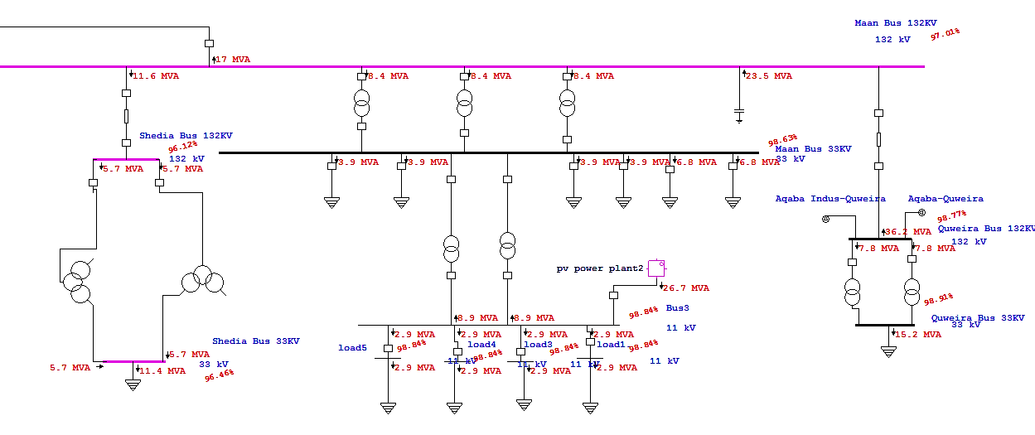
The load flow for the transformers and distribution lines is shown in Figure 10.

Figure 9. ETAP load flow diagram for case III.

- RESULTS AND ANALYSIS

6.1 Impact of PV System on Power Losses Values
A large penetration ofdistributed PV solar generation can be used to alleviateoverloads on highly loaded distribution feeders and releasecapacity on these feeders and substation transformers. This allows distribution planners to defer capital investments toother areas. Total distribution power losses can be minimized. [25, 26] According to the analysis of simulated results, the total power losses through the branches are shown in table 4 for the three cases. In case of connecting solar plant to the 33 kV bus bar, the power losses are decreased slightly compared to the normal system's losses, and when connecting the solar plant on 11 kV bus bar, the total losses decrease clearly with comparison to the normal system's losses. Figure 11 illustrates the power losses versus the penetration rate of the solar PV system.

Table 4: Power losses of the power network for different cases
Penetration rate % | Active power losses, 33kV connection point [MW] | Active power losses ,  11kV connection point [MW]
0 | 55.68 | 55.68
16 | 55.518 | 55.496
33.3 | 55.37 | 55.34
50 | 55.236 | 55.21
66.6 | 55.115 | 55.106
83 | 55.007 | 55.028
100 | 54.912 | 54.978

Figure11.Active power losses versus penetration rate of PVs.

6.2 Impact of PV system on voltage Variation

Due to the high penetration of the solar PV system poses a major concern on distribution network is high steady state voltage generation. Depending on the network characteristics and the location of the PV system ,the effect of the voltage varies.[27,28,29]
In this paper, a load flow analysis of the distribution network is performed for various cases (3cases). Table 5 shows bus voltages in percentage of the distribution network for the three different cases. Figure 12 illustrates the voltage profile versus the penetration rate of the solar PV system.

Table 5: Bus voltages in percentage of the distribution network for different cases
Penetration rate % | Load bus voltage% ,33 kV connection point | Load bus voltage%,11kV  connection point
0 | 96.890 | 96.890
16 | 97.209 | 97.491
33.3 | 97.506 | 97.980
50 | 97.78 | 98.359
66.6 | 98.032 | 98.629
83 | 98.261 | 98.791
100 | 98.468 | 98.842

Figure 12. Voltage profile with various PV installation capacities.

6.3 Impact of the installation PV system on the short circuit current level

Distribution network with the presence of solar PV sources is subject to some protection problems such as variations in the short circuit current levels, fault currents magnitudes and directions. [30, 31, 32].According to the short circuit calculations the peak and steady state values of three phase short circuit current are determined. The results are shown in Tables6 and 7 in the studied cases.Figures13 and 14 illustrate the short circuit current levels before and after a PV system connection on 33kV and 11kV buses.

Table 6: the short circuit current levels before and after PV system connection with 33kV buses.
 | Bus ID | Nominal kV | Peak Value[kA] | Steady State [kA]
Original system | Ma'an Bus 33KV | 33 | 13.706 | 5.527
After adding solar farm ,33kv connection point | Ma'an Bus 33KV | 33 | 13.617 | 5.638
After adding solar farm ,11kv connection point | Ma'an Bus 33KV | 33 | 14.139 | 5.917

Table 7: the short circuit current levels before and after PV system connected with 11kV buses.
 | Bus ID | Nominal kV | Peak Value[kA] | Steady State [kA]
Original system | Bus 3 | 11 | 19.003 | 7.56
After adding solar farm ,33kv connection point | Bus 3 | 11 | 18.993 | 7.647
After adding solar farm ,11kv connection point | Bus 3 | 11 | 19.502 | 8.435

Figure 13. Short circuit current levels before and after PV system connection to 33 and 11kV buses.

Figure 14. the short circuit current levels before and after PV system connection on 11kV buses.

7. Conclusion
This paper discusses electricity production in Jordan, using renewable energy sources in distributed generation systems. The system was designed and simulated using ETAPsoftware. Also in this paper, the impact of connecting large scale solar PV energy plants to the national grid of Jordan has been investigated. Load flow analysis has been carried out.The effect of increasing the penetration levels of solar PVs , during normal conditions, on the voltage profile ,power losses and the short circuit current level under faults has been analyzed and evaluated. After selecting the suitable site for PV solar plant presented by Ma'an town, A PV plant of 18 arrays with (6969) panels for each array were needed in order to cover the demand of the loads connected to the system. Implementation of PV solar system slightly reduces the power losses and hence can be benefited from all of the systems produced energy. It provides a better network voltage profile on the distribution network elements, especially when the PV solar system is connected to the grid near the center of electrical loads. This is important for improving the voltage stability of the system, especially during deep reactive power consumption. The addition of PV system reduces the chance of voltage collapse. The short circuit current levels are slightly increased in the grid.and should be considered for protection settings.

REFERENCES(10 PT)

- Al-Mofleh Anwar, Ali S. K. Dalabeeh, “Approach to Jordanian Energy Resource Efficiency Management Using Energy Efficiency Practices”, International Journal of Electrical and Electronic Science, 2017; 4(6): 47-53.
- M. Al zou'bi (2010) Renewable Energy Potential and Characteristics in Jordan, Jordan Journal of Mechanical and Industrial Engineering , Volume 4, Number 1, Pages 45 – 48.
- Jaber J, Badran OO, Abu-Shikhah N. Sustainable energy and environmental impact: role of renewables as clean and secure source of energy for the 21st century in Jordan. Clean Techn Environ Policy Vol. 6, 2004, 174–86.
- T. Key, "Finding a bright spot", IEEE Power and Energy Magazine, vol.7, no.3, pp.34-44, May-June 2009.
- Y. Anagreh, A. Bataineh and M. Al- Odat, solar energy potential in Jordan, ICEGES 2009.
- Renewable Energy and Energy Efficiency Law, Law No. (13) Of 2012. [Online] Available:http://www.erc.gov.jo
- Ali Salameh Khraiwish Dalabeeh and Anwar AL-Mofleh, Modeling of a High Performance Grid Connected Photovoltaic System, British Journal of Applied Science & Technology 4(32): 4520-4532, 2014. ISSN: 2231-0843
- Ministry Mineral and Energy of Resources, “Annual report,”Amman,Jordan, 2015, available at:http://www.memr.gov.jo/echobusv3.0/SystemAssets/6df2053d-ee21-4fa0-ada8-613049ab7015.pdf
- Mentesidi, K., Aguado, M.: ‘Dynamic behavior analysis of distributed generation in an off-grid network with power system simulator for engineering (PSS/E)’. IEEE Int. Energy Conf. (ENERGYCON), Dubrovnik, Croatia, 2014, pp. 1042–1049
- Mentesidi, K., Aguado, M.: ‘The potential integration of electrical distributed generation in an island power system’, Int. J. Distrib. Energy Res. Smart Grids, 2013, 9, (4), pp. 341–366
- A. Ruiz, “System aspects of large scale implementation of a photovoltaic power plant,” MS Thesis, KTH, Stockholm, Sweden 2011.
- B. Tamimi, C. Cañizares, K. Bhattacharya “Modeling and performance analysis of large solar photo-voltaic generation on voltage stability and inter-area oscillations,” 2011 IEEE Power and Energy Society General Meeting, 24-29 July 2011.
- Haval Sardar Kamil, Dalila Mat Said, Mohd Wazir Mustafa, Mohammad Reza Miveh, Nasarudin Ahmad, “Low-voltage Ride-through Methods for Grid-connected Photovoltaic Systems in Microgrids: A Review and Future Prospect,” International Journal of Power Electronics and Drive System (IJPEDS) Vol. 9, No. 4, December 2018, pp. 1834~1841
- Nur IzzatiZolkifri, Chin Kim Gan, MeysamShamsiri, “Performance analysis of Malaysian low voltage distribution network under different solar variability days” Indonesian Journal of electrical Engineering and Computer Science Vol. 13, No. 3, March 2019, pp. 1152~1160
- Salma Azzam, EyadFeilat, Ahmed Al-Salaymeh “Impact of Connecting Renewable Energy Plants on the Capacity and Voltage Stability of the National Grid of Jordan”, The 8th International Renewable Energy Congress (IREC 2017)
- Issa Etier, Mohammad Ababneh, Anas Al Tarabsheh, Simulation of a 10 kW Photovoltaic System in Areas with High Solar Irradiation, American Journal of Applied Sciences 8 (2): 177-181, 2011, ISSN 1546-9239, 2010 Science Publications.
- Irena, International Renewable Energy Agency. Renewable Energy Cost Analysis: Concentrating Solar Power. Web.
- Nabeel I.A. Tawalbeh, “Daily load profile and monthly power peaks evaluation of the urban substation of the capital of Jordan Amman,” International Journal of Electrical Power & Energy Systems, Vol 37, Issue 1, May 2012, Pages 95-102
- Omar Al-Nhoud, Mohammad Al-Smairan. Assessment of Wind Energy Potential as a Power Generation Source in the Azraq South, Northeast Badia, Jordan, Modern Mechanical Engineering, 2015, 5, 87-96
- M. Saeedan, “Sustainable Energy Mix and Policy Framework for Jordan,” Freidrich, 2011, available at: http://library.fes.de/pdffiles/bueros/amman/08883.pdf
- Abdallah R. Alzyoudz, Ali S. Dalabeeh and Anwar Almofleh, "Power Losses Minimization Using on Load Tap Changer Transformers and Injected Reactive Power", Journal of Engineering and Applied Sciences 13 (8): 2156-2161, 2018, ISSN: 1816-949X © Medwell Journals, 2018.
- http://www.solardesigntool.com/components/module-panel-solar/Suniva/438/ART245-60-2-240/specification-data-sheet.html
- Sneha Kulkarni, Sunil Sontakk, Power System Analysis of a Micro grid using ETAP, International Journal of Innovative Science and Modern Engineering (IJISME) ISSN: 2319 -6386, Volume -X, Issue- X ,
- Ali S. Dalabeeh, Anwar ALMofleh, Abdallah R.Alzyoud , Hindi T. Ayman. Economical and Reliable Expansion Alternative of Composite Power System under Restructuring, International Journal of Electrical and Computer Engineering (IJECE), Vol 8, No 6: December 2018
- A.E. Curtright; J. Apt: “The Character of Power Output from Utility-Scale Photovoltaic Systems”, Carnegie Mellon Electricity IndustryCenter Working Paper CEIC-07-05,www.cmu.edu/electricity.
- Quanta Technology White Paper: “Grid Impacts and Solutions ofRenewables at High Penetration Levels”, June 2009, www.quantatechnology.com.
- A.F. Povlsen: “Distributed power using PV: Challenges for the grid”Renewable ENERGY World, Vol. 6, No. 2, pp. 62 – 73, March-April2003.
- R. Tonkoski, D. Turcott, and T. H. El-Fouly, “Impact of high PV penetrationon voltageprofiles in residential neighborhoods,” IEEE Trans. Sustainable Energy, vol. 3, no. 3, pp. 518–527, Jul. 2012.
- Ameerul A. J. Jeman, Naeem M. S. Hannoon, Nabil Hidayat, Mohamed M. H. Adam,Ismail Musirin, Vijayakumar V, “Simulation on microgrid connected PV system under balance and unbalance fault,” Indonesian Journal of Electrical Engineering and Computer Science Vol. 13, No. 3, March 2019, pp. 1332~1336
- Danling Cheng, Barry A. Mather, Richard Seguin, Joshua Hambrick,Robert P. Broadwater, “Photovoltaic (PV) Impact Assessment for Very HighPenetration Levels” IEEE JOURNAL OF PHOTOVOLTAICS, VOL. 6, NO. 1, January 2016
- Mahmoud Alhalalmeh, Saleh Al-Jufout, Impact of Photovoltaic Penetration on the Distribution System Protection: A Case Study of 5-MW Plants of Mu'tah University and Kempinski Hotel,”2019 IEEE Jordan International Joint Conference on Electrical Engineering and Information Technology (JEEIT)
- Hossein Hooshyar,MesutE.Baran, Fault Analysis on Distribution Feeders with High Penetration of PV Systems, Power Systems 2013, IEEE Transactionson,Vol 28,Pages 2890-2896
- Bhattacharys,T.Saha,M.JHossain,Faultcurrentcontributionfromphotovoltaicsystemsinresidentialpowernetworks,ProceedingsoftheAustralasianUniversitiesPowerEngineeringConference,Hobart,2013,Australia,pp.1-6.
- M. J. Reno, A. Ellis, J. Quiroz, and S. Grijalva, “Modeling distributionsystem impacts of solar variability and interconnection location,” in Proc.World Renewable Energy Forum, May 2012.
- M. J. E. Alam, K. M. Muttaqi, D. Sutanto,”An Approach for Online Assessment of Rooftop SolarPV Impacts on Low-Voltage Distribution Networks,” IEEE TRANSACTIONS ON SUSTAINABLE ENERGY, VOL. 5, NO. 2, APRIL 2014 pages pp. 663-672.
- Chao Long and Luis F. Ochoa, "Voltage Control of PVRichLV Networks: OLTC-Fitted Transformer andCapacitor Banks," IEEE Transactions on PowerSystems, pp. 1-10, 2015.

BIOGRAPHIES OF AUTHORS

 | Abdallah R.Alzyoud : received his Master Degree in Electrical Power Engineering, Donetsk Polytechnic Institute,1980. Ukraine And the Ph.D. in Electrical Power Engineering, Kiev Polytechnic Institute, 1992, Ukraine. He is currently promoted the Associate professor with Department of electrical engineering Faculty of Engineering Technology, Al- Balqa’ Applied University, Al-Salt, Jordan. His research interests include solar energy, renewable energy and protection
 | Ali S.K. Dalabeeh: received his B.S from Alleppo University/Engineering College/Syria in 1981 and PH.D in electrical engineering from Moscow power Institute in 1988. Currently he is an associate professor in electrical engineering department of Faculty of Engineering Technology/Al-Balqa’ Applied University. his research interests include renewable energy and deregulation in electrical power systems
 | Anwar Al-Mofleh : received his B.Sc and MSc from Byelorussian Polytechnic academy in 1993.He is currently, working as lecturer in Al-Balqa Applied University in Jordan and as candidate for PhD, at the fields of power and energy efficiency E-mail address: anwaralmofleh@yahoo.com
 | Ahmad S.Allabadi: : received his B.Sc. in Electrical Power Engineering from Al-Balqa’ Applied University, Amman, Jordan .. His research interests are in solar energy, renewable energy

