Substrate Integrate Waveguide and Microstrip Antennas at 28 GHz
¹Yaqdhan Mahmood Hussein, ²Mohamad Kamal A. Rahim, ³Noor Asniza Binti Murad, ⁴Mustafa Mohammed Jawad, ⁵Hatem.O.Hanoosh, ⁶Huda A Majid, ⁷Hussam. H. Keriee, ⁸Fahad Taha Al-Dhief and ⁹Muhammad Naeem Iqbal.
^{1,2,3,4,5,7,8}Advanced RF&Microwave Research Group, School of Electrical Engineering
Faculty of Engineering, Universiti Teknologi Malaysia,
81310, Skudai, Johor Bahru, Johor, Malaysia
⁶Faculty of Engineering Technology (FTK) Department if Electrical Engineering Technology
Universiti Tun Hussein Onn Malaysia, Hab pendidikan Tinggi Pagoh KM1 Jalan Panchor, Panchor Johor84600 Malaysia
yaqthanm79@gmail.com

Article Info |  | ABSTRACT
 |  | In this paper, two antennas are designed using substrate integrated waveguide (SIW) and microstrip technology at 28 GHz. Parametric study for both antennas is presented to demonstrate the performance at millimeter wave frequency. Roger RT5880 substrates are used to implement the antennas with two thicknesses of 0.508 mm and 0.127 mm respectively. Both antennas have the same size of substrate 12 mm × 12 mm with a full ground plane was used. The simulation results showed that the antenna with SIW and roger RT 5880 substrate thickness 0.508 has better performance in term of return loss and radiation pattern than the microstrip patch antenna at 28 GHz. A return loss more than -10 dB and the gain is 6.4 dB obtained. This proving to increase the realized gain by implementing SIW at millimeter wave frequency.
Keyword:
SIW
microstrip
millimeterwave

- INTRODUCTION
Recently, the demands for high gain antenna with low profile for millimeter wave (mm-Wave) are needed. The target is to increase the receiver sensitivity at the user point. However, the pathloss and components loss are the major factors that should be taken in consideration in the mm-wave frequency [1]. various techniques are based on the finite-difference time-domain technique or the finite-difference frequency domain [2], the boundary integral-resonant mode expansion (BI-RME) technique [3], the method of lines [4] and the transverse resonance method [5]. there are antenna configurations that have been done in the literature. A modified Vivaldi radiator was introduced in [6]: it consists of a dual V-type linearly tapered slot antenna, with center frequency at 36 GHz. Also, this antenna topology suited for integration in SIW technology. Cavity-backed SIW antennas have been improved [7 – 9]. The single structure was offered in [7]: it contains a slotted SIW cavity supported by a coplanar waveguide, Compact, single-substrate cavity-backed slot and patch oscillator antennas were offered in [10], respectively. A non-detailed schematic of the design circuit. Various techniques of active antennas, such as injection locking, cavity control, varactor tuned antenna, and oscillation feedback loop, have been presented [11]. Microstrip patch antennas (MPAs) have been used in wireless and telecommunication systems but It offers lower gain also It has lower power handling capability. Recently, substrate integrated waveguide (SIW) has been used more than common waveguide and microstrip because it is bulky and expensive [12]. The parameters of the SIW cavity should be designed with care. The vias spacing (S) and diameter (D) affect considerably the return and radiation losses, whereas, the waveguide width (WSIW) controls the cut-off frequency and propagation constant [13]. the current flowing through the probe makes a magnetic field, which matches with the magnetic field inside the SIW structure [14]. At millimeter-wave frequencies, high gain antennas are required to overcome the signal attenuation due to oxygen molecules absorption [15]. to make the antenna radiate two-band need to request in order to use the currently available allocated 5G spectrums in a wave system [16]. [17] The antenna consists of a 1-to-8 way SIW power divider and 8 Vivaldi element however this design wide bandwidth (38.9 GHz ~ 45.1 GHz) with this high-frequency be a complex design. [18], [19] Multiple-input-multiple-output (MIMO) and designed with the guidance of a Genetic Algorithm (GA) antennas are broadly used for the improvement of antenna capacity and this technology has been done for 4G as well as 5G communications. Wireless systems have taken an increased interest, as new applying for millimeter waves (mm-waves) is being introduced and improved. In fact, a kind of application has been recently offered in the frequency range over 60– 94 GHz, including wireless networks [20], automotive radars [21], imaging sensors [22] and biomedical devices [23].
This paper introduces four types of antennas, two antennas implemented by using microstrip technology with different thickness. And the other antennas implemented using SIW technology with various thickness. To prove the concept of SIW performance better than microstrip at mm-wave frequency in term of gain and return loss. A simulation has been done by using computer simulation technology CST software to compare the performance of the four antennas.

- DESIGN METHOD
The proposed SIW antennas were designed using Rogers RT5880 substrate. The substrate has a dielectric constant of 2.2 and loss tangent of 0.0009. Two different substrate thickness were chosen, which is 0.508 mm and 0.127 mm. microstrip patch antenna is implemented using same substrate Roger RT5880 with two different thickness 0.508 mm and 0.127 mm. The vias dimeter D and spacing S are calculated using equations in [24], [25]. Full ground plane is used for all the antennas. Figure 1 shows the dimensions of the proposed antennas at 28 GHz. As can be seen from Figure 1 (a), the microstrip patch has the dimension of 4.6 mm × 8 mm with substrate thickness 0.508mm and figure 1(b) the dimension of structure 7.24mm × 7.8mm with thickness 0.127mm. figure1 (c) refer to the SIW antenna with thickness substrate 0.127 and the dimension of structure is 7.38mm × 8.2mm, figure1 (d) to explain the SIW antenna with a thickness 0.508mm and the dimension of structure is 7.68mm × 8.2mm.
On the other hand, the proposed dimension of substrate of the SIW and microstrip antenna are 12mm × 12mm.

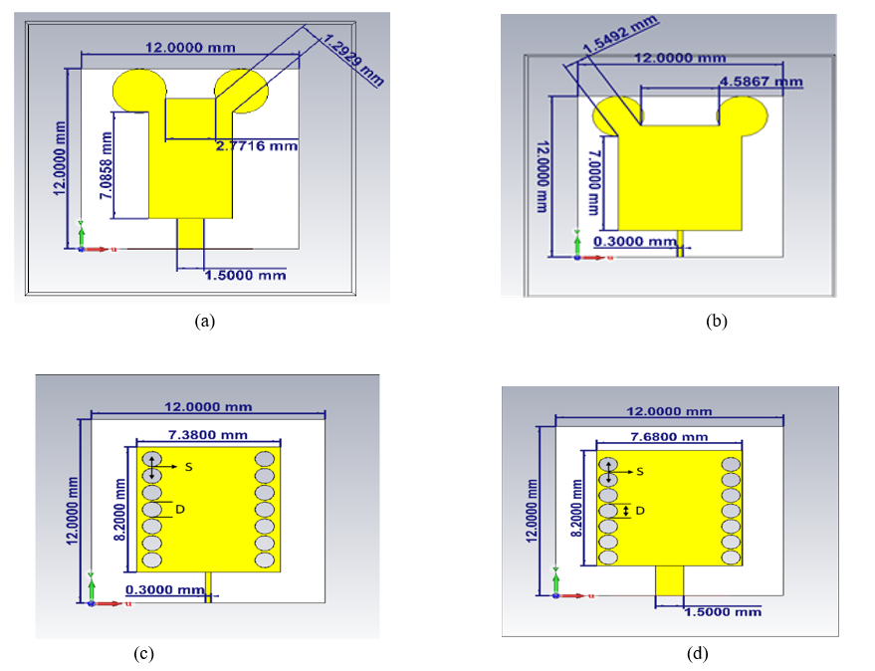

Figure 1. Proposed SIW and microstrip Antennas with two different thickness of the substrate.

- RESULTS AND DISCUSSIONS
All the antennas were simulated by using CST program, the characteristics of computer which used to design are RAM 8GHz and processor intelCPU E3-1240 v2 @3.40GHz (8CPU) with windows 10 software with this characteristic of computer the time smilution was around one hour for each design. The return loss of the proposed antennas is shown in Figure 3. It can be clearly seen that the SIW antenna with thickness of 0.508 mm has the best return loss of -34 dB at 28 GHz compared to others, the SIW antenna was able to achieve a bandwidth of 1 GHz from 27.3GHz to 28.6GHz at 10db while the patch antenna was able to achieve 400MHz at 10dB, On the aspect of return loss, it can be seen evidently that the SIW performed better then the patch antenna.
in this paper, there is relation between the thickness of substrate and the width of feedline. Two structures have been designed with different widths of feedline. The feedline, er, frequency and the thickness of substrate have effect on 50 ohm impedance matching. The feedline having a width of 0.3mm with substrate thickness 0.127mm and the feedline having a width 1.57mm with substrate thickness 0.508mm

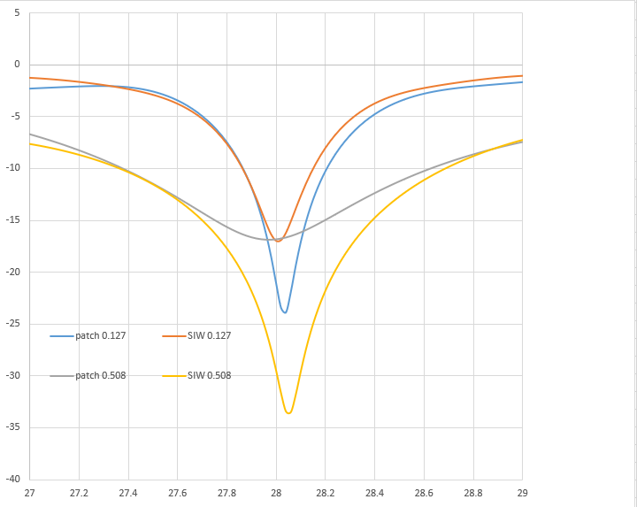

Figure 2. the return loss of the microstrip and SIW antenna with different thickness

The 3D radiation pattern of the proposed antennas can be seen in Figure 4. SIW antenna using rogers RT5880 substrate RT5880 with thickness 0.508mm archived better gain, directivity and return loss as compared to the different thickness and. Table 1 summaries the performance of the proposed antennas at 28 GHz. In term of gain and directivity, it can be seen as show by the 3dB radiat onto pattern that the SIW performed better then the patch antenna, the SIW’s gain is 6.4dB while the patch antenna is 5.59dB.

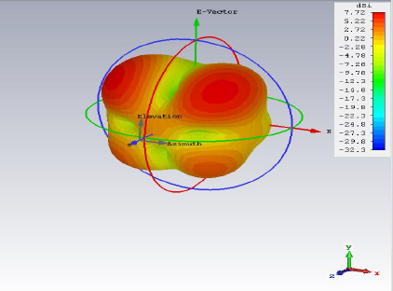
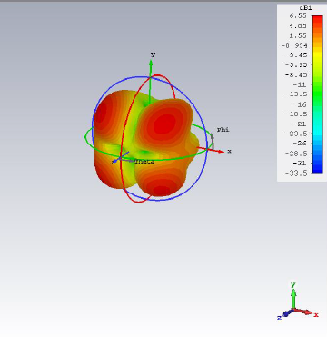

          - (b)

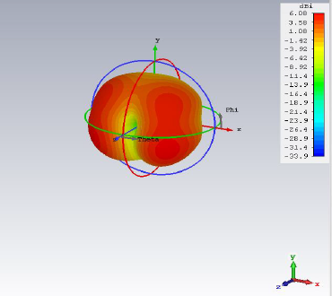
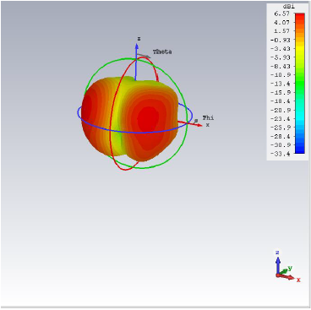

(c) (d)

Figure 3. 3D radiation pattern. (a) SIW with thickness 0.508 mm. (b) SIW with thickness 0.127 mm. (c) microstrip with thickness 0.508 mm. (d) microstrip with thickness 0.127 mm.

As shown in figure 4 the radiation pattern 2D of the fure structure, it explain the different radiation of the structures and can see the radiation of the microstrip antenna with two the thicknesses 0.127mm and 0.508 in one dirction howervey it have back loop and side loop, and the SIW s design with thickness 0.127mm has back and side loop also it not ragualer radiation, the radiation of SIW design with thickness 0.508 has wide radiation and regualer.

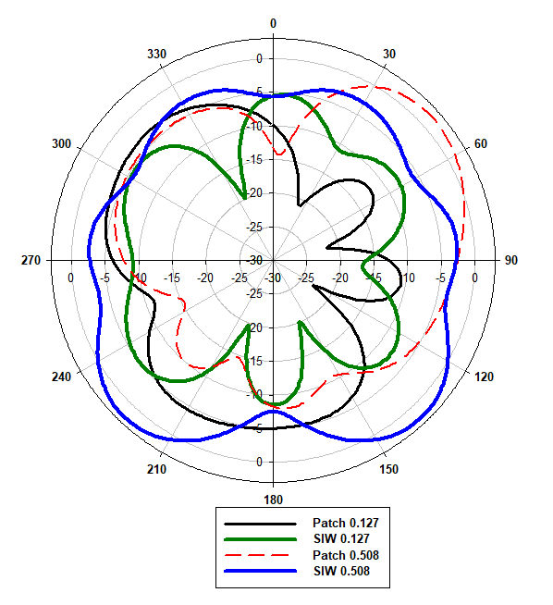
in figure 4 the radiation pattern 2D of the four structure

Table 1. Performance Comparison between microstrip and SIW antenna
SIW antenna
Type of substrate | Size of thickness | Gain dB | Directivity dBi | S11
Rogers RT5880 | 0.508 | 6.4 | 7.67 | -33.44
Rogers RT5880 | 0.127 | 5.02 | 6.55 | -16.9
Patch antenna
Rogers RT5880 | 0.508 | 5.59 | 6.08 | -16.7
Rogers RT5880 | 0.127 | 5.07 | 6.57 | -23.6

It can be noticed from the above table, that the SIW antennas have better performnce in term of gain and return loss than common patch microstrip antenna. When the thickness is decreased in SIW the gain is reduced. Therfore, SIW anenna with substrate thickness of 0.508 is sutable at 28 GHz.

- CONCLUSIONS
A substrate integrate waveguide and microstrip patch antenna are presented in this work by using CST, substrates rogers RT5880 used to design SIW and patch antennas the performance and the results under this different substrate size, antenna gave different results. SIW with rogers RT5880 and thickness 0.508 gave better return loss -33.44 at 28GHz with gain ieee 6.4 dB and the directivity is 7.67, in addition, the side loops of the antenna reduced. Rogers 5880 RT with 0.508 thickness is suitable for the millimeter wave.

ACKNOWLEDGEMENT

The authors would like to thank the Ministry of Education (MOE), Research Management Centre (RMC) School of Postgraduate Studies (SPS), Advanced RF and Microwave Research Group (ARFMRG), School of Electrical Engineering, and Universiti Teknologi Malaysia (UTM), Johor Bahru, for the support of the research under Grant 06G15 and 04G67. The authors also would like to acknowledge all members of the Advanced RF and Microwave Research Group (ARFMRG).

REFERENCES
[1] M. Stanley, Y. Huang, T. Loh, Q. Xu, H. Wang, and H. Zhou, "A high gain steerable millimeter-wave antenna array for 5G smartphone applications," in 2017 11th European Conference on Antennas and Propagation (EUCAP), 2017, pp. 1311-1314: IEEE.
[2] Xu, F., Zhang, Y., Hong, W., Wu, K., Cui, T.J.: ‘Finite-difference frequency-domain algorithm for modeling guided-wave properties of substrate integrated waveguide’, IEEE Trans. Microw. Theory Tech., 2003, MTT-51, (11), pp. 2221– 2227
[3] Cassivi, Y., Perregrini, L., Arcioni, P., Bressan, M., Wu, K., Conciauro, G.: ‘Dispersion characteristics of substrate integrated rectangular waveguide’, IEEE Microw. Wirel. Compon. Lett., 2002, 12, (9), pp. 333–335
[4] Yan, L., Hong, W., Wu, K., Cui, T.J.: ‘Investigations on the propagation characteristics of the substrate integrated waveguide based on the method of lines’, Proc. IEE Microw. Antennas Propag., 2005, 152, pp. 35–42
[5] Deslandes, D., Wu, K.: ‘Accurate modeling, wave mechanisms, and design considerations of a substrate integrated waveguide’, IEEE Trans. Microw. Theory Tech., 2006, 54, (6), pp. 2516–2526
[6] Cheng, Y.J., Hong, W., Wu, K.: ‘Design of a monopulse antenna using a dual V-type linearly tapered slot antenna (DVLTSA)’, IEEE Trans. Antennas Propag., 2008, 56, (9), pp. 2903– 2909
[7] Luo, G.Q., Hu, Z.F., Dong, L.X., Sun, L.L.: ‘Planar slot antenna backed by substrate integrated waveguide cavity’, IEEE Antennas Wirel. Propag. Lett., 2008, 7, pp. 236–239
[8] Bohorquez, J.C., Pedraza, H.A.F., Pinzon, I.C.H., Castiblanco, J.A., Pena, N., Guarnizo, H.F.: ‘Planar substrate integrated waveguide cavity-backed antenna’, IEEE Antennas Wirel. Propag. Lett., 2009, 8, pp. 1139– 1142
[9] Awida, M.H., Fathy, A.E.: ‘Substrate-integrated waveguide Ku-band cavity-backed 2 × 2 microstrip patch array antenna’, IEEE Antennas Wirel. Propag. Lett., 2009, 8, pp. 1054–1056
[10] Giuppi, F., Georgiadis, A., Bozzi, M., Via, S., Collado, A., Perregrini, L.: ‘Hybrid nonlinear and electromagnetic design of an active oscillator SIW cavity backed slot antenna’. Applied Computations Electromagnetics Society Symp. (ACES), Tampere, Finland, 23–29 April 2010
[11] F. Giuppi, A. Georgiadis, M. Bozzi, S. Via, A. Collado, and L. Perregrini, “Hybrid nonlinear and electromagnetic design of an active oscillator SIW cavity backed slot antenna,” 26th Annual Review of Progress in Applied Computational Electromagnetics (ACES), pp. 260-263, Tampere, Finland, April 2010.
[12] D. Deslandes and K. Wu, "Integrated microstrip and rectangular waveguide in planar form," IEEE Microwave and Wireless Components Letters, vol. 11, no. 2, pp. 68-70, 2001.
[13] M. Asaadi and A. Sebak, "High gain low profile slotted SIW cavity antenna for 5G applications," in 2016 IEEE International Symposium on Antennas and Propagation (APSURSI), 2016, pp. 1227-1228: IEEE.
[14] Deslandes, D., Wu, K.: ‘Analysis and design of current probe transition from grounded coplanar to substrate integrated rectangular waveguides’, IEEE Trans. Microw. Theory Tech., 2005, 53, (8), pp. 2487–2494.
[15] O. M. Haraz, A. Elboushi, S. A. Alshebeili, and A.-R. Sebak, "Dense dielectric patch array antenna with improved radiation characteristics using EBG ground structure and dielectric superstrate for future 5G cellular networks," IEEE Access, vol. 2, pp. 909-913, 2014.
[16] Nadeem Ashraf 1, Osama Haraz 1,2, Muhammad A. Ashraf 1 and Saleh Alshebeili, "28/38-GHz Dual-Band Millimeter Wave SIW Array Antenna with EBG Structures for 5G Applications," 2015 international conference on information and communication technology research (ICTRC2015), 978-1-4799-8966-9/15/$31.0020©15IEEE.
[17] Pengfei Liu, Xiaowei Zhu, Xiang Wang and Ling Tian," A SIW-Based Vivaldi Array Antenna for 5G Wireless Communication Systems," 2017 IEEE International Symposium on Antennas and Propagation & USNC/URSI National Radio Science Meeting, 978-1-5386-3284-0/17/$31.00 ©2017 IEEE
[18] Asim Ghalib1, Mohammad S. Sharawi1, Hussein Attia1 and Raj Mittra2, “Broadband Substrate Integrated Waveguide Slotted Array Antenna at mm-Wave Bands,” 2018 IEEE MTT-S International Microwave Workshop Series on 5G Hardware and System Technologies (IMWS-5G) , 978-1-5386-1197-5/18/$31.00 ©2018 IEEE.
[19] Mohammad S. Sharawi, Printed MIMO Antenna Engineering Norwood,
MA, USA: Artech House, 2014.
[20] Daniels, R.C., Heath, R.W.: ‘60 GHz wireless communications: emerging requirements and design recommendations’, IEEE Veh. Technol. Mag., 2007, 2, (3), pp. 41–50
[21] Fleming, W.J.: ‘New automotive sensors – a review’, IEEE Sens. J., 2008, 8, (11), pp. 1900– 1921
[22] Yujiri, L., Shoucri, M., Moffa, P.: ‘Passive millimeter wave imaging’, IEEE Microw. Mag., 2003, 4, (3), pp. 39– 50
[23] Mizuno, K., Wagatsuma, Y., Warashina, H., et al.: ‘Millimeter-wave imaging technologies and their applications’. IEEE Int. Vacuum Electronics Conf., IVEC ’07, 15– 17 May 2007
[24] M. A. Rahim, I. Ibrahim, R. Kamaruddin, Z. Zakaria, and N. Hassim, "Characterization of Microstrip Patch Array Antenna at 28 GHz," Journal of Telecommunication, Electronic and Computer Engineering (JTEC), vol. 9, no. 2-8, pp. 137-141, 2017.
[25] M. Bozzi, A. Georgiadis, and K. Wu, "Review of substrate-integrated waveguide circuits and antennas," IET Microwaves, Antennas & Propagation, vol. 5, no. 8, pp. 909-920, 2011.

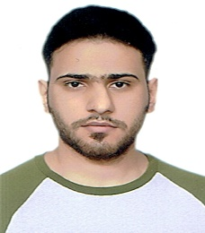 | Yaqdhan Mahmood Hussein was born in sammawah, Iraq, in 1991. He received the B.S in computer techniques engineering in 2014-2015 from Islamic University College in Najaf city. and M.S. degrees in electronic engineering (telecommunication system) from University technical Malaysia Melaka, Malaysia, in 2018, respectively, and he studies the Ph.D. degree in electronic engineering in university technology Malaysia in Johor Bahru city, His current research interests include millimeter wave antennas, base station antennas, and SIW technology with butler matrix.
 | Dr Mohamad Kamal is the professor at Communication Engineering Department Faculty of Electrical Engineering UTM. He is Deputy Dean Research and Innovation and Head of Advanced RF&Microwave Research Group. His research interest includes the areas of design of Dielectric resonator antennas, microstrip antennas, small antennas, microwave sensors, RFID antennas for readers and tags, Multi-function antennas, microwave cicuits, EBG, artificial magnetic conductors, metamaterials, phased array antennas.
 | Noor A Murad currently works at the School of Electrical Engineering, Faculty of Engineering, Universiti Teknologi Malaysia. Noor does research in antenna design as well as other microwave and millimeterwave devices. Her current research is on waveguide based devices at millimeterwave.
 | Mustafa Mohammed jawad abed was born in Baghdad, Iraq, in 1991. He received the B.S in computer techniques engineering in 2010 from Al Rafidain University College in Baghdad city. and M.S. degrees in electronic engineering (telecommunication system) from University technical Malaysia Melaka, Malaysia, in 2018, respectively, and he studies the Ph.D. degree in electronic engineering in university technology Malaysia in Johor Bahru city, His current research interests include wireless body area network, frequency-selective surface.
 | Hatem Oday Hatem Hanoosh was born in samawah, Iraq, in 1991. He received the B.S in computer techniques engineering in 2014-2015 from Islamic University College in Najaf city. and M.S. degrees in electronic engineering (telecommunication system) from University technical Malaysia Melaka (UTEM), Malaysia, in 2018, respectively, and he studies the Ph.D. degree in electronic engineering in university technology Malaysia (UTM) in Johor Bahru city, His current research interests include millimeter-wave antennas, base station antennas, and waveguide slot antennas.
 | Huda A. Majid received the B Eng. degree in electrical engineering (telecommunication) from Universiti Teknologi Malaysia in 2007 and the M.Eng. degree and the Ph.D. degree in electrical engineering from Universiti Teknologi Malaysia in 2010 and 2013, respectively. He is currently a Lecturer with the Department of Electrical Engineering Technology, Faculty of Engineering Technology, Universiti Tun Hussein Onn Malaysia. He has published over 50 articles in journals and conference papers. His research interests include the areas of design of microstrip antennas, small antennas, reconfigurable antennas, metamaterials structure, metamaterial antennas, and millimeter wave antennas.
 | Hussam Hamid Abed Keriee was born in Baghdad, Iraq, in 1985. He received the B.S in computer techniques engineering in 2010 from Al Rafidain University College in Baghdad city. and M.S. degrees in electronic engineering (telecommunication system) from University technical Malaysia Melaka, Malaysia, in 2018, respectively, and he studies the Ph.D. degree in electric engineering in university technology Malaysia in Johor Bahru state, He is an active student member of IEEE, and a member of IEEE Communications Society. His current research interests include antenna design for mobile applications , metamaterial antenna , Split-ring resonator, frequency-selective surface.
 | Fahad Taha Al-Dhief was born in Iraq, Amarah city. He received the B.S. in Software Engineering from Imam Jaafar Al-Sadiq University, Iraq in 2013 and also received M.S. in Computer Science from University Kebangsaan Malaysia, Malaysia in 2016. Currently, he is a Ph.D. student at School of Electrical Engineering, Universiti Teknologi Malaysia, Malaysia. He is an active student member of IEEE, and a member of IEEE Communications Society. His research interests are sensor network, routing protocols, mobile ad-hoc network, social network, Internet of things, machine learning, artificial neural networks, deep learning and location-based service.
 | Muhammad Naeem Iqbal was born in Mangla, Pakistan in 1987. He received his Bachelors and Masters degree in electrical Engineering from National University of Sciences and Technology, Pakistan in 2009 and 2013. Currently, he is pursuing his PhD in Electrical Engineering from Universiti Teknologi Malaysia. His research interests include the Transmitarrays, Reflectarrays Antennas, beamforming and polarization converters.

