Comparative Analysis of Observer-Based LQR and LMI Controllers of an Inverted Pendulum

Nura Musa Tahir¹, Mustapha Muhammad², Musa Idi³, SalindaBuyamin⁴, LadanMaijama’a⁵, Sa’id Musa Yarima⁶
^{1,3}Department of Mechatronics and System Engineering, Abubakar Tafawa Balewa University, Bauchi, Nigeria
⁶Department of Electrical and Electronics Engineering, Abubakar Tafawa Balewa University, Bauchi, Nigeria
²Department of Mechatronics, Bayero University Kano, Kano Nigeria
⁴Division of Control and Mechatronics Engineering, School of Electrical Engineering, Faculty of Engineering, UniversitiTeknologi Malaysia, Johor, Malaysia
⁵Department of Electrical and Electronics Engineering, Federal Polytechnic, Bauchi, Nigeria.

Article Info |  | ABSTRACT
Article history:  ReceivedJun x, 20xx  Revised Novx, 20xx  Accepted Dec x, 20xx |  | An inverted pendulum is a multivariable, unstable, nonlinear system which is used as a yardstick in control engineering laboratories to study, verify and confirm innovative control techniques. Observer-based Linear Quadratic Regulator (LQR) controller and Linear Matrix Inequality (LMI) are proposed for upright stabilization of the system. Simulation studies are performed using step input magnitude, and the results are analyzed. Time response specifications and level of disturbances rejection are employed to investigate the performances of the proposed controllers where the LMI controller exhibits better performances in both stabilization and robustness.
Keywords:
Inverted pendulum
Nonlinear
LQR
LMI
Multivariable
Optimization
This is an open access article under the CC BY-SAlicense.

Corresponding Author:
SalindaBuyamin,
Division of Control and Mechatronics Engineering,
School of Electrical Engineering,
Faculty of Engineering, UniversitiTeknologi Malaysia, Johor, Malaysia..
Email: salinda@utm.my

- INTRODUCTION
A variable speed control moment gyroscope (VSCMG) actuator was employed to control an atypical pendulum configuration [1]. The work employed both the angular momentum variation in amplitude and direction to implement the control. Coupled state-dependent Riccati equation (SDRE) method for scientifically designing nonlinear quadratic regulator (NLQR) and H infinity control of an under-actuated Furuta rotary pendulum was developed[2]. Mukhtar et al. described the main control objectives of a rotary inverted pendulum as swing-up control, stabilization control, switching control and trajectory tracking control [3]. Tian et al. proposed RBF-ARX(state-dependent Auto-Regressive model with exogenous input and Radial Basis Function network type coefficients) model-based efficient robust predictive control method for systematic inverted pendulum design[4].Output feedback laws with a minimum switching rule for saturated switched linear systems were developed, and it provided control synthesis conditions of spherical inverted pendulum [5].Improvement of Polekhin's theorem by lowering the regularity motion and a periodic solution for the carriage moving periodically on the plane was obtained[6].Galan et al. offered an open-source online lab experiment for the Furuta pendulum, a system helped researchers to study nonlinear dynamics and control theory [7]. The two-stage inverted pendulum was presented using a differential equation where the equation was linearized to near an equilibrium position to derive a linear state equation[8]. Mahmood et al. feedback linearization and sliding mode control approach was established to stabilize a class of fourth-order nonlinear systems where design parameters of the sliding surface were modified using the adaptation laws, based on the gradient descent technique[9]. Xu et al. stabilized a wheeled inverted pendulum using one accelerometer with a modified mechanical structure [10]. Approximate feedback linearization and sliding mode methods were employed to control a cart-type inverted pendulum, where stability was achieved by using an optimized hybrid algorithm based on the particle swarm optimization and genetic algorithm[11]. Hanwate et al. proposed an adaptive control logic to serve as a supervisory control system sufficient to reduce disturbance due to modelling uncertainties[12]. Trentin et al. controlled reaction wheel oscillation using a proportional-integral controller[13]. Bui et al. stabilized an inverted pendulum with a fuzzy controller in the vertical position of a damped-elastic-jointed subjected to a time-periodic follower force[14]. Lin et al. developed an a pneumatic cart-pendulum-seesaw system for the vertical balancing of the pendulum [15]. Xu et al. stabilized inverted pendulum using a single accelerometer where he introduced a new position selection process[16]. Yigit developed nonlinear modelling, simulation and sliding mode stabilizing control of a real rotary inverted pendulum[17].Linear Quadratic Regulator (LQR) was considered to stabilize the system in a vertical position where the disturbances rejection of the system was analyzed [18]. In pole-placement method the closed loop pole location must be determined, but the researcher may not really know where they are located. The optimal control method ignores finding the desired pole location.The control law of the optimal control method always optimizes performance of the system in the accurate sense and the above all drawbacks are avoided. So, a linear state feedback controller based on the linearized Inverted Pendulum model can instead be used and may also be extended with a disturbance observer (Kalman Filter), to improve the disturbance rejection performance.
This paper presents observer based LQR and LMI controllers for stabilization control of an inverted pendulum system and using the simulation studies, the performances of the designed controllers were compared and analyzed. Next section of the paper presents detail dynamic model of the system, control schemes are given in Section 3. Results and discussion were presented in Section 4. And finally, conclusions and future recommendation was given in Section 5.

- SYSTEM DISCRIPTION
The 33-000-V73 version of laboratory-scale feedback inverted pendulum system is presented. The system consists of dual pendula, a cart, a D.C motor, and a rail. For the pendula to rotate freely through 3600, the two are hinged at the cart’s centre. The D.C motor moves the cart horizontally on the rail, freely. Figure 1 shows the mechanical system. The system is unstable whenever the pendula are positioned vertically but downright stable when positioned at a downwardly. Any slight deviation from the equilibrium point would render the pendulum totally unstable. The movement region of the inverted pendulum in which control is achievable has been shown in Figure 2.

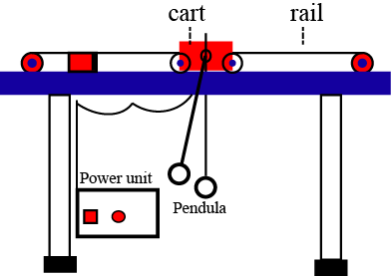
Figure 1. The laboratory-based inverted pendulum

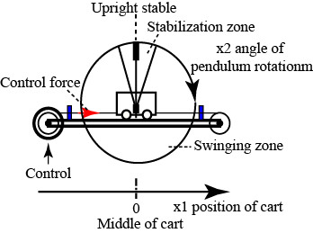
Figure 2. Schematic diagram of inverted pendulum

2.1. System modelling

Figure 3 shows the system representations, where x, f(t), and θ are the cart displacement, the applied force (N) and the pendulum angle respectively. I is the moment of inertia (kgm²) of the rod from the centre of mass, M is the cart’s mass (kg) and l is the length (m) of the pendulum. b and c are the cart’s viscous and translation damping (Ns/m) respectively. And system parameters is as recorded in table1 [18].

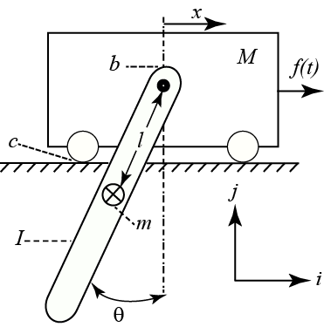

Figure 3.Schemetic diagram

Parameters | Values
Mass of the cart (M) | 2.4Kg
Mass of pole (m) | 0.23Kg
Length of pole (l) | 0.38m
Moment of inertia of the pol (l) | 0.099Kg/m2
Coefficient of friction of cart (b) | 0.05
Damping coefficient of pendulum (d) | 0.005Nms/rad
Gravity (g) | 9.8m/s2
Table 1. System Parameters [18]

Based on Figure 3, the system’s overall dynamic equations were obtained as;
$\left\{\begin{aligned}\left(M+m\right)\ddot{x}+c\dot{x}+mlcosθ\ddot{θ}+mlsinθ{\dot{θ}}^{2}=f(t) \\ \left(ml^{2}+I\right)\ddot{θ}+ml\ddot{x}cosθ+mglsinθ+b\dot{θ}=0\end{aligned}\right.$ (1)
In addition, this was represented in a state-space form as;
$\dot{x}=Ax+Bu$ (2)
$y=Cx$ (3)
And states vector of the system was expressed as;
$z=\left[\begin{matrix}z_{1} \\ z_{2} \\ z_{3} \\ z_{4}\end{matrix}\right]=\left[\begin{matrix}θ \\ \dot{θ} \\ x \\ \dot{x}\end{matrix}\right]$ (4)
Where;
$θ$,$\dot{ θ,} x and \dot{x}$ are the pendulum angle, angular velocity, cart displacement and velocity of the cart respectively. The system matrix was obtained as;

- CONTROL SYSTEM DESIGN
In this part, observer-based LQR was designed and then compared with LMI controller for upright stabilization control of the inverted pendulum. The position of closed-loop poles of a given linear dynamic system in a complex plane determined the stability and transient response of the system. Thus, the system closed-loop poles were located in an LMI region in order to stabilize the system.

3.1. LQR Control
In the LQR control system, a control law is selected to regulate the state x and to get the performance index minimized:
(5)

Where;
J is the performance index, $R>0 and Q≥0$are the weight matrices for the control variable $u(t)$ and state variable $x(t)$ respectively. Figure 4 shows a typical LQR control system.

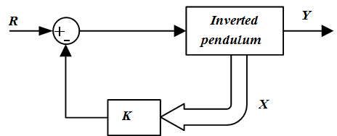
Figure 4.Typical LQR Control System

R and Q are positive definite and the semi-positive definite matrices respectively.
Thus, K can be obtained to satisfy the feedback control law[19], [20].
$u=-Kx=-R^{-1}B^{T}Px$ (6)
Where;
P is the solution of Riccati equation;
$A^{T}P+PA+Q-PBR^{-1}B^{T}P=0$ (7)
And
$K=R^{-1}B^{T}P$ (8)
The closed-loop controller gains was found as; K = [20.9777 8.3690 -3.9528 -4.1689].

3.2. Observer Feedback Control Design
In full state feedback control design, it is assumed that all states are available for feedback and the system has to completely state observable. As a rule of thumb, the observer poles are chosen so that its response is at least two to five times faster than the system response. This will make the observer states to quickly converge to the actual state; the observer equation is as shown in (9) [21].
$\dot{\hat{x}}=\left(A-LC\right)\hat{x}+Bu+L(y-\hat{y }$) (9)
Where L is observer gain, $\hat{x}$ estimate states, u is the control signal and y is the output.
$u=-K\hat{x}$ (10)
Equation (10) is the observed feedback control law. The observer error equation is written as;
$\dot{e}=\left(A-LC\right)e$ (11)
Thus Figure 5 shows the block diagram of the observer feedback control system.

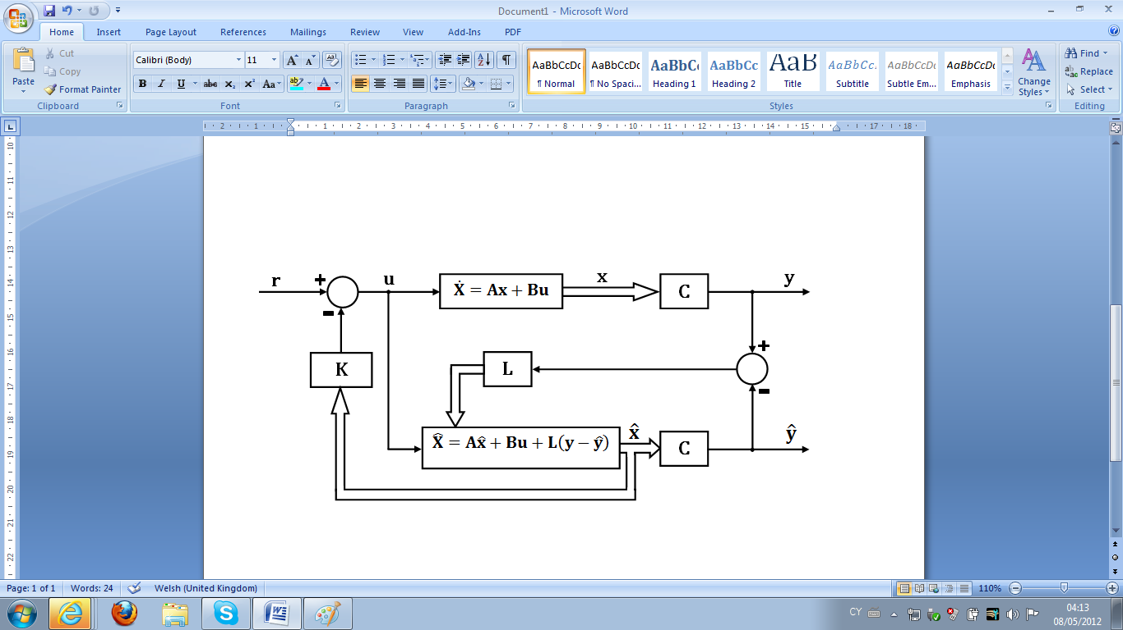
Figure 5. Observer Feedback Control System

The estimator poles were chosen ten times as faster as the system poles. The observer gain L was obtained using MATLAB routine called “place”. The observer pole was assigned as P. Therefore the observer gain was obtained as;
L = place (A', C’, P)' (12)
This generated an observer gain that placed the poles in the desired position. The control law with the observer design was combined to get a compensator. The following parameters were used in the design of the observer in MATLAB.The weight due to angle and position values are Qdiag. [25, 0, 250, 0] and R = 1.6. Thus, the closed-loop system gain was obtained as;
K = [55.5439 22.2266 -12.5000 -12.0038]
Hence, the observer gain was obtained as;
3.3 Reduced order Observer Design
In reduced order observer design, it is assumed that some of the states are known while some are unavailable. Based on this assumption the state space equation can be expressed as:
$\left[\begin{matrix}{\dot{x}}_{u}(t) \\ {\dot{x}}_{a}(t)\end{matrix}\right]=\left[\begin{matrix}A_{uu} & A_{ua} \\ A_{au} & A_{aa}\end{matrix}\right]\left[\begin{matrix}x_{u}(t) \\ x_{a}(t)\end{matrix}\right]+\left[\begin{matrix}B_{u} \\ B_{a}\end{matrix}\right]u(t)$ (13)
$x_{a}$ is available state
$x_{u}$ is unavailable states (states to be estimated)
Based on equation (13), the reduced order observer equation is obtained as shown in (14).
${\dot{\tilde{x}}}_{u}=\left(A_{uu}-LA_{au}\right){\tilde{x}}_{u}+\left(A_{ua}-LA_{aa}\right)x_{a}+L{\dot{x}}_{a}+\left(B_{u}-LB_{a}\right)u$ (14)
The observed feedback control law
$u(t)=-\left[\begin{matrix}K_{u} & K_{a}\end{matrix}\right]\left[\begin{matrix}x_{u}(t) \\ x_{a}(t)\end{matrix}\right]$ (15)
The reduced order observer error equation is written as;
${\dot{e}}_{u}(t)=\left(A_{uu}-LA_{au}\right)e_{u}(t)$ (16)
In this work, the unavailable states arethe pendulum angle and angular velocity, while the available states arecart displacement and velocity of the cart. Therefore
$x_{u}\left(t\right)=\left[\begin{matrix}θ \\ \dot{θ}\end{matrix}\right]$ (17)
$x_{a}\left(t\right)=\left[\begin{matrix}x \\ \dot{x}\end{matrix}\right]$ (18)
From the system matrix $A_{uu}$,$A_{au}$, $B_{u}$ and $B_{a}$can be obtained as:
$A_{uu}=\left[\begin{matrix}0 & 1 \\ 6.263 & 0\end{matrix}\right], A_{au}=\left[\begin{matrix}0 & 0 \\ 0.3358 & 0\end{matrix}\right]$, $B_{u}=\left[\begin{matrix}0 \\ 7.0501\end{matrix}\right]$ and $B_{a}=\left[\begin{matrix}0 \\ 10.6649\end{matrix}\right]$
The reduced order observer gains can be obtained using MATLAB as:
L = place (A_{uu}', A_{au}’, P)' (19)
  - Internal and external stability
Internal stability dictates the system behavior when no input is applied, while external stability dictates the behavior of the system under action of external input.
Therefore to show the system is internally unstable the open loop system will be simulated without any external input (with initial condition only) whileto show the system is externally unstable the open loop system will be simulated with an external input.

3.5. LMI algorithms
Stability and transient response of linear systems depend on the locations of the poles in the complex plane.Brood over a linear dynamic system;
$\dot{X}=A_{c}X$ (20)
Equation (21) represents an asymptotically stable system when all its poles are placed in the left-hand side of the complex plane as seen in Figure 6.
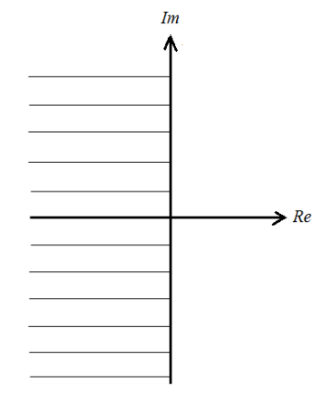
Figure 6. Left half-plane

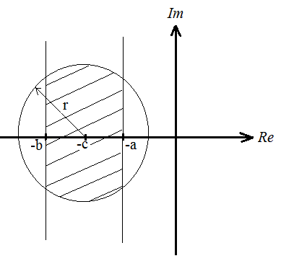
Figure 7. LMI region
The Lyapunov theorem states that the system in equation (21) is said to be asymptotically stable once a real symmetric matrix P satisfying the following LMIs exists [22];
$A_{c}P+A_{c}A^{T}<0, P=P^{T}>0$ (21)
The LMIs in Equations (21) provides the conditions for the stability of the system in equation (20). The LMI region is as presented in Figure 7.
All the poles of the system in equation (20) will be lying in the LMI region of Figure 7 if and only if there exists asymmetrical positive definite matrix P such that;
$A_{c}P+P{A_{c}}^{T}+2aP<0,$ (22)
$A_{c}P+P{A_{c}}^{T}+2bP>0,$ (23)
$\left[\begin{matrix}-rP & cP+P{A_{c}}^{T} \\ cP+A_{c}P & -rP\end{matrix}\right]<0, P=P^{T}>0$ (24)
The LMIs in (22) and (23) represent the vertical strip, while the LMI in (17) represents the circle centred at $\left(c,0\right)$ with radius$r>0$.

3.5. Proposed Controller Design
The block diagram of the proposed control system is shown in Figure 8.U is the control input, the reference input vector is denoted by r, Xrepresents the state vector, N represents the reference input scaling factor vector while the controller gain vector is denoted by K.

r

AX + BU
U
Nr

N
X
K
+
+

Figure 8. Proposed control system block diagram

From Figure 8, the control law is, therefore;
$U=KX+Nr$ (25)
Inserting the proposed control law of equation (18) into the system yields;
$\dot{X}=\left(A+BK\right)X+BNr$ (26)
$\dot{X}=A_{c}X+BNr$ (27)
At steady-state;
$\dot{X}=0$ (28)
$X=X_{ss}$ (29)
The aim here is to make the system states Xto track the reference inputs r at steady state.
Hence;
$X_{ss}=r$ (30)
Inserting equations (28)-(30) in equation (20) yields;
$0=\left(A+BK\right)X_{ss}+BNX_{ss}$ (31)
Therefore;
$BN=-\left(A+BK\right)$ (32)
Pre-multiplying both sides of equation (32) by B^{T}gives;
$B^{T}BN=-B^{T}\left(A+BK\right)$ (33)
Pre and post multiplying both sides of equation (33) by ${\left(B^{T}B\right)}^{-1}$gives:
$N=-{\left(B^{T}B\right)}^{-1}B^{T}\left(A+BK\right)$ (34)
From equations (11) and (12):
$A_{c}=\left(A+BK\right)$ (35)
Inserting equation (35) in (28)-(30) makes the following LMIs:
$AP+PA^{T}+BM+M^{T}B^{T}+2aP<0,$ (36)
$AP+PA^{T}+BM+M^{T}B^{T}+2bP>0,$ (37)
$\left[\begin{matrix}-rP & cP+PA^{T}+M^{T}B^{T} \\ cP+AP+BM & -rP\end{matrix}\right]<0$ (38)
$P=P^{T}>0$ (39)
Where;
$K={MP}^{-1}$ (40)
Mand P can be obtained by solving the LMIs in (36)-(39).
The controller gains K can, therefore, be found by inserting M and P in equation (40). The reference input scaling factor N can then be found through equation (34). Hence, N and K were found as [20.9777 8.3690 -3.9528 -4.1689] and [-461.5637 -178.3047 155.2348 104.0856] respectably by using MATLAB codes to solve the LMIs (36)-(39).

- RESULTS AND DISCUSSION
In this section, MATLAB software was used in the implementation of the proposed control schemes. Figure 9 shows the open-loop response of the system which confirms the system is completely unstable. Therefore the observer design is required to determine the observer gain matrix L to estimate the system output and generate the control signal and yield the desired closed-loop performance.
Thus, the closed-loop poles of the observed states feedback system have system poles and the observer poles. They can be designed separately and combine to form an observer feedback control system. Therefore the observer poles are chosen in such a way that the observer response is much faster than the system response so that the observer has less effect on the system. Figure 10 shows the pole-zero map of the closed-loop observer poles. Figure 11 shows the response of the system with initial pendulum angle of 0.1 rad and turned parameters values as; Qdiag.[25,0,250,0] and R = 1.6. The systems stabilized at 2 sec with 0.262 m undershoot of cart position and 0.08 m of the swing angle.
In addition, LMI controller was designed and compared with observer-based LQR. In this control schemes, the closed-loop poles need to be placed in the LMI region of the complex left-half plane so as to achieve a stabilized system and good transient response. The LQR controller does its job of maintaining the pendulum angle in an upright position, but its response is sluggish as compared to the LMI Controller. The performance comparisons of the two controllers clearly show that LMI is superior as compared to the LQR controller as shown in Figure 12.

Figure 9. Open Loop Response of the system
Figure10. Close Loop Pole Zero Map

Figure11. System Closed Loop Response with observer-based LQR

Figure12.The response of LQR and LMI controllers

CONCLUSION
In this paper, the performances of the observer-based LQR and LMI controllers were investigated for upright stabilization control of nonlinear inverted pendulum. LQR and LMI controllers were designed to stabilize the pendula. Based on simulation results, a better performance was achieved using LMI controller. To further reduce the amplitude and frequencies of the oscillation, frictional coefficients were taken into consideration.

ACKNOWLEDGEMENTS
The authors gratefully acknowledged the support of Universiti Teknologi Malaysia (Vote No. R. J130000.7351.4B428) and Abubakar Tafawa Balewa University Bauchi for the resources

REFERENCES
[1] T. João F. S. ; da Silva, Samuel; Schaub, Hanspeter, “Variable Speed Control Moment Gyroscope in an Inverted Pendulum,” J. Dyn. Syst. Meas. Control, vol. 141, pp. 111012 (1–9), 2019.
[2] W. Xin ; Yaz, Edwin E. ; Schneider, Susan C., “Coupled State-Dependent Riccati Equation Control for Continuous-Time Nonlinear Mechatronics Systems,” J. Dyn. Syst. Meas. Control, vol. 140, pp. 11013(1–10), 2018.
[3] H. Mukhtar Fatihu ;Yap, Hwa Jen; Choudhury, Imtiaz Ahmed; Isa, Abdulbasid Ismail; Zimit, Aminu Yahaya; Kumbasar, Tufan, “Current development on using Rotary Inverted Pendulum as abenchmark for testing linear and nonlinear control algorithms,” Mech. Syst. Signal Process., vol. 116, pp. 347–369, 2019.
[4] T. Xiaoying; Peng, Hui; Zhou, Feng, “RBF-ARXmodel-based fast robust MPC approach to an inverted pendulum,” ISA Trans., vol. 93, pp. 255–267, 2019.
[5] D. C. W. Fen, “New Results On Continuous-Timeswitchedlinear Systems With Actuator Saturation,” in Proceedings of the ASME 2013 Dynamic Systems and Control Conference, 2013, pp. 1–9.
[6] R. Srzednicki, “On Periodic Solutions In The Whitney’s Inverted Pendulum Problem,” Discret. Contin. Dyn. Syst. S, vol. 12, pp. 2127–2141, 2019.
[7] G. Daniel ; Chaos, Dictino ; de la Torre, Luis ; Aranda-Escolastico, Ernesto ; Heradio, Ruben, “Customized Online Laboratory Experiments A General Tool and Its Application to the Furuta Inverted Pendulum,” IEEE Control Syst. Mag., vol. 39, pp. 75–87, 2019.
[8] W. LIU ; H., HUANG ; S., CHEN, “Interference observer-based two-stage inverted pendulum adaptive sliding mode control method, involves establishing sliding mode parameters, and establishing sigmoid function instead of symbol-function to eliminate chattering phenomenon,” 2019.
[9] M. M. Javad; Khoobroo, Haghbayan Hamed, “An optimal adaptive hybrid controller for a fourth-order under-actuated nonlinear inverted pendulum system,” Trans. Inst. Meas. Control, 2019.
[10] Q. X. S. G. Z. Wang, “Balancing a wheeled inverted pendulum with a single accelerometer in the presence of time delay,” J. Vib. Control, vol. 23, pp. 604–614, 2017.
[11] A. Sahnehsaraei M.; J., Mahmoodabadi M. ; A., Bagheri, “Pareto optimum control of a 2-DOF inverted pendulum using approximate feedback linearization and sliding mode control,” Trans. Inst. Meas. Control, vol. 36, pp. 496–505, 2014.
[12] M. M. H. HK, “Design and implementation of adaptive control logic for cart-inverted pendulum system,” Proc IMechE Part I J Syst. Control Eng., vol. 233, pp. 164–178, 2018.
[13] T. João F. S. ; da Silva, Samuel ; Schaub, Hanspeter, “Attitude control of inverted pendulums using reaction wheels: Comparison between using one and two actuators,” J Syst. Control Eng., vol. 2019, pp. 1–10, 2019.
[14] B. Hai-Le; Tran, Duc-Trung; Vu, Nhu-Lan, “Optimal fuzzy control of an inverted pendulum,” J. Vib. Control, vol. 18, pp. 2097–2110, 2011.
[15] J. Lin; Sheng, Ding You ; Julian, Chang, “Balancing and swinging-up control for a cart-pendulum-seesaw system by decomposed fuzzy coordination control,” J. Vib. Control, vol. 20, pp. 925–942, 2014.
[16] X. Qi; Gabor, Stepan; Zaihua, Wang, “Balancing a wheeled inverted pendulum with a single accelerometer in the presence of time delay,” J. Vib. Control, vol. 23, pp. 604–614, 2017.
[17] I. Yigit, “Model-free sliding mode stabilizing control of a real rotary inverted pendulum,” J. Vib. Control, vol. 23, pp. 1645–1662, 2017.
[18] M. Idi; Tahir, N. M.; Ibrahim, A. G., “Real-Time Optimal Implementation Of Stabilizing Controller For Inverted Pendulum,” J. Eng. Technol., vol. 9, pp. 1–17, 2018.
[19] N. M. Tahir, S. M. Hassan, Z. Mohamed, A.G. Ibrahim, “Output-Based Input Shaping for Optimal Control of Single-Link Flexible Manipulator,” Int. J. Smart Sens. Intell. Syst., vol. 10, pp. 367–386, 2017.
[20] N. M. Tahir, A. Amir, U. I. Bature, A. U. Sambo, Y. B. Adamu, “Vibration and Tracking Control of A Single-Link Flexible Manipulator Using LQR andCommand Shaping” Journal of Multidisciplinary Engineering Science and Technology, Vol. 3, pp. 45-67, 2016.
[21] K. Ogata, “Modern Control Engineering”. 5th edition, New Jersy: Prentice-Hall, 2010.
[22] M. Mohammad, “Linear Matrix Inequality-Based State Feedback Control of a Gantry Crane System”. Bayero Journal of Engineering and Technology. 13(2), pp. 107-115, 2018.

BIOGRAPHIES OF AUTHORS

 | Nura Musa Tahir received the B.Eng. degree in Electrical Engineering from Bayero University, Kano in 2012 and M.Eng. Degree in Mechatronics and Automatic Control from the Universiti Teknologi Malaysia in 2016. He has been involved in research at Mechatronics systems and Robotics Laboratory in Universiti Teknologi Malaysia on vibration control, robotics and Mechatronics system design. He has been a lecturer at the Department of mechatronic and system Engineering, Abubakar Tafawa Balewa University, Bauchi Nigeria since 2014. His main research interests include Vibration Control, Mechatronics Systems Design, Control System Design and Robotics.
 | Mustapha Muhammad is currently an Associate Professor in the Department of Mechatronic Engineering Bayero University, Kano, Nigeria. He received his Bachelor of Engineering and Master of Engineering degrees from Bayero University, Kano, Nigeria in January 2001 and February 2007 respectively. He received his PhD in Electrical Engineering (Robotics) in March 2014 from UniversitiTeknologi Malaysia. His research interest includes the areas of artificial neural networks, fuzzy modeling and control, intelligent control theories and robotics.
 | Salinda Buyamin is currently an associate professor at the school of Electrical Engineering, Faculty of Engineering, UTM. She received her Bsc. in Electrical Engineering in 1998from the university of Toledo, Ohio, USA. She has joined the school of Electrical Engineering, UTM since November 2001. She completed her Msc in Automation and Control in 2003 and obtained her PhD in 2007 from the universityof Newcastle upon Tyne, UK. Her current research interest includes Modelling and Simulation of Dynamic Systems, Control and Development of Electric Drives System, System Identification and Estimation, Optimisation and Intelligent Control
 | LADAN MAIJAMA’A holds the following: National Diploma and Higher National Diploma in Electrical Electronics Engineering from Kaduna Polytechnic, Nigeria. Post Graduate Diploma and a Master’s degree in Electrical Electronics Engineering from Abubakar Tafawa Balewa University, Bauchi, Nigeria. And also hold Post Graduate Diploma in Education from Federal college of Education Kano, Nigeria. He is currently undergoing his doctoral studies in Electrical Electronics Engineering Department at Abubakar Tafawa Balewa University, Bauchi, Nigeria. His current research focuses in Control System Engineering on Unmanned Aerial Vehicle. He is working with Federal Polytechnic, Bauchi, Nigeria as a Principal Lecturer in the Department of Electrical Electronics Engineering.
 | Musa Idi obtained his MSc. Degree in Applied Instrumentation and Control from the Glasgow Caledonian University, Scotland, in 2012 and a B.Eng. Degree in Electrical and Electronics Engineering from Abubakar Tafawa Balewa University, Bauchi in 2006. He worked as an Engineer in the Nigerian Television Authority Bauchi Nigeria between 2009 and 2011 before joining Abubakar Tafawa Balewa University Bauchi Nigeria as a lecturer in the Department of Mechatronics and Systems Engineering in 2013. He conducted, supervised and published research articles in the area of Automation, Control and Robotics. His research areas of interest include optimal control, nonlinear control, intelligent control, system identification and robotics.

