Performance investigation of stand- alone induction generator based on SSC for wind power application

Mohammed Y. Suliman¹, Ziad Saeed Mohammed², Ahmed A. J. Ali³ , Rakan Khalil Antar⁴
^{1,3,4}Department of Technical Power Engineering, ²Department of Computer Engineering Technology, Engineering Technical College, Northern Technical University, Iraq

Article Info |  | ABSTRACT
Article history:  Received Jun x, 20xx  Revised Nov x, 20xx  Accepted Dec x, 20xx |  | Self-Excited Induction Generator (SEIG) has many advantages over other types of generators in the industrial applications. SEIGs are largely used in the wind turbine system because of high reliability, rigidity, simple structure, and capability to work under severe badly operating conditions. However, this type of generator has a poor terminal voltage and frequency regulation during changing the connected loads. All these due to the absence of constant excitation current. Therefore, it is essential to stabilize the generated voltage and frequency in addition to suppress the injected harmonic current components. In the current work, the dynamic performance of SEIG with static series compensator (SSSC) is analyzed. The SSSC based on Neuro-Fuzzy controlled (NFC) is applied to control both voltage and frequency to enhance the regulation of SEIG. The NFC is used to control the SSSC which leads to balance the requirement of the reactive and active power of stand-alone grid under load variation and attempts to obtain a constant terminal voltage. The model is built and simulated based on MATLAB/Simulink environment. The NFC structure designed to regulate and control the output voltage of the SEIG driven by a wind turbine to feed a consumer in remote and rural places. In addition, the power system parameters calculated depending on the d-q theory. Simulation results explained that the suggested controller is reliable and robust compared with the conventional types.
Keywords:
SEIG
FACTS
SSSC
Neuro-Fuzzy controller
d-q theory
This is an open access article under the CC BY-SA license.

Corresponding Author:
Mohammed Y. Suliman,
Department of Technical Power Engineering,
Northern Technical University,
AlMinsaa St, Mosul City, Nineveh Governorate, Iraq.
Email: mohammed.yahya@ntu.edu.iq

- INTRODUCTION (10 PT)
Series capacitors are widely used for compensation in long transmission lines to keep the total impedance of the transmission line, where increases the power transfer capacity and enhances transient stability as well. The dielectric capacitors are an efficient and economical way for providing compensation. The new technologies like flexible AC transmission system (FACTS) controllers have made as electric utilities to deal with mentioned issues [1]. It can control the parameters of the network like line impedance, terminal voltage, and load angle to enhance both steady-state and dynamic performances of the power system [2]. FACTS devices provide variable series compensation that is highly effective in both controlling and enhancing stability and power flow through the lines. The series compensator based on static synchronous compensator (SSC) can provide the virtual compensation to the impedance of transmission line by injecting the controllable voltage (magnitude and phase angle) in parallel with the transmission system [3]. Self-excited induction generator (SEIG) is one of the most suitable applicant’s generators in stand-alone mode grid networks. The SEIG has a wide attraction in many uses due to its characteristics of robustness, reliability, low losses, and high efficiency. These types of generators are used in large ships and to supply electric power to farm fields. It is also used in supplying customers who live in rural societies and remote places. The supply of electrical power through the convention grid is useless and needs very high costs. This type of induction generators is usually driven by a wind energy system with a bank of capacitors that connected on the terminals of the stator [4-7]. The shunt capacitors are used to supply the generator with the primary excitation current for the no-voltage build-up. When the SEIG works, the excitation current is fed through the stator currents. There are several ways to connect the capacitors on the generator such as shunt, long shunt, and short shunt. In this work, along the shunt method or the so-called series connection has been applied. Unfortunately, these types of generators are affected by the sudden change of loads that change both frequency and the generated voltage. Based on these issues, voltage and frequency regulation is weak and unacceptable. These drawbacks can be solved using several topologies such as static series synchronous compensator (SSSC) to the ends of the self-exciting inductor [8-9]. SSSC has been used to compensate for the effect loading currents connected across the stator terminals of the three-phase SEIG. The SEIG can be safe feeds the applied 3-phase loads the rated power. When the applied load changed according to increase demand or due to any abnormal operation leads to a shortage on reactive power. Additionally, the SSSC has been used to adjust the terminal voltage of the SEIG by supplying the required reactive compensation power and suppress the injected components of harmonics due to loads at the same time. The performance operation of the induction generator–compensator system is tested under both balanced and unbalanced loads. Also, the dynamic performance of the SEIG for different loads has been considering to examine the voltage regulation. Therefore, different methods have been applied to obtain a constant voltage on the terminals of SEIG. These approaches include an arrangement of a constant capacitor and thyristor-controlled device which is called the static var compensator, which is used to improve the voltage regulation of the generator, it produces a low order of harmonics due to line current switching and heavyweights and large size of capacitors [8-9]. Due to fast improvements on the switching process of power electronic devices, a voltage source multilevel inverter based PWM has been used as active power filter and static synchronous compensator (STATCOM) to supply demand reactive power [10]. In the last years, new approaches of artificial intelligence have been recommended to design a FACTS-based controller such as particle swarm optimization [11], genetic algorithm [12], differential evolution [13], and the algorithm of multi-objective evolutionary [14]. Since 1988, the methodology of artificial neural networks (ANN) has attracted the interest in many applications of power engineering. These applications are including power system stabilizers, economical load dispatching, etc. Results of these applications have illustrated that ANN controllers enhance power system in the off-line and online applications [15]. The ANN with fuzzy logic controller (neuro-fuzzy controller) is useful for parallel FACTS devices. The aim of this study is to build a SSC depending on neuro-fuzzy controller (NFC) to control power flow and regulate voltages in the transmission line.

- MATHEMATICAL MODEL OF SELF-EXCITED INDUCTION GENERATOR
Explaining The dynamic model of SEIG in stationary reference frame theory (d-q axis) is given below depending on the in the figure1 [16-17]:

$\left[V\right]=\left[R\right]\left[i\right]+ \left[L\right]\frac{d}{dt}\left[i\right]+w_{r}\left[G\right]\left[i\right]$ (1)

Then based on (1), the derivative currents matrix can be written by:

$\frac{d}{dt}\left[i\right]={\left[L\right]}^{-1}\{\left[V\right]-\left[R\right]\left[i\right]- w_{r}\left[G\right]\left[i\right]$ (2)

Where V, i, R, L, and G are voltage, current, resistance, inductance and rotational inductance matrices which are given by:
$\left[V\right]={\left[v_{ds} v_{qs }v_{dr} v_{qr}\right]}^{T}$, $\left[i\right]={\left[i_{ds} i_{qs }i_{dr} i_{qr}\right]}^{T}$

$$\left[R\right]=Diag\left[\begin{matrix}R_{s} & R_{s} & R_{r}\end{matrix} R_{r}\right]$$
$$\left[L\right]=\left[\begin{matrix}L_{ls+}L_{m} & 0 & L_{m} \\ 0 & L_{ls+}L_{m} & 0 \\ \begin{matrix}L_{m} \\ 0\end{matrix} & \begin{matrix}0 \\ L_{m}\end{matrix} & \begin{matrix}L_{ls+}L_{m} \\ 0\end{matrix}\end{matrix}\begin{matrix}0 \\ L_{m} \\ \begin{matrix}0 \\ L_{ls+}L_{m}\end{matrix}\end{matrix}\right]$$
$$\left[G\right]=\left[\begin{matrix}0 & 0 & 0 \\ 0 & 0 & 0 \\ \begin{matrix}0 \\ L_{m}\end{matrix} & \begin{matrix}-L_{m} \\ 0\end{matrix} & \begin{matrix}0 \\ L_{ls+}L_{m}\end{matrix}\end{matrix}\begin{matrix}0 \\ 0 \\ \begin{matrix}L_{ls+}L_{m} \\ 0\end{matrix}\end{matrix}\right]$$

The developed electromagnetic torque of the induction generator is computed based on the following formula:

$T_{e}=\frac{3}{2}\frac{P}{2}L_{m}(i_{qs}i_{dr}-i_{qr}i_{ds})$ (3)

- (b)
Figure 1. d–q model of SEIG. (a) d-axis. (b) q-axis.

- SSSC MODEL AND CONTROL
The SSC injects almost sinusoidal voltage with variable amplitude. The heart of SSC is a VSC that is supplied by a DC source. The fundamental configuration of SSC with SEIG is illustrated in Figure 2. The injected voltage without external DC link is in quadrature with the line current and follows an inductive or capacitive reactance in parallel with the transmission line. Also, a small part of the injected voltage is in-phase with the line current to cover the losses of the inverter. The injected voltage will compete with a capacitive reactance in parallel with the line if it is leading the line current that causing the line current as well as power flow through the line to increase. When the injected voltage is lagging the line current, which will emulate an inductive reactance in parallel with the line, causing the line current as well as power flow through the line to decrease. The controller can adjust the magnitude and phase of this inserted compensating voltage rapidly. The transmitted active power (P) and load voltage (V) become a parametric function of the injected voltage. Therefore, the transmittable power can increase or decrease by inversing the injected ac voltage polarity. The inversed voltage will add straight to the reactive voltage drop of the line, if the reactive line impedance is increased. Also, if the injected voltage is larger than the voltage impressed across the uncompensated line (|Vcomp| > |Vs - Vr|), then the power flow can reverse. The stable operation of the system with both positive and negative power flow can also be observed. The SSC has an excellent (sub-cycle) response time and the transition from positive to negative power flow through zero voltage injection is perfectly smooth and continuous [18]. A typical voltage enhancement using SSC is shown in Figure 3.

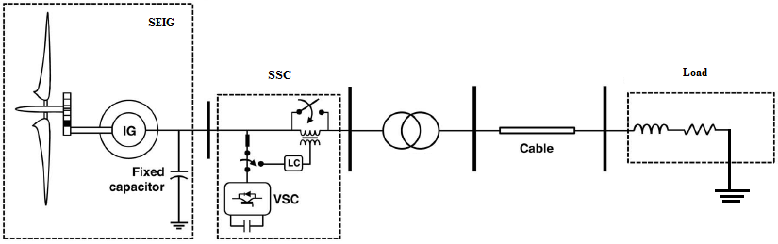

Figure 2. Fundamental configuration of SSC with SEIG

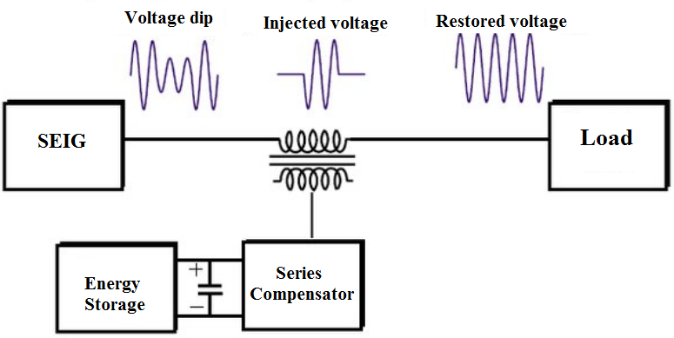

Figure 3. The restored voltage after injection.

- MEASURING LOAD VOLTAGE
For measuring load voltage and active power, dq theory is applied, which is suitable for transient or steady state operation. Also, it is valid for generic voltage and current power system waveforms. Another important characteristic of this theory is the simplicity of the calculations, which involves algebraic calculation exception to the need of separating the mean and alternated values of the calculated power component [19]. The dq-theory performs a transformation known as “park transformation” of a stationary reference system of coordinates abc to d-q rotating coordinates [20]. The transform applied to time-domain voltages in the natural frame (i.e. va, vb and vc) is explained as:

$\left[\begin{matrix}v_{d} \\ v_{q} \\ v_{0}\end{matrix}\right]=\frac{2}{3}\left[\begin{matrix}\cos{(∅)} & cos({∅-\frac{2π}{3}}) & \cos{(∅+\frac{2π}{3})} \\ -sin⁡(∅) & -sin⁡(∅-\frac{2π}{3}) & -sin(∅+\frac{2π}{3}) \\ \frac{1}{2} & \frac{1}{2} & \frac{1}{2}\end{matrix}\right]\left[\begin{matrix}v_{a} \\ v_{b} \\ v_{c}\end{matrix}\right]$ (4)

$\left[\begin{matrix}i_{d} \\ i_{q} \\ i_{0}\end{matrix}\right]=\frac{2}{3}\left[\begin{matrix}\cos{(∅)} & cos({∅-\frac{2π}{3}}) & \cos{(∅+\frac{2π}{3})} \\ -sin⁡(∅) & -sin⁡(∅-\frac{2π}{3}) & -sin(∅+\frac{2π}{3}) \\ \frac{1}{2} & \frac{1}{2} & \frac{1}{2}\end{matrix}\right]\left[\begin{matrix}i_{a} \\ i_{b} \\ i_{c}\end{matrix}\right]$ (5)

$∅=(ωt+θ)$ (6)

Where$(∅)$ is the angle between fixed and rotating coordinate systems and (θ) represents the phase shift of the voltage. From eq. (4) and (5), the active power and load voltage compensated values are calculated by:

$p=V_{d}I_{d}+V_{q}I_{q}$ (7)

$V=\sqrt{{V_{d}}^{2}+{V_{q}}^{2}}$ (8)

The block diagram of SSC control system is presented in Figure 3. The load voltage (V) are calculated depending using eq. (8). The (V) operates as a feedback closed loop control signal. The desired Vref is compared with the V to generate error signals (Erorr_{v}) as:

${Erorr}_{V}=V_{ref}-V$ (9)

The phase angle of the injected voltage can be adjusted to make the compensation either in phase or anti-phase with the reference.

$δ=∅±γ$ (10)

Where γ can be adjusted depending on the sign of the Error in equation (9).

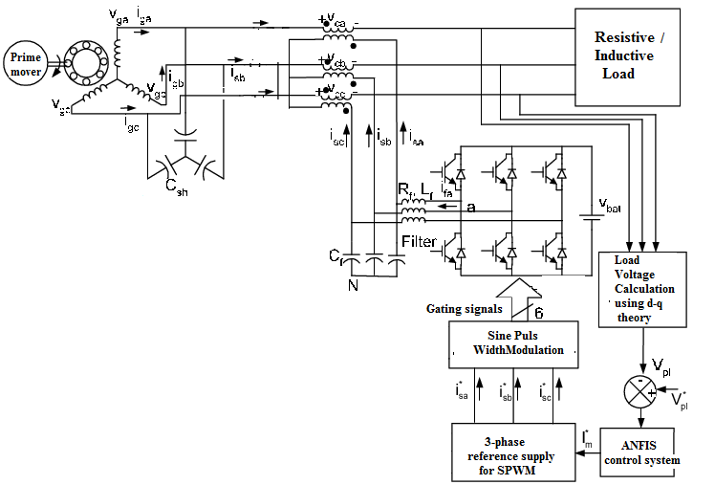
Figure 4. Block diagram for SSC control system

- SYSTEM CONTROL DESIGN
Fuzzy systems are suitable for uncertain or approximate reasoning, especially for the system with mathematical model that is difficult to derive. There are many fuzzy inference mechanisms in fuzzy logic control system and Takagi-Sugeno (TS) is chosen in this study. The ANN is used in this study to tune the membership functions of the TS fuzz-like-PI controller. The TS fuzzy controller has a non-linear variable gain controller. It produces wide variations of the controller gain. Arbitrary selection of these parameters may lead to an adequate system response or instability [21]. Better system response may be achieved by using Neuro-Fuzzy system to adapt the fuzzy system parameters and rules by employing ANN learning algorithm [22]. The parameters of the input and output membership functions are to be determined during the training stage. The designed fuzzy system consists of seven layers; each layer has either fixed nodes (no parameters to be tuned) that have parameters to be tuned during training. The output of the seven layers which emulate the fuzzy system design steps is given and explained by [23]. The objective of the learning algorithm is to adjust the parameters of the input and output membership functions so that the Neuro-Fuzzy output matching the training data better than other types. A hybrid learning strategy (Gradient Descent-GD and Lease Squares Estimate-LSE) is applied to identify the network parameters. In this work the input universe of discourse is split into 9 triangular membership functions with 50% overlapping. Therefore, for two inputs, 81-control rule consequent linear functions need to be determined. To tune the TS rules using Neuro-Fuzzy, two sets of data are to be generated. The input data is a vector of the Errorp, Errorv and the output (m), which is the modulation index. The proposed Neuro-Fuzzy controller has small computation time compared with classical fuzzy controller's mamdani type. The selected system consists of single machine infinite bus bar.

- SIMULATION STUDY
The designed power system of SEIG with SSC controller is modelled using MATLAB/Simulink. The system illustrated in Figure 5 is built to study the performance of the proposed control system with step change of the load state. The system consists of SEIG with inductive load. The compensation system is providing with a DC voltage source to feed or absorb the active and reactive power from the system. The load voltage for two steps change in the load at time equal to 1and 2 second respectively, the parameters (load voltage, rms of load voltage, load current, electromagnetic torque, rotor current, active and reactive power) are shown in Figures 6-13 without SSC. After adding the SSC by injected controlled voltage, the performance of SEIG enhanced as shown from the parameters in figures 14-21. Figure 22 shows the injected voltage versus the load voltage as the load voltage drop happened due to the increasing of load at t=1 and the SSC injects the compensated voltage. Figure 23 shows the THD of the load voltage. Results illustrate the capability of the SSC to compensate the load voltage and enhanced the performance of the SEIG in other parameters. The simulation results illustrate the effectiveness of the NFC in optimizing the SSC performance. In addition, the results prove that the proposed controller can develop the voltage shape of SEIG and the system becomes more efficient in its performance.

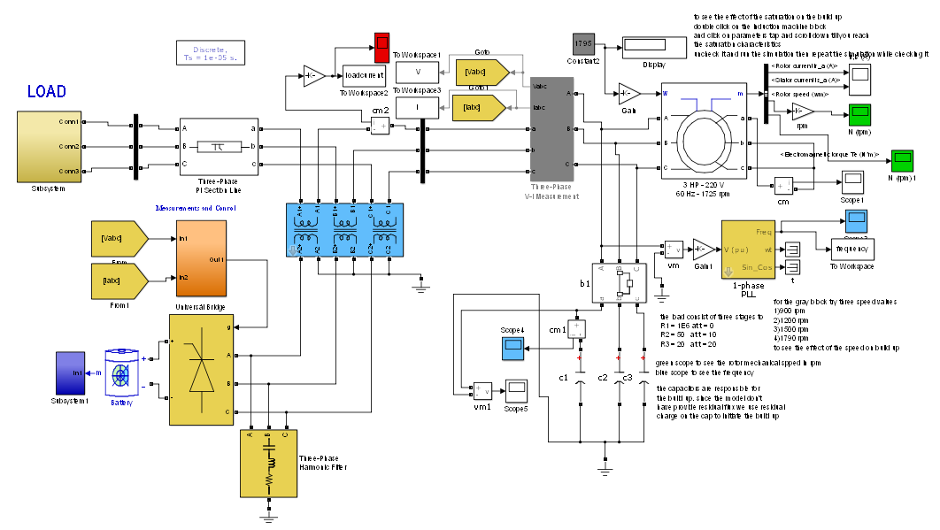

Figure 5 System model for simulation

Figure 6 load voltage waveform

Figure 7 RMS load voltage waveform

Figure 8 line current by increasing the load waveform.

Figure 9 line frequency by increasing the load waveform.

Figure 10 Electromagnetic torque by increasing the load waveform.
Figure 11 Rotor current by increasing the load waveform.
Figure 12 Step change response active power waveform.
Figure 13 Reactive power in PU waveform.
Figure 14 Load voltage waveform.
Figure 15 RMS load voltage waveform.
Figure 16 Line current waveform.
Figure 17 line frequency waveform.
Figure 18 Electromagnetic torque waveform.
Figure 19 Rotor current waveform.
Figure 20 Active power waveform.
Figure 21 Reactive power in PU waveform.

Figure 22 Injected voltage versus the load voltage waveform

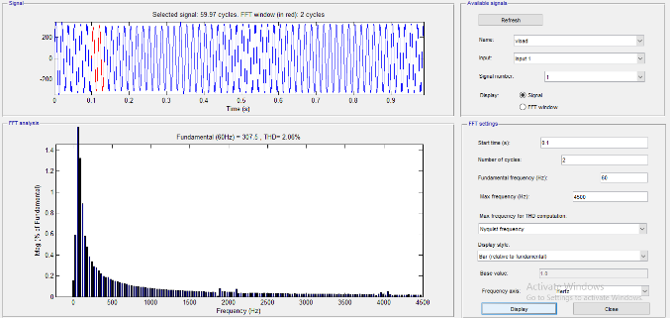

Figure 23 THD of the load voltage after injection
- CONCLUSION
In this paper, NFC algorithm is suggested to control the SSC with SEIG. The tuning algorithm is done off-line to employ the theory of Neuro-Fuzzy System. By using Takagi-Sugeno fuzzy logic system, the small computation time of the controller has obtained and this is probable to implement in real-time. The suggested controller has been applied effectively to control the load voltage and the line current flow to the load. The simulation results demonstrate that the suggested controller can offer a satisfactory presentation for the SSC operation.

REFERENCES (10 PT)

- E. Acha, C. Fuerte, H. Ambriz and C. Angeles-Camacho. (2004). "FACTS Modeling and Simulation in Power Networks", John Wiley & Sons Ltd, pp. 21-23.
- R. Mathur and R. Varma (2002). "Thyristor-based FACTS Controllers for Electrical Transmission Systems", Wiley-IEEE Press Power engineering, Piscataway, NJ, Mar, pp 34-36
- Hingorani and L. Gyugyi. (2000). "Understanding FACTS, Concepts and technology of flexible AC transmission systems", IEEE Press, pp. 172-174.
- B. Jena and A. Choudhury, "Voltage and frequency stabilization in a micro-hydro-PV based hybrid microgrid using FLC based STATCOM equipped with BESS," 2017 International Conference on Circuit, Power and Computing Technologies (ICCPCT), Kollam, 2017, pp. 1-7. doi: 10.1109/ICCPCT.2017.8074291
- Ali, A.J., Suliman, M.Y., Khalaf, L.A., Sultan, N.S., "Performance investigation of stand-alone induction generator based on STATCOM for wind power application," International Journal of Electrical and Computer, vol. 10 no. 6 pp. 5570-5578. 2020.
- T. B. Kumar and M. V. G. Rao, "Mitigation of Harmonics and power quality enhancement for SEIG based wind farm using ANFIS based STATCOM," 2014 International Conference on Smart Electric Grid (ISEG), Guntur, 2014, pp. 1-7. doi: 10.1109/ISEG.2014.7005595
- D. Chermiti and A. Khedher, "Voltage and Frequency Control of a Self-Excited Induction Generator using Bidirectional STATCOM Devoted to Rural Electrification," 2019 10th International Renewable Energy Congress (IREC), Sousse, Tunisia, 2019, pp. 1-6. doi: 10.1109/IREC.2019.87534570
- T. Ahmed, K. Nishida and M. Nakaoka, "Static VAr compensator-based voltage regulation implementation of single-phase self-excited induction generator," Conference Record of the 2004 IEEE Industry Applications Conference, 2004. 39th IAS Annual Meeting., Seattle, WA, USA, 2004, pp. 2069-2076 vol.3.
- T. Ahmed, K. Nishida, K. Soushin and M. Nakaoka "Static VAR compensator-based voltage control implementation of single-phase self-excited induction generator" IEE Proceedings C (Generation, Transmission and Distribution), Volume 152, Issue 2, March 2005, p. 145 – 156. DOI: 10.1049/ip-gtd:20051251
- Rakan Kh. Antar, Basil M. Saied, and Rafid A. Khalil, “Using Seven-Level Cascade H-Bridge Inverter with HVDC System to Improve Power Quality”, The 1st National Conference For Engineering Sciences, FNCES’12, University of Al-Nahrain, Baghdad, Iraq, November 2012.
- Bo Yang, Guang Zeng, Yanru Zhong and Zhonglai Su (2014). "Cascade STATCOM step wave optimization based on PSO", IEEE International Power Electronics and Application Conference and Exposition, shanghai, china, pp1445-1450
- Hussain, Ali Nasser, Ahmed Jadaan Ali, and Firas Saaduldeen Ahmed. "Power quality improvement based on hybrid coordinated design of renewable energy sources for DC link channel DSTATCOM." International Journal of Electrical & Computer Engineering (2088-8708) 10.5 (2020). ‏
- R. Vanitilaand M. Sudhakaran. (2012). "Differential Evolution algorithm based Weighted Additive FGA approach for optimal power flow using multi-type FACTS devices", Emerging Trends in Electrical Engineering and Energy Management conference (ICETEEEM), Chennai, pp. 198-204.
- Liu Qing and Wang Zengzing. (2009)."Coordinated design of multiple FACTS controllers based on fuzzy immune co-evolutionary Algorithm", IEEE Power & Energy Society General Meeting, Calgary, AB, pp. 1-6
- Mohammed Y. Suliman, Mahmood T. Al-Khayyat, " Power flow control in parallel transmission lines based on UPFC," Bulletin of Electrical Engineering and Informatics, vol. 9, no. 5, pp. 1755-1765, October 2020
- M.Y. Suliman and Farrag M. E.,"Power Balance and Control of Transmission lines using Static Series Compensator", 53rd International Universities Power Engineering Conference (UPEC), pp 1-5, 2018
- Ali, A. J., Suliman, M. Y., Khalaf, L. A., & Sultan, N. S. (2020). “Performance investigation of stand-alone induction generator based on STATCOM for wind power application.” International Journal of Electrical & Computer Engineering (2088-8708), 10(6). ‏
- Ziyaad H. Saleh, Zaid H. Ali, Raid W. Daoud, "A study of voltage regulation in microgrid using a DSTATCOM," Bulletin of Electrical Engineering and Informatics, vol. 9, no. 5, pp. 1766-1773, October 2020
- Mohammed Y. Suliman and S. Bashi, "Fast Response SSSC Based on Instantaneous Power Theory", First International Scientific Conference (ICECCPCE13), Mosul, Iraq, 17-18 Dec, (2013).
- V. Ponananthi and B. Rajesh Kumar. (2015). "Three-phase statcom controller using D-Q frame theory for a three-phase SEIG feeding single phase loads", Electronics and Communication Systems (ICECS), 2nd International Conference IEEE Conference, Coimbatore, India, 2015,26-27 Feb., pp.926-931.
- Mohammed Y. Suliman,"Voltage profile enhancement in distribution network using static synchronous compensator STATCOM", International Journal of Electrical and Computer Engineering, Vol. 10, No. 4, 2020.
- Mohammed Y. Suliman and Rakan Khalil Antar” Power Flow Controller Based on a New Proposed Statcom Controller”, International Journal of Engineering and Technology, Vol. 7, No. 4, pp 3826-3829, 2018
- M. Y. Suliman, " Active and reactive power flow management in parallel transmission lines using static series compensation (SSC) with energy storage", International Journal of Electrical and Computer Engineering (IJECE), vol 9, no 6, pp 4598-4609, 2019

