Miniaturised T-shaped slotRectangular MicrostripPatch Antenna for 5G Application

Yaser Khalil¹, Ali Abdulateef Abdulbari^{1,2}, Takialddin Al Smadi³ , Sarosh Ahmad⁴

^{1,2}Mazaya University College ; Iraq
²Wireless Communication Centre (WCC), School of Electrical Engineering, Universiti Teknologi Malaysia (UTM), Skudai, Malaysia
³Faculty of Engineering, Jerash University, Jordan
⁴Department of electrical engineering Government college university, Faisalabad, Pakistan

Article Info |  | ABSTRACT
Article history: |  | This paper presents a miniaturised T-shaped rectangular microstrip patch antenna workings; the T-shaped patch operating at 3.6 GHz resonating frequency range for 5G application (from 2.9 to 4.4 GHz). The overall size of the proposed antenna is 22 × 24 × 0.25 mm3, using a 50 Ω microstrip line to feed the antenna from the bottom. The proposed antenna is a fabrication of R/Duroid 588lz substrate having (ɛ_{r}) 2.00dielectric constant and (tan δ) 0.02 in loss tangent. The proposed antenna introducesmany advantages like small size, low profile, and simpler structure. The characteristics such as radiation pattern, reflection coefficient, gain, current distribution, and radiation efficiency are respectively presented and discussed,using CST Microwave Study insimulatingand analysing. Introducing a slot with a rectangular T-shaped patch antenna achieved lower frequency with 98.474% radiation efficiency and peak gain of the proposed antenna at 2.52 dB. The fractional bandwidth is 42.81% (2.90 GHz to 4.48 GHz) with a resonant frequency of 3.6 GHz and return loss at 28.76dB. Thisfrequency band attributessuited 5G mobile application.
Keywords:
T-shaped patch antenna 5G
Miniaturised
Microstrap antenna
Rectangular slot
This is an open access article under the CC BY-SAlicense.

Corresponding Author:
Yaser Khalil,
Mazaya University College ; Iraq,
dr.yasir.khalil@gmail.com

- INTRODUCTION
The cellular services explosive growthcalls for higher capacity and faster data speeds. Anew spectrum with 5G technology and more bandwidth (BW), advanced antennas, such as multi-wide input multiple outputs (MIMO) is a promising solution tomeet these challenging requirements. Many countries employN78 (3.3-3.8GHz) band for the new 5G radio in 6 GHz sub-band. Antennas were required in the 3.5 GHz range for the past WiMAX network. With the advent of 5G, the 3.5GHz band experienced rapid growth. Many large scale5G networks experiments are being successfully conducted around the world. In the past few decades, researchers have been studying to improve the radiative performance of communication antennas. The Microstrip patch antenna is disused in [1][2]. Therefore, the development of wireless networks is crucial because 5G technology uses high-frequency bands and wide signal bandwidth to increase the transmission bit rate, thus providing better coverage with less powerconsumption [3][4].be developed in the wireless 4Gand 5G communication generation to meet the required performance. Wireless communication is amultiple systems convergencein wireless access technologies [5][6]. Thus3.5 GHz band has broad application prospects in 5G implementation [7]. For most mobile data where internal traffic is generated, antenna distributionplays an increasingly significant role in indoor wireless communication systems. In addition, toprovide better communication services, many frequency bands are designed and commercially used in different communications systems such as 4G WiMAX and WLAN. Therefore, a capable broadband distribution antenna is required in simultaneously meeting multiple service frequency bands [8]. The microstrip (MSA) antenna withmany advantages, such as small size, low cost, and easy integration with active circuits;suitable for multi-band design and dual-polarisation antennas [9][10], are widely usedin printed circuits. Main drawback ofmicrostrip patch antenna is itsnarrow bandwidth. Therefore, many techniques have been used to increase the bandwidth [11][12][13].
Microstrip patch antennas have been used in wireless and communication systems, but their gain and power handling abilityaresmall [14]. In [15][16], methods such as U-shaped and rectangular segmentation have been proposed to improve the bandwidth of microstrip antennas. Many frequency bands have narrowband applications [17][18] like 3.3 GHz to 3.7 GHz forWiMAX [19], lower frequency band (4.5 - 5.5 GHz) for 5G applications [20], 5.15 GHz to 5.35 GHz, and 5.725 to 5.825 GHz forWLAN [21]. Antenna bandwidth can also be enhanced through using two pairs of quarter wavelengths (λ / 4) microstrip line resonators, paired close to the rectangular patch antenna [22][23]. The T-shaped patch antenna is optimised to have a rectangular hole and can be directly inserted into the 50 microstrip line using the following method; the IE3D emulator optimisedbandwidth at 2.45GHz by changing each of the four parameters while keeping the other three constants [24]. In this paper, aminiaturized T-shape microstrip patch antenna using substrate RT/durood 5880lz has a loss tangent of 0.0021 and 0.254mm thick parasitic radiator has been analysed, designed, and fabricated for 2.9 – 4.4 GHz WiMAX,5G applications. The substrate material choice greatly influences the bandwidth and patch antenna size. Decreasing the dielectric constant will increase both the bandwidth and antenna size while increasing the dielectric constant increases the bandwidth, efficiency, and antenna size.

- ANTENNA CONFIGURATION
In designing a rectangular microstrip patch antenna, the calculations for width and length of the rectangle patch is as follows [25].

W = $\frac{C}{{2f}_{r}}$ $\sqrt{\frac{2}{ɛ_{r}+1}}$ (1)

The speed of light in free space is (c) (3 x 108 m / s), εr isthe dielectric constant of the substrate, while f_{r} is the design antenna frequency, the correction width is W, and the effective dielectric constant ε_{reff}, is given in [25].

ε_{reff} = $\frac{ɛ_{r}+ 1}{2}$ + $\frac{ɛ_{r} - 1}{2}{\left(1 + \frac{12h}{W}\right)}^{-\frac{1}{2}}$ (2)

The extension length, L, of the patch is calculated as[25]

$\frac{ΔL}{h}$ = 0.412 $\frac{(ε_{reff} +0.3)\left(\frac{w}{h }+ 0.264\right)}{{(ε}_{reff} - 0.258)\left(\frac{w}{h }+ 0.8\right)}$ (3)

Thus, the actual length of the patch can be calculated as [25]

L = $\frac{C}{{{2f}_{r}}_{ \sqrt{ɛ_{reff}}}}$ - 2ΔL (4)

The rectangular microstrip patch, length and width of the ground plane can then be calculated as

L_{g} = 6h + L (5)

W_{g} = 6h + W (6)

- DESIGN OF T-SHAPE MICROSTRIP ANTENNA
A miniaturised T-shaped microstrip structure as shown in Figure 1, is presented to enhance the antenna performance. The designed T-shaped microstrip patch antenna was fabricatedon the R/Duroid 5880lz with a dielectric substrate constant of 0.0021 and 3.6 GHz in design frequency. The dielectric height of the substrate is 0.254 mm. This proposed microstrip is used for 5G application. The microwave studio program CST is used as the main program to design and simulatethe antenna. One of the main issues that must be carefully considered in any design processes is the choice of materials. The thickness of the material can also play a decisive role in small tapesprompting for a careful selection during designing the antenna. In designing the microstrip arc structure, Roger’s RT / Duroid 5880 LZ is used as raw materials. These materials were chosen because they are cheap and readily available.

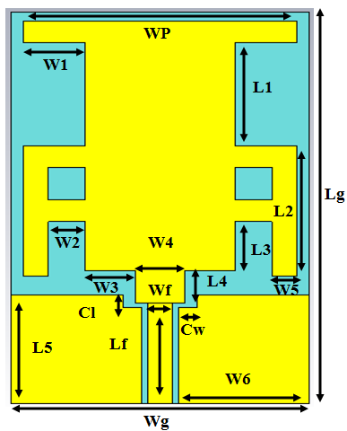

Figure 1. The geometry of the proposed T-shape microstrap patch antenna

- ANTENNA STRUCTURE
The dimensions of the proposed microstrip antenna were calculated by applying Equations (1-6). The simple rectangular microstrip patch antenna is excited by 50 ohms impedance microstrip line to get better impedance matching and the dimension of the feed line microstrip patch is 9.20 mm longand 2 mm wide;excitation was created using a 3.6 GHz resonance frequency. The T-shape microstrip patch antenna was designed following the specification parameters shown in Table 1. The maximum bandwidth of the T- shape microstrip patch is 2.9 to 4.4 at 3.6 GHz resonating frequency with Return loss(S11) is28.809 dB. Inserting edge pieces into the design makes the resonatingHulk works in a band operation. Strings in the slot will enhance the antenna gain. The tapered ground is inserted into the rear of the chassis to improve the bandwidth and feeder. Matching the proper impedance will make the design resonate in enhanced performance of the antenna design parameters. The structure of the designed antenna with the optimised dimensions is shown in Figure 1.

Table 1 . The specification of antenna design

S.no. | Parameters | Value
1 | Design frequency (f _{r}) | 3.6 GHz
2 | Dielectric constant (ɛ_{r}) | 2
3 | Height of the substrate (h) | 0.254 mm
4 | Loss tangent ( tan δ) | 0.02
5 | Width of the T- shape patch (Wp) | 22 mm
6 | The ground plane width (Wg) | 24 mm
7 | The ground plane length (Lg) | 36 mm
8 | The feed line strip length of (Lf) | 9.2 mm
9 | The feed line strip width (Lw) | 2 mm
10 | Width of the edge cut (Cw) | 1.5 mm
11 | Length of the edge cut (Cl) | 1.2 mm

Table 2. T- shape patch antenna parameters

S.no. |  | Parameters |  | Value
1 | W1 |  | 5 mm
2 | W2 |  | 3 mm
3 | W3 |  | 4 mm
4 | W4 |  | 3.5 mm
5 | W5 |  | 2 mm
6 | W6 |  | 10.5 mm
7 | L1 |  | 9.5 mm
8 | L2 |  | 12 mm
9 | L3 |  | 4.5 mm
10 | L4 |  | 3 mm
11 | L5 |  | 10 mm

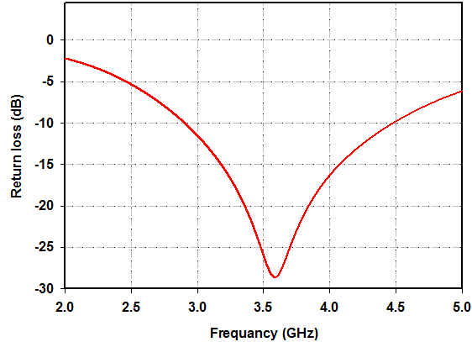

(a)
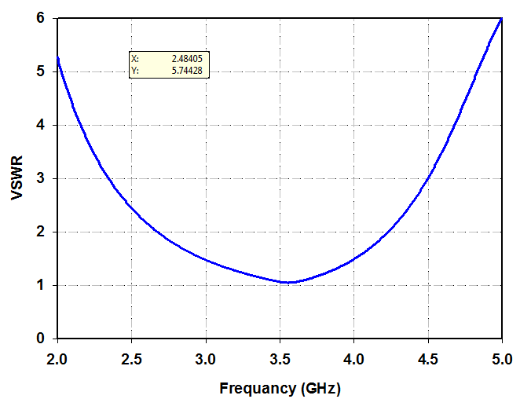

(b)

Figure 2. (a) Return loss for propoed antenna (b) VSWR plot

The microstrip patch antenna length and width are 22 mm and 34 mm, respectively. The overall size of the proposed microstrip patch antenna ground plane is 24 × 36 × 0.25mm3 mm.Shownin Table 1 and Table 2 are the specification parameters of the T-shaped rectangular patch antenna. These different parameters keep the other parameters separately stable. The strings in the slot will enhance the antenna gain. The ground is inserted into the rear of the chassis to improve the bandwidth and feeder. Two rectangular T-shaped in the patch antenna with diminutive 5× 2 mm and 12× 2 mm were designed with horizontal and vertical arms of the rectangular T- shaped patch antenna, respectively. The simulation resultsin the return loss at resonant frequency 3.6 GHz and the matching of the return loss (S11) is -28 dB. The maximum bandwidth of 1.5 GHz is observed at 3.6 GHz and VSWR of the structure is shown in Figure 2.

- RESULT AND DISCUSSION
The simulation and fabrication results in the T-shape patch antenna incorporating RT/Duroid 5880lz materials as the substrate with a thickness of 0.25 mm and loss tangent (tan δ) 0.02. It can be seen in Figure 3 that the antenna was matched in the (S11) at about 28.76 dB for the simulation while the measurement (S11) was about 20.4 dB, respectively. The BW of T-shape microstrip patch antenna wassimulated from2.90 GHz to 4.48 GHz, at 42.81% efficiency, meanwhile, the measured bandwidth is from 3. 27 GHz to 4. 22 GH.Four parameters of the T-shape microstrip patch antenna was found enhanced;simulated and analysed using CST Microwave studio at the resonant frequency of 3.6 GHz. The performance indicators such as return loss (simulated and measured), radiation pattern, gain, efficiency, directivity, and surface current distribution of the proposed T-shape patch antenna are plotted for this frequency range of 2-5 GHz in Figures 3, 4, 5, 6,7 and 8,

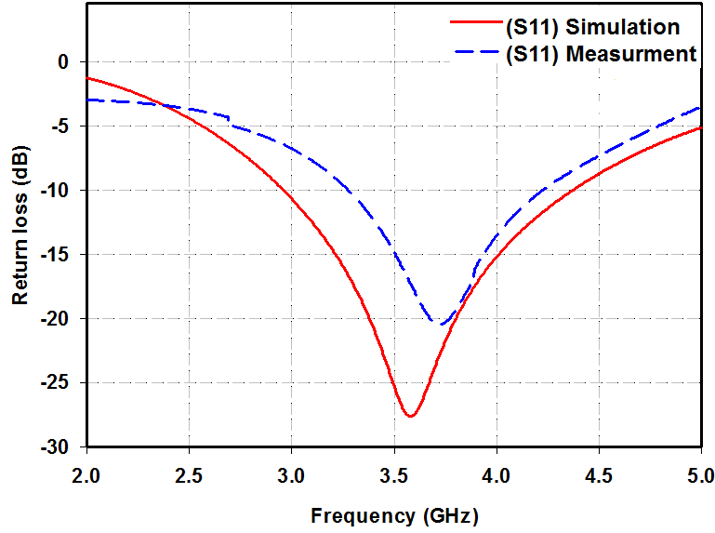

Figure 3 . The comparison (S11) for simulated and measured return loss of T-shape patch antenna

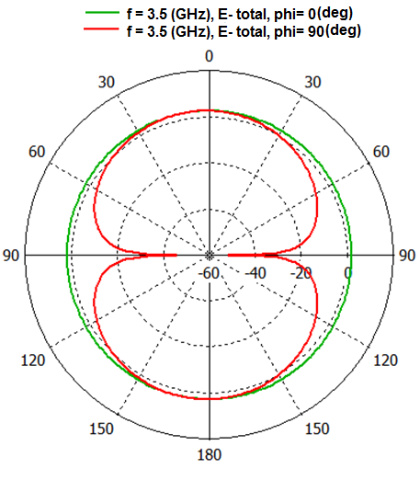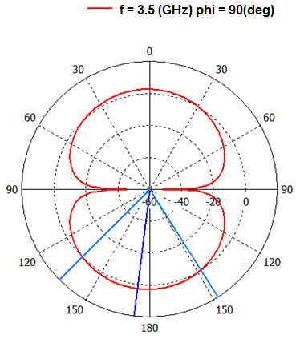
- (b)
Figure 4 . Radiation pattern characteristic for both (a) (b) phi = 0º and 90º at 3.5 GHz

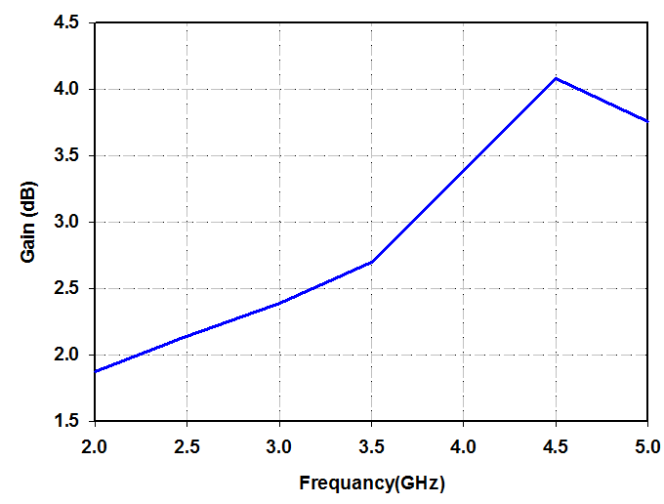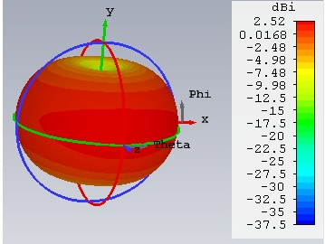

Figure 5. The graph of the gain proposed antenna Figure 6: 3-D plot of the gain characteristics

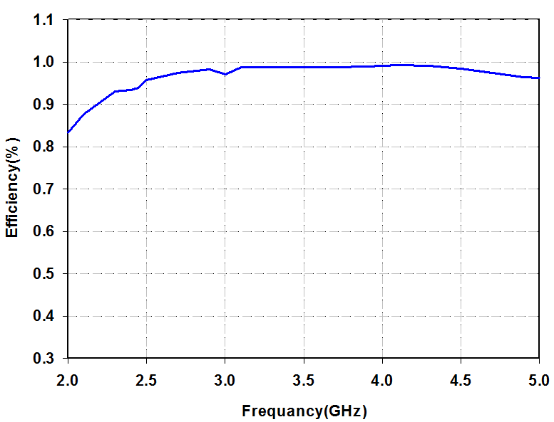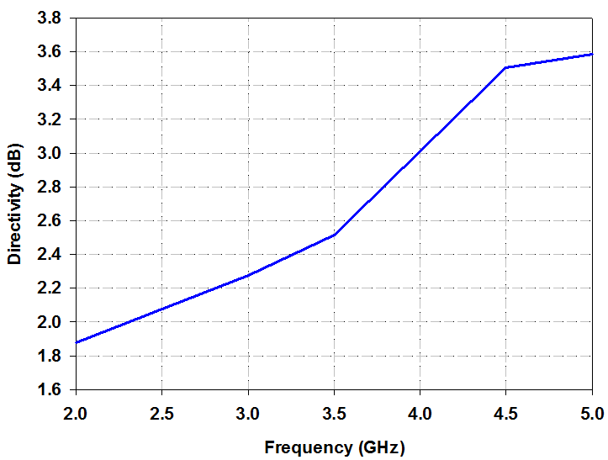

Figure 7. The graph of the efficiency proposed antenna Figure 8. The graph of the directivity proposed antenna
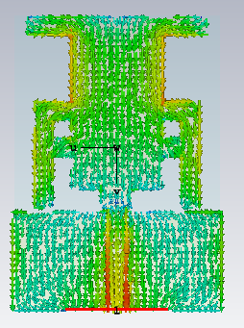

Figure 9. The graph of surface current distribution for proposed antenna

- CONCLUSION
A miniaturised T-shape microstrip antenna wassimulated, optimised, and fabricated. The proposed microstrip patch antenna was fabricated and tested using R/Duriod 5880lz, with an overall size of the microstrip patch antenna was 22 × 24 × 0.25mm3. Designing T-shape microstrip patch is done to overcome the narrow bandwidth limitation of the conventional microstrip patch antenna. Thisstructure provides the best impedance matching at different frequencies and thus has stable radiation characteristics at different frequencies. Introducing a rectangular T-shaped aperture at ground level can improve the bandwidth of the low-frequency band. The optimised antenna’s fractional bandwidth is 42.81% (2.90 GHz to 4.48 GHz) with a resonant frequency of 3.6 GHz and return loss 28.76 dB. The proposed antenna gain is 2.52 dB as shown in Figure 6 and the antenna efficiency is98.474% at 3.6 GHz resonant frequency. This type of structure is more suitable for a long term information technology due to the direction of their development. This feature has improved the proposed architecture makingit suitable for various wireless communications such as in 5G applications.

REFERNCE

[1] M. Ciydem and E. A. Miran, “Dual-Polarization Wideband Sub-6 GHz Suspended Patch Antenna for 5G Base Station,” IEEE Antennas Wirel. Propag. Lett., vol. 19, no. 7, pp. 1142–1146, 2020, doi: 10.1109/LAWP.2020.2991967.
[2] F. Zhu et al., “Ultra-wideband dual-polarized patch antenna with four capacitively coupled feeds,” IEEE Trans. Antennas Propag., vol. 62, no. 5, pp. 2440–2449, 2014, doi: 10.1109/TAP.2014.2308524.
[3] A. S. B. Mohammed, S. Kamal, Z. A. Ahmad, and U. Ullah, “Microstrip Patch Antenna : A Review and the Current State of the Art,” no. January 2020, 2019.
[4] A. A. A. Sharul Kamal Abdul Rahim, Mohamad Zoinol Abidin Abd Aziz, K. G. Tan, N. K. Noordin, M. Z. M. Nor, “New design of wideband microstrip branch line coupler using T-shape and open stub for 5G application,” Int. J. Electr. Comput. Eng., vol. 11, no. 2, pp. 1346–1355, 2021, doi: 10.11591/ijece.v11i2.pp1346-1355.
[5] H. Hao, D. Hui, and D. Lau, “Material advancement in technological development for the 5G wireless communications,” Nanotechnol. Rev., vol. 9, no. 1, pp. 683–699, 2020, doi: 10.1515/ntrev-2020-0054.
[6] R. Chávez-Santiago et al., “5G: The Convergence of Wireless Communications,” Wirel. Pers. Commun., vol. 83, no. 3, pp. 1617–1642, 2015, doi: 10.1007/s11277-015-2467-2.
[7] Q. C. Li, H. Niu, A. T. Papathanassiou, and G. Wu, “5G Network Capacity,” no. March, pp. 71–78, 2014.
[8] A. A. Abdulbari, Z. Zakaria, S. K. A. Rahim, Y. M. Hussein, M. M. Jawad, and A. M. Hamzah, “Design and development broadband monopole antenna for in-door application,” Telkomnika (Telecommunication Comput. Electron. Control., vol. 18, no. 1, pp. 51–56, 2020, doi: 10.12928/TELKOMNIKA.v18i1.13171.
[9] B. Cheng, Z. Du, and D. Huang, “A Broadband Low-Profile Multimode,” IEEE Antennas Wirel. Propag. Lett., vol. 18, no. 7, pp. 1332–1336, 2019.
[10] A. K. Jassim and R. H. Thaher, “Design and analysis of broadband elliptical microstrip patch antenna for wireless communication,” Telkomnika (Telecommunication Comput. Electron. Control., vol. 16, no. 6, pp. 2492–2499, 2018, doi: 10.12928/TELKOMNIKA.v16i6.9246.
[11] J. U. Yoo and H. W. Son, “A Simple Compact Wideband Microstrip Antenna Consisting of Three Staggered Patches,” IEEE Antennas Wirel. Propag. Lett., vol. 19, no. 12, pp. 2038–2042, 2020, doi: 10.1109/LAWP.2020.3021491.
[12] T. Huynh and K. F. Lee, “Single-layer single-patch wideband microstrip antenna,” Electron. Lett., vol. 31, no. 16, pp. 1310–1312, 1995, doi: 10.1049/el:19950950.
[13] D. Sun, W. Dou, L. You, X. Yan, and R. Shen, “A broadband proximity-coupled stacked microstrip antenna with cavity-backed configuration,” IEEE Antennas Wirel. Propag. Lett., vol. 10, pp. 1055–1058, 2011, doi: 10.1109/LAWP.2011.2169389.
[14] Y. M. Hussein et al., “Substrate integrate waveguide and microstrip antennas at 28 ghz,” Bull. Electr. Eng. Informatics, vol. 9, no. 6, pp. 2462–2468, 2020, doi: 10.11591/eei.v9i6.2190.
[15] K.-L. Wong, Compact and Broadband Microstrip Antennas, vol. 3. Wiely,New York, 2002.
[16] S. B. and Dinesh, “MINIATURIZED DUAL BROADBAND PRINTED SLOT ANTENNA WITH PARASITIC SLOT AND PATCH,” Microw. Opt. Technol. Lett., vol. 55, no. 11, pp. 2562–2568, 2014, doi: 10.1002/mop.
[17] S. Bhunia, D. Sarkar, S. Biswas, P. P. Sarkar, and B. Gupta, “REDUCED SIZE SMALL DUAL AND MULTI-FREQUENCY MICROSTRIP ANTENNAS,” Microw. Opt. Technol. Lett. /, vol. 50, no. 4, pp. 961–965, 2008, doi: 10.1002/mop.
[18] L. A. and M. Rezvani, “‘Compact UWB CPW-fed monopole antenna with variable triple-band-notched property,’” IETE J, pp. 1–9, 2018, doi: 10.1049/el.2010.2772.
[19] M. M. H. Mahfuz, S. Islam, and I. Rafiqul, “Design of UWB microstrip patch antenna with variable band notched characteristics,” vol. 19, no. 2, pp. 357–363, 2021, doi: 10.12928/TELKOMNIKA.v19i2.18147.
[20] "Final report by 5G taskforce NFCP, “" in Malaysia, submitted to MCMC, Cyberjaya, Malaysia on 15 Oct,” 2019. [Online]. Available https//www.nfcp.my/5G-Task-Force/5GMedia. [Accessed Dec. 26, 2019], 2019.
[21] M. Ahmad, W. A. E. Ali, S. Das, and A. Zugari, “International Journal of Electronics and Communications ( AEÜ ) Design and investigation of a multi-functional antenna with variable wideband / notched UWB behavior for WLAN / X-band / UWB and Ku-band applications,” AEUE - Int. J. Electron. Commun., vol. 111, p. 152895, 2019, doi: 10.1016/j.aeue.2019.152895.
[22] J. Zhang, L. Zhu, Q. Wu, N. Liu, and W. Wu, “A Compact Microstrip - Fed Patch Antenna With Enhanced Bandwidth and Harmonic Suppression,” no. c, 2016, doi: 10.1109/TAP.2016.2618539.
[23] A. M. Hamzah, L. Audah, N. Alkhafaji, H. J. Mohammed, and A. A. Abdulbari, “Substrate Integrated Waveguide SIW Technology-based Miniaturization and Performance Enhancement of Antennas :,” Int. J. Adv. Sci. Technol., vol. 29, no. 6, pp. 1739–1754, 2020.
[24] R. Kumar and V. D. K. Srivastava, “Bandwidth enhancement of a slot loaded T-shape patch antenna,” J. Comput. Electron., vol. 18, no. 1, pp. 204–209, 2019, doi: 10.1007/s10825-018-1277-7.
[25] K. V Rop, D. Konditi, and H. A. Ouma, “Parameter optimization in design of a rectangular microstrip patch antenna using adaptive neuro-fuzzy inference system technique,” Int. J. “Technical Phys. Probl. Eng., no. 4(12), pp. 16–23, 2012.

