Cloud Resources Modelling Using Smart Cloud Management

Haitham Salman Chyad¹, Raniah Ali Mustafa², Dena Nadir George ³
^{1,2,3} Computer Science Department, Collage of Education, Mustansiriyah University, Baghdad, Iraq

Article Info |  | ABSTRACT
Article history:  Received month dd, yyyy  Revised month dd, yyyy  Accepted month dd, yyyy |  | Cloud computing complexity is growing rapidly with advancement in it. It has created a requirement to ease the process of configuring cloud and re-configuring it when require, it also involves tasks like auto scaling of infrastructure, elastic computing and maintaining the health of the servers. The proposed method introduces a smart cloud management using a knowledge base, which models the resources of cloud, it handles service level agreement and its evaluation, it also implements the strategy foe efficient resource management I smart cloud. The proposed architecture is consisting of smart cloud engine, KB, server and cloud enrolment, designated monitoring tool and moderator. The resulted module is easy to integrate with any of the existing cloud management tool or orchestrator. As It is developed using REST protocol and XML language it is also easy to integrate with existing monitoring tool or APIs.
Keywords:
Knowledge base
Smart cloud engine
Cloud configuration manager
Orchestrator
RDF query
Service level agreement
This is an open access article under the CC BY-SA license.

Corresponding Author:
Raniah Ali Mustafa
Department of Computer Science
Collage of Education
Mustansiriyah University, Baghdad, Iraq
Email: rania83computer@uomustansiriyah.edu.iq

- INTRODUCTION
Cloud computing provides an advantage like Flexibly of space, Security, cost optimization, accessibility from any remote location. In cloud computing a database can be outsourced and security and remote access provides an incredible benefit to end users. Because of such incredible feature many infrastructures prefer cloud services for managing resources. Based on the need of an infrastructures these services could be used in different types of layer such as SaaS, PaaS and IaaS. There are plenty cloud service providers who offers different types of cloud services to users. Based on the requirement users selects the cloud service provider. However, after the selection of cloud services there is a requirement of continues monitoring, adaption, VM movements and need of optimising the resources from the same servers or from different cloud service providers to enhance the cloud reliability and resource migration.
Smart cloud-based infrastructure concentrates on providing the interoperability with private and public clouds maintained by different cloud providers. It makes the procedure to move the existing functionality and services from one cloud vendor to another cloud vendor. Validating and verifying the configuration of cloud resources. It makes it simpler to validate the configuration of cloud like resource management and re-configure it if require. Discover broker resource and cloud services. Providing simulation functionality. Maintaining and adapting cloud workloads condition. Provide high security and privacy preservation in cloud infrastructure. It provides an elastic computing power to cloud services. Elastic computing is the provides functionality to automatically expand or decrease computer processing, memory and storage resources to manage changing demands without configuring the capacity planning and peak usage.The proposed research introduced a smart cloud management using a knowledge base, which models the resources of cloud, it handles service level agreement and its evaluation, it also implements the strategy foe efficient resource management Intelligent smart cloud.

- LITERATURE REVIEW
Various previously proposed researches focus on different aspects like SLA broker [1,2,3] and other focuses on minimal monitoring requirement for cloud resources. E. Badidi in his research, a broker-based framework for integrated SLA-aware SaaS provisioning discussed about the service level agreement in the cloud infrastructure. In this research he proposed a broker-based framework to manage the issues related with the Software as a Service provisioning. He proposed a utility-driven selection algorithm which selects the best SaaS service provider for the user based on the rank of Quality-of-service offerings [4]. N. Sfondrini proposed a conceptual SLA-aware broker which acts a central control between the cloud users and cloud vendors. It manages the end-to-end lifecycle of services present on published on the public cloud [5]. Chyad proposed an importance of resource allocation in the cloud, in this research. soft computing is implemented for the optimization and scheduling of the resources with the higher performance on cloud [6]. Various research has been proposed to reduce and simplify the resource monitoring in the cloud architecture [7]. Villar proposed a resource brokerage ontology for vendor-independent Cloud Service management, in this an ontology was proposed which is based on the cloud service information. This ontology is then used in inter-cloud federation API for monitoring and acquiring and maintaining [8]. The proposed research paper concentrates on knowledge base. The implementation of knowledge base in the cloud infrastructure can provide a cloud ontology which will help in management of resource and provides intelligent to smart cloud. This research paper is formatted in the following sections. Section III of this research explains the smart cloud infrastructure and corelation between different cloud elements. Section IV represents the cloud modelling based on the knowledge base which enables reasoning, resource configuration and SLA. Section V presents the smart cloud engine’s structure and solutions. Section VI explains the experimental setup and result analysis. Section VII proposed conclusion of the research and experiment.

- ARCHITECTURE
The proposed architecture includes smart cloud engine which contains smart cloud engine schedular and interface. This smart cloud engine can be triggered by any cloud configuration managers or Orchestrators. This provides features like new configuration registration and provides service level agreement. It also verifies and validate the configuration and take a feedback based on the current configuration setting. It requests control activation for service level agreement and monitoring. It provides an elastic computing feature which involves auto scaling and migration allowing with provides rules, which can be applied to every business configuration separately. It controls the cloud resources and services to maintain the business configurations.
Smart cloud engine is linked with knowledge base service and hence using the sematic query an information is fetched into the smart cloud engine. These uses RDF query language for query processing. These queries are meant to perform auto scaling, migration and cloning. It also supports in verifies and validate the configuration. Using these features, it maintains the business configuration and service level agreement for every business. Hence to provide this features, multiple queries are fired every second on distributed schedular of smart cloud engine.

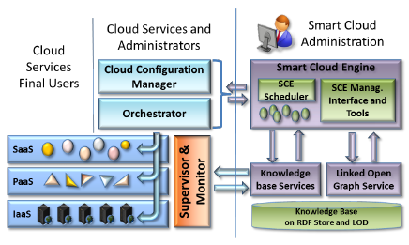
Figure 1. Architecture model of Proposed Cloud System

These smart cloud servers are processed in the parallel and distributed system which contain multiple nodes like VM machine and schedulers which maintains the scalability and handle faults in the cloud. Smart cloud engine provides a user interface to monitor service level agreement and assessment, different strategy building and configuration. Linked open graph is integrated with the knowledge base and user interface so that users can formalize the semantic RDF query for the better performance [9]. In the whole architecture a RESTful service is used and hence it is very easy to integrate with any system. This makes the system more flexible as it can be integrated with different type of cloud configuration manager or Orchestrators or with different monitoring tools. Orchestrators can directly configure the cloud engine or it can be invoked through configuration manager as well. In case of validation, it is handled by high level configuration manager which address various orchestrators. Figure 1 illustrates the architecture model of proposed cloud system.

- KNOWLEDGE BASE
Knowledge base maintains the configuration of complete cloud architecture which consist of data centre infra, various application structure and various metrics value and definition. There exist few researches which explains the usage of knowledge base in relation with cloud infrastructure [10].
The implementation of knowledge base in the cloud infrastructure can provide a cloud ontology which will help in management of resource and provides intelligent to smart cloud. The application of knowledge base manages the interoperability with private and public clouds maintained by different cloud providers. Validating and verifying the configuration of cloud resources. Discover and broker resource and cloud services. Providing simulation functionality. Maintaining and adapting cloud workloads condition. Provide high security and privacy preservation in cloud infrastructure. Providing elastic computing power to cloud services.
Knowledge base does not only store the component of cloud like application and configuration settings but it also has to store value metrics of component. It is needed as knowledge base should be able to determine which host should be configured for new virtual machine or which host is utilizing high memory and resource. Since this is huge amount of information, it will take high resources to store this information and thus it will increase the cost. To solve this issue high level metrics is preferred which contains the average information of low-level metrics. This low-level metrics includes components like CPU utilization, memory usage, disk usage and size of database. Example of this high-level metrics could be average usage of disk over an hour. High level metrics improves the storage issue and hence its cost effective.
Along with value metrics there is need to store the application-level data. This is also a huge data as it contains the type of application, various instances of application, this each instance has various constrains and services running on it. To avoid this issue OWL class model is used which uses RDF to collect the information related to the duplicate instances or types, and OWL2 is used to model feature for expressing constrains like cardinality. Along with this it is also important to collect information of various server, application and VM’s for building a business configuration. So that application tenants can be placed in the business configuration.

- Smart cloud ontology
There are few researches which focuses on ontology which describes the cloud services, the main aim of this services is to search and match the cloud offer which satisfy discovery and demands of cloud. However, there is not a single point of contact from where all the information cloud be gathered like an existing API or forum. Hence for ontology was developed and kept in the server for accessing it from cloud. This ontology models contains infrastructure, application, description, configuration and service level agreement whereas it contains low level metrics such as host ID, VM machines, various network information, adapter settings and monitoring aggregated information.

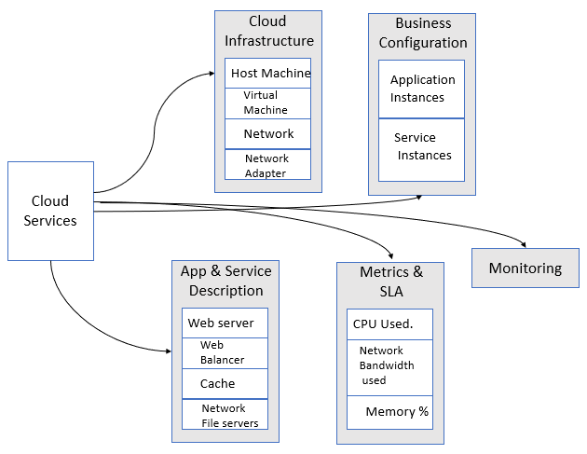
Figure 2. Modelling of cloud services using cloud ontology

To define and verify the service level agreement’s metrics value is required to compare with referenced value. This contains two types of metrics which are high- and low-level metrics. Low level metrics are collected from the integration of supervisor and sub-system monitors. However, the High-level metrics are computed by this low-level metrics and then it is stored. Ontologies contains both type of metrics. For computation of different high level metrics various aspects like high, low or arrearage value of low-level metrics is used. This is based on the conditions applied in an algorithm. Even though the it involves a mathematical computation it does not consumes memory as it mainly uses small multitactical functions like addition, subtraction and multiplication. The service level agreement can be linked to the application, tenant and business configuration. A service level agreement is a group of objectives defined at service level which is required to verify within specified time interval. These objectives are generally termed as service level objectives. These objectives are linked with a logical expression like AND logic and OR logic which required to be verify using the comparison operators of high-level metrics and referenced values. These service level objectives are also liked with the actions which gets invoked when objective is null or not defined.

- Validation and Verification
The proposed knowledge base supports RESTful services to store and manipulate different cloud aspects like type of application, business configuration, and metrics value and its type. This data is stored in RDF store. It also provides an endpoint for RDF query to be executed. When data is transferred using RDF-JSON or RDF-xml, validation is carried out to the consistency with ontology.
In the proposed architecture instead of OWL, RDF query language is used. In other previously proposed researchers OWL was used however for not having unique name assumption [11], RDF query is preferred in this architecture. Along with this RDF query provides other advantages over OWL like verifying and validating other aspects of cloud services. Examples of this could be like

- RDF query can be modified for checking if host can provide a memory to new VM
- For searching for a host to allocation new VM

One more big advantage of RDF query is that it is stored inn the configuration file in system which provide more flexibility as it allows to adapt ontologies with new requirement without making any changes to existing code and there is no need to rebuild the solution.

- SMART CLOUD ENGINE
In cloud computing architecture task scheduling is the most important aspect. As many other tasks like VM configuration and reconfiguration, cloning and migration, disk space management, load balancing, recovery and auto-start up required continues checking of system and based on the condition and algorithm it needs to adapt and perform some action. Hence task scheduling is an important aspect in cloud management however it is analysed as a challenging task a many previous researches [12,13,14]. Cloud Engine is an important component of cloud architecture as it is responsible for checking the resources status like running services and VM’s. It also uses RDF queries to connect with the knowledge base. Based on the service level agreement and the status of resources it calls the RESTful services to perform necessary action towards configuration manager. This task could be balancing, cloning and configuration [15].
Cloud engine provides autonomous services which helps to exploit cloud resources for service optimization and to perform service automation. Cloud engine is scheduled to validate and verify the metrics and status of various service at application, infrastructure and service level of specific cloud and it also has a knowledge of system configuration and status of cloud. As the cloud engine also has a knowledge of specified rules it checks the status and based on the conditional logic specified in the rule it invokes the event. Inside the cloud engine, polices are defined which handles the emergency event and management to exploit the distributed resources across different data centres. It involves events like capacity computation and migration of data. In widely distributed and complex cloud architecture there is a requirement of running cloud agent with distributed instances to perform collective task and being integrated in the architecture to perform load balancing for different tasks. Hence cloud engine provides a feature of clustered multiplatform scheduling. It allows the cloud engine to insert new node for scheduling and assign a job for management of smart cloud, without any need to rebuild. Every job is consisting of different entities as illustrated in figure 3. This information acts as an identification, metadata and event trigger when requires to invoke some event and perform task.

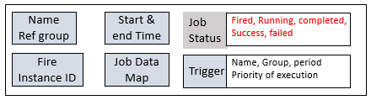
Figure 3. Entity structure of Job

Cloud engine provides multiple ways to connect with other application include web platform and hence it is possible to show the infrastructural data of cloud on the user interface. This can contain host information, VM data, application information and high-level metrics, various disabled and enabled alters and network information. Apart from the infrastructural data it also contains information related to service level agreement and overall summary of complete nodes from cluster[16]. Using this user interface, users can even check the data is more structured from to have a better insight of infrastructural data. To monitors the service present in the service level agreement cloud engine frequently calls the knowledge base using RDF query. Using the metrics and threshold value cloud engine evaluates the status of system and based on that it invokes the cloud configuration manager to perform specified action like adapting the storage size and resources size. This action is triggered by calling a RESTful service as defined in the service level agreement endpoints. Cloud engine maintains all log information related to monitoring of services[17]. The frequency of this validation and verification can be modified based on requirements. The cloud engine also has a policy for missed events and triggers, so that if the trigged event fails to perform task, even gets re-trigged with all the metrics including the time of first trigger, second trigger, action performed and time interval. Metrics can be visualized on user interface and it can be cluster together based on Service level agreement. Every single metrics provides information about multiple service level agreement violation which occurred in the specified time interval. This provides the information like exact timestamp, metric name, thresholds and registered value and configuration details. Cloud engine provides a report with a compete details of status of clusters, it also contains information of all scheduled nodes and information about all resources and computation memory used by cluster.

- EXPERIMENTS AND VALIDATIONS
For experimental testing and validation of proposed knowledge-based solution, it is deployed othe ICARO cloud simulator. For the experimental purpose a service level agreement with 75 different application condition is used.
The setup is configured with 13 virtual machines and 12 running services. Service level agreement contains a CDN based balanced frontend and backed social network, index, search and ingestion.
Virtual machine is equipped with following software:

Table 1. Virtual machine configuration
Software | Quantity | Version
HTTP balancer | 1 | Mod_proxy_balancer
Web server | 3 | Apache HTTP Server
Apache Tomcat serve | 1 | 9.0.52
MySQL database | 1 | MySQL 5.7
AXCP schedular | 1 | -
AXCP Grid Nodes | 5 | -

Service metrics of 3 months is collected for the evaluation purpose. Every metrics contains 3800 measures. For evaluation of service level agreement and to collect the current metrics value, 30 seconds is required. However, for the service level agreement using a single virtual machine and 4 metrics which are CPU utilization, memory utilization, resource and disk storage and network, 2 second time is required. By keeping 30 minutes as an average interval all this data is recorded.

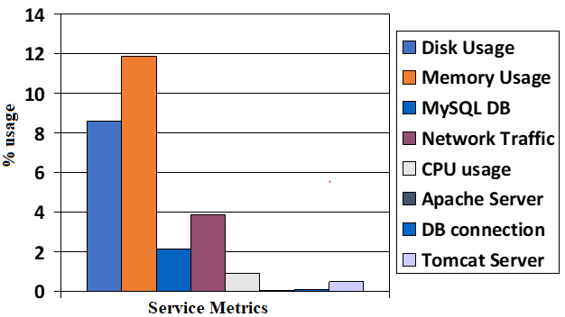
Chart 1. Service metrics usage in percentage

This chart shows that the major triggers are invoked for the memory utilization, disk utilization, network congestion and database utilization. Out of the total trigger 11.87% trigger were invoked for memory utilization, 8.58% triggers were invoked for disk utilization and for network congestion and database utilization were 3.86% and 2.13% respectively. The cluster of scheduler contains 2 scheduling node and one SQL database. The computational cost per scheduling node CPU utilization was recorded as 108.44 MHz which shows a better performance with low computation cost. For every trigger a RESTful service event was called and the data were stored in the logs for record.

- CONCLUSION
The proposed method introduces a smart cloud management using a knowledge base, which models the resources of cloud, it handles service level agreement and its evaluation, it also implements the strategy foe efficient resource management Intelligent smart cloud. The proposed knowledge base supports RESTful services to store and manipulate different cloud aspects like type of application, business configuration, and metrics value and its type. Cloud engine provides autonomous services which helps to exploit cloud resources for service optimization and to perform service automation. Cloud engine is scheduled to validate and verify the metrics and status of various service at application, infrastructure and service level of specific cloud and it also has a knowledge of system configuration and status of cloud. It provides a cloud management platform and smart reasoning which can be applied into multiple contexts like hybrid cloud or federated cloud. The proposed solution also provides features like Virtual machine configuration and reconfiguration, cloning and migration, disk space management, load balancing and recovery.
For experimental testing and validation of purpose a service level agreement with 75 different application condition is used. The setup is configured with 13 virtual machines and 12 running services. Experimental results shows that major triggers are invoked for the memory utilization, disk utilization, network congestion and database utilization. The computational cost per scheduling node CPU utilization against a complex cloud configuration was recorded and it was observed that the proposed architecture provides better performance with low computation cost.

ACKNOWLEDGEMENTS
The authors would like to thank Mustansiriyah University (www.uomustansiriyah.edu.iq) Baghdad, Iraq for its support in the present work.

REFERENCES
[1] N. Sfondrini and G. Motta, “SLA-aware broker for Public Cloud”, 2017 IEEE/ACM 25th International Symposium on Quality of Service (IWQoS), Vilanova i la Geltrú, Spain ,10.1109/IWQoS.2017.7969136, July 2017.

[2] R. A. Neves and P. E. Cruvinel, “Ontology for Structuring a Digital Databases for Decision Making in Grain Production”, 2021 IEEE 15th International Conference on Semantic Computing (ICSC), Laguna Hills, CA, USA, DOI: 10.1109/ICSC50631.2021.00071, Jan. 2021.

[3] I. Haddar,B. Raouyane and M. Bellafkih “Generating a service broker framework for service selection and SLA-based provisioning within network environments”, Ninth International Conference on Ubiquitous and Future Networks (ICUFN), 2017.

[4] E. Badidi, “A BROKER-BASED FRAMEWORK FOR INTEGRATED SLA-AWARE SAAS PROVISIONING”, International Journal on Cloud Computing: Services and Architecture (IJCCSA), Vol. 6, No. 2, DOI: 10.5121/ijccsa.2016.6201, April 2016.

[5] N. Sfondrini and G. Motta,”SLA-aware broker for Public Cloud”, IEEE/ACM 25th International Symposium on Quality of Service (IWQoS) Vilanova i la Geltrú, Spain, DOI: 10.1109/IWQoS.2017.7969136, June 2017.

[6] H. S. Chyad,R. A. Mustafa and K. T. Saleh, “Study and Implementation of Resource Allocation Algorithms in Cloud Computing”, ,International Journal of Engineering & Technology, 7 (4.28) (2018) 591 -594, 2018.
[7] J. S. Ward and A.Barker,“Observing the clouds: a survey and taxonomy of cloud monitoring”, Journal of Cloud Computing, 2014.

[8] B.Karim, Q. Tan, J. R. Villar and E.de la Cal, “Resource brokerage ontology for vendor-independent Cloud Service management” IEEE 2nd International Conference on Cloud Computing and Big Data Analysis (ICCCBDA), Chengdu, China, DOI: 10.1109/ICCCBDA.2017.7951959, 2017.

[9] P.Ravindra,H. Kim, K. Anyanwu,”Rewriting complex SPARQL analytical queries for efficient cloud-based processing”, IEEE International Conference on Big Data (Big Data), 2015.

[10] M. Bohlouli and S. Hellekes,”Cloud-enabaled Multimodal Knowledge Modeling and Acquisition for Education and Learning (KaaS), IEEE International Conference on Big Data (Big Data), 2020.

[11] Algebri, H. K., Husin, Z., Abdulhussin, A. M. and &amp;Yaakob, N. ,”Why Move toward the Smart Government” , International Symposium on Computer Science and Intelligent Controls (ISCSIC), (pp. 167-171). Budapest, Hungary, 2017.
[12] M. Abdel-Basset, N. Moustafa, R. Mohamed and O. M. ELkomy, “Multi-objective Task Scheduling Approach for Fog Computing”, IEEE, 10.1109/ACCESS.2021.3111130,1, September 2021.

[13] M. Sarvabhatla, S. Konda, C. S. Vorugunti, M.M. N.Babu,”A Dynamic and Energy Efficient Greedy Scheduling Algorithm for Cloud Data Centres” , IEEE International Conference on Cloud Computing in Emerging Markets (CCEM) ,2017.

[14] Algabri, H. K., Taha, Y. A., Gaikwad, S. S., and amp; Kamat, R. K. ,”Curriculum Technology Integration for Higher Education”, Journal of Advanced Research in Dynamical and Control Systems, pp.295-300, (2020).

[15] H. S.Chyad,R.A. Mustafa, R. A. Haleot ,”An Effective Protocol and Algorithmic Approach for Disaster Management using Wireless Sensor Networks” , Journal of Advanced Research in Dynamical & Control Systems, Vol. 10, 13-Special Issue, 2018.

[16] Y. Li,S. Wang,X. Hong, Y. Li, “Multi-objective Task Scheduling Optimization in Cloud Computing based on Genetic Algorithm and Differential Evolution Algorithm”, 37th Chinese Control Conference (CCC), 2018.

[17] B. D.Martino,G. Cretella and A. Esposito,”Towards a Unified OWL Ontology of Cloud Vendors' Appliances and Services at PaaS and SaaS Level”, Eighth International Conference on Complex, Intelligent and Software Intensive Systems, 2014.

