A Comprehensive Analysis on IoT based Smart Farming Solutions Using Machine Learning Algorithms

S.Ahamed Ali^{1*}, Y.Justindhas², A.Manjunathan³, A.Karthikram⁴, S.Jeevitha⁵,S.Kannadhasan⁶
^{1, 2} Assistant Professor, Department of Computer Science and Engineering, Easwari Engineering College, Chennai, India
³Assistant Professor, Department of Electronics and Communication Engineering, K.Ramakrishnan College of Technology, Trichy, Tamilnadu, India
⁴Assistant Professor, Department of Computer Science and Engineering, Vel Tech Rangarajan Dr.Sagunthala R & D Institute of Science and Technology, Chennai, Tamilnadu, India
⁵Assistant Professor, Department of Computer Science and Information Technology, Kalasalingam Academy of Research and Education, Krishnankoil, Tamilnadu, India
⁶Assistant Professor, Department of Electronics and Communication Engineering, Cheran College of Engineering, Tamilnadu, India,
¹ahamedali.s@eec.srmrmp.edu.in, ²justindhas.y@eec.srmrmp.edu.in, ³manjunathankrct@gmail.com, ⁴karthikram86@gmail.com, ⁵jeevitha.ramkumar@gmail.com, ⁶kannadhasan.ece@gmail.com

Article Info |  | ABSTRACT
Article history:  Receivedmonth dd, yyyy  Revised month dd, yyyy  Accepted month dd, yyyy |  | Agriculture and farming are the most important and basic industries that are very important to humanity and generate a considerable portion of any nation's GDP. For good agricultural and farming management, technological advancements and support are required. Smart Agriculture (or) Farming is a set of approaches that uses a variety of current information and communication technology to improve the production and quality of agricultural products with minimum human involvement and at a lower cost. Smart agricultural techniques are expected to pave the way for the "Third Green Revolution." Smart farming relies heavily on IoT, machine learning algorithms, and data analytics. Smart farming is mostly based on IoT technology, since there is a need to continually monitor numerous aspects in the agricultural field, such as water level, light, soil characteristics, plant development, and so on. Machine learning algorithms are used in smart farming to increase production and reduce the risk of crop damage. Data analytics has been shown through extensive study to improve the accuracy and predictability of smart agricultural systems. Data analytics is utilised in agricultural fields to make decisions and recommend acceptable crops for production. This study provides a comprehensive overview of the different methods and structures utilised in smart farming. It also provides a thorough analysis of different designs and recommends appropriate answers to today's smart farming problems.
Keywords:
Smart Farming
IoT
Machine Learning
Data Analytics
This is an open access article under the CC BY-SA license.

Corresponding Author:
Ahmed Ali
Department of Computer Science and Engineering,
Easwari Engineering College, Chennai, India
Email: ahamedali.s@eec.srmrmp.edu.in

1. INTRODUCTION
Internet connectivity is available to more than 80% of the world's population. Random mobile contact, spot messaging, mobile phone calls, immersive two-way video chat, Voice-Over-Internet-Protocol (VoIP), social networking, and ecommerce websites are all examples of how technology has influenced modern living. The Internet of Things (IoT) is the future web platform for environmental and technological communication. The Internet of Things (IoT) is a cost-effective and secure technology that may be used to upgrade a variety of domains. IoT-based solutions are being developed to autonomously monitor and track farms with minimum human interaction. The Internet of Things (IoT) is a technical advancement that allows smart gadgets and machines to communicate with one another while reducing human involvement. As young people relocate to major cities, agricultural human resources are dwindling, and farmland is shrinking as a result of urbanisation. As a result, many agricultural operations will need to be simplified in order to fulfil rising food demand.

Smart farming has recently piqued the interest of many academics, since it may assist farmers in making dynamic farm and crop management decisions. The quality of agricultural goods and the lives of farmers may be considerably improved with the adoption of different new technologies in the information and communication industry. Smart farming technology is employed by approximately 80 percent of farmers in the United States, and about 24 percent of farmers in Europe. Intelligent farming enables farmers to improve, automate, and optimise conventional farming practises, resulting in improved agricultural productivity and a simpler cultivation system. Various IoT sensors are used in intelligent farming, and these sensors are connected with agricultural equipment, resulting in a synergistic rise in crop output and productive agriculture experiences.
1.1 Basics of Smart Farming
This section presents the basic components which are essentially needed for smart farming. The details of the various components are listed below.
- Sensors: To provide vital information regarding various farm parameters(soil moisture, water level, fertilizer level etc.,) to do precise farming
- Connectivity : Cellular(3G/4G/5G),ZigBee,WiFi
- Gateway : Microcontrollers
- Location : GPS
- Data Analytics:R,Pandas
- IoT Components: DeviceHive,Arduino,Raspberry PI
A typical smart farming is a four stage process as illustrated in figure 1.1
Sensors(Record Farm Parameters)
Diagnostics
Decision Making
Farming Solution
Machine Learning Algorithms
Microcontrollers
As
Gateways

Figure 1.1 Basic Smart Farming Architecture

Sensors are used to determine numerous agricultural factors that are required for a given crop, such as soil type, moisture level, nutrient presence, and so on. The readings collected from the sensors are mapped with certain criteria in order to identify the agricultural product's unique demands or inadequacies. To make intelligent judgments, machine learning algorithms are applied, and it gives a good agricultural solution. The smart farming cycle continues as a result of the reaction. The specifics of several kinds of sensors used in smart farming are shown in Table 1.1.
Sensor Name | Details | Sensor Image
Decagon ECH2O 5TM FDR Sensor -  Frequency Domain Refractometry (FDR) | Measure the water level in the field | 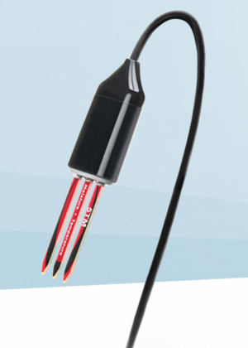
GroPoint Pro TDT Sensor- Time Domain Transmissiometry (TDT) | Measure the water level in the field | 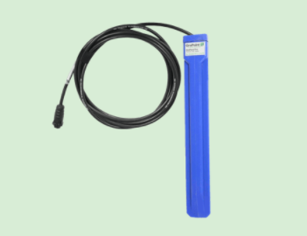
Soil Moisture Sensor - Soil Hydrometer-Humidity Detector | Measure the amount of humidity in the soil | 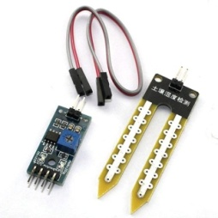
DHT11 - Temprature and Humidity Sensor Module | Measure the amount of humidity and temperature in the Environment | 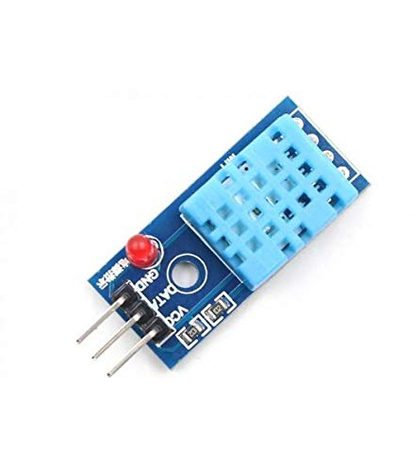
LM35DZ/LFT1  Temperature Sensor Analog | Measure the amount of temperature in the Environment | 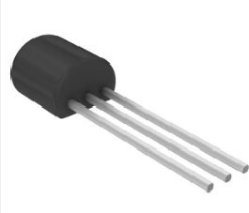
Water-level-sensor | Measure the depth of the water level | 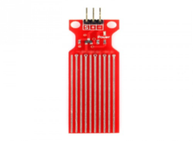
DN25 1inch Water Flow Sensor | Measure velocity variations at varying flow speeds. The sensor with hall effect transmits the appropriate signal. | 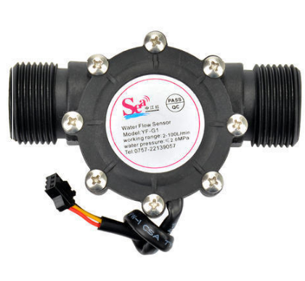
PROD-WM30-1280x960 | Measure wind direction and measure wind speed. | 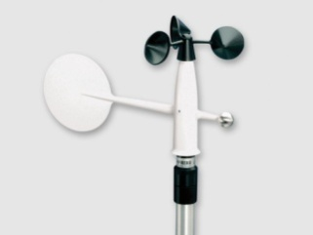
MQ135 - Air Quality Gas Sensor | Sensor for air quality to track a variety of gases like NH3, NOx, alcohol, benzene, smoke, and CO2. | 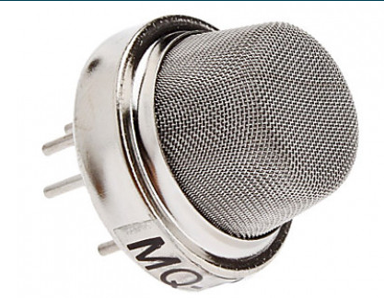
Pollution Monitoring Module ZP07-MP503 - 5V Air Quality Sensor Module | For detecting chemical reactive gases, e.g. formaldehyde, benzene, carbon monoxide, ammonia, hydrogen, alcohol and smoke and so on. | 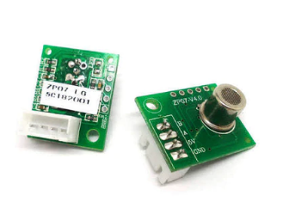
Rain Drop Sensor Module | Rain sensor or detector module for rain detector is easy and convenient to use. When rain hits on the sensor, the module acts like a switch. It also tests rain intensity | 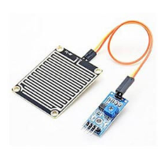

Table 1.1 Sensors for Smart Farming

2. SMART FARMING SOLUTIONS BASED ON IOT AND MACHINE LEARNING APPROACHES
Nermeen Gamal Rezk et al. (2020) developed "An efficient IoT based smart farming system employing machine learning algorithms," a novel IoT-based smart farming technology. To increase crop production, they used a system dubbed WPART, which is based on a wrapper feature selection approach. In their method, they've included a powerful decision-making tool called PART. The outputs of the PART algorithm do not need any global optimization. The wrapper algorithm is used to improve the performance of the classifier. Their technique has a flaw in that it just looks at time series data and does not forecast future values. According to Nermeen Gamal Rezk et al. (2020), their model obtained 92.51 percent accurate results.
Vincent et al. (2019) developed an expert methodology [2] for using sensor networks to assess agricultural land suitability. The agricultural dataset was created using a variety of IoT sensors, including pH sensors, soil moisture sensors, salinity sensors, and electromagnetic sensors. Their assessment and analysis method is based on the Multi-Layer-Perceptron (MLP). The cloud platform was used to store the data collected from the different IoT devices. The network architecture, weight correction, and activation properties all play a role in the effectiveness of this study model. R. Varghese et al. demonstrated a simple and economical IoT system [3] for monitoring diverse crops under real-time conditions (2018). In order to construct a low-cost intelligent agricultural module, they combined IoT and machine learning technologies. All of the agricultural data sets that are monitored have been moved to the cloud (Amazon AWS). The generated dataset is trained using Logistic Regression (LR) and Support Vector Machine (SVM), which are useful for forecasting future crop conditions based on historical data. R. Anand et al. created a novel model [4] that analyses soil quality and forecasts the optimum crop type suited for cultivation in that soil (2019). The Node MCU ESP8266 microcontroller is used in their technique. The key soil data were aggregated using three primary sensors: a temperature sensor, a rain sensor, and a humidity sensor to examine its fertility and quality. The technique for obtaining environmental data was also described in their model. This information may be used to anticipate environmental conditions and aid farmers in making decisions. As a storage server, an Open cloud server (ThingSpeak) is employed. A hybrid technique, which combines Multiple Linear Regression (MLR) and K-Means clustering, is used to forecast the crop suited for cultivation in that soil.
K. S. Pratyush Reddy et al (2020) [5] proposed an unique smart irrigation system. To anticipate a crop's water consumption, they used a decision tree paired with several regression and classification techniques algorithm. Multiple agricultural sensors were used to create their model, which can monitor temperature, wetness, and humidity. The information acquired by the system is sent to a cloud-based IoT system. The Raspberry Pi and the DHT11 soil moisture sensor are used in their model. T. Truong et al. (2017) [6] built an IoT framework that includes sensors, an LTE HUA8372 Wi-Fi internet module, and a microcontroller. Their model can collect environmental data in real time and send it to a cloud storage service. The SVMr (Support Vector Machine Regression) technique is used to detect fungal infections in a range of environments. They've also devised a method for predicting and spreading severe fungal diseases. SVMr is a popular tool for delivering intelligent solutions. By monitoring soil moisture, soil temperature, and climatic variables, Marendra Goap et al (2018) [7] established an open-source technique for identifying field-based irrigation needs using soil characteristics. The approach uses Support Vector Regression (SVR) and k-means clustering to estimate soil moisture differences (SMD) during rapid changes in meteorological conditions. This method provides more accuracy while reducing mean square errors (MSE). When compared to the SVR technique, this new algorithm gives better accuracy (R = 96%) and lower MSE in ground moisture prediction. The hybrid learning approach for SVR+K-Means is utilised for irrigation planning since it has a greater accuracy and lower MSE. On the basis of agronomic knowledge, Goldstein et al. (2017) [8] developed cultivation recommendations. Gradient-Boosted-Regression-Trees (GBRT) was shown to be the best regression model solution for smart irrigation advice, with a precision of 93 percent. The agronomist may utilise the designed setup to regulate irrigation.
Roopaei et al (2017) [9] suggested an Intelligent Monitoring Method based on thermal imaging. Their study recommended using a thermal imaging sensor placed on a drone. The pictures generated by the imaging sensor are utilised to analyse crucial irrigation characteristics including as water demand, leaf quality, and fertiliser requirements. Acar et al. [10] used an extreme learning machine (ELM) based on a regression model to forecast soil moisture on the surface. The information gathered there is utilised to predict soil moisture content. Validation is carried by using a brand-new approach known as the "leave-one-out" cross endorsement method. The sine kernel function was used to assess the experimental setup, and the Root-Mean-Square-Error (RMSE) was discovered to be about 2.19 percent. Wang et al. [11] suggested a method for analysing soil nutrient concentration in order to improve irrigation efficiency. They employed soft sensors based on ELM to calculate the generation of nutrient solutions. In the production of nutrient solutions, the method effectively tracks pH values, temperatures, and concentration fluctuations. Park et al. [12] forecasted soil moisture using soil moisture algorithms and MODIS data. The authors lowered the moisture level by using Random-Forest (RF) and cubist methods. An ensemble of these methods is used to acquire soil humidity data. The findings of their technique were compared to those of the least-squares method. Using machine learning techniques, Reda et al. [13] examined several approaches to assess Soil-Organic-Carbon (SOC) and Total-Nitrogen (TN). To carry out their research, they took soil samples from four agricultural areas in the African nation of Morocco. Instead of employing traditional chemical soil analysis procedures, they used near-infrared (NIR) spectroscopy to gather data for their study. This method reduces the amount of time and other computing overheads. This method uses the ensemble learning modelling (ELM) technique to predict SOC and TN.
Morellos et al. [14] employed visible and near-infrared (NIR) spectroscopy to assess total nitrogen (TN), soil carbon, and humidity levels in an agricultural field. The spectroscopic dataset is used to estimate the three soil characteristics listed above. The predicted machine learning models are then built using these datasets. For the analysis, Least-Squares-Support-Vector-Machines (LS-SVMs) and Cubist approaches were applied. Their findings demonstrated that the Ls-SVM strategy is superior to linear-multivariate approaches for estimating soil parameters.Machine learning techniques were investigated by Mahmoudzadeh et al. [15] to estimate and forecast soil carbon concentration. They discovered that, in addition to SVM, KNN, Cubist, and Extreme-Gradient-Boosting (XGBoost), RF accurately predictions SOC with R2 of 0.60 and RMSE of 0.30 percent on simulated data. SOC is influenced by air temperature, yearly rainfall, valley depth, and terrain roughness, according to the study. Vereset et al. [16] investigated deep learning architectures, especially convolution neural networks (CNN) and conditional restricted Boltzmann machines, in order to predict soil properties using infrared spectroscopic findings. Stamenkovic et al. [17] proposed an SVR (Support-Vector-Regression) model for predicting soil moisture levels in remotely sensed hyperspectral images. Because the climate in this region varies throughout the year, Mohammadi et al. [18] used an extreme learning machine model to estimate daily water droplets and temperature in several sectors of Iran. Extreme learning machine models were shown to predict more correctly than SVM and ANN algorithms in the study [19]-[27].

3. COMPARISON OF VARIOUS SMART FARMING ALGORITHMS
Smart Farming Approach | Attributes | Algorithms /Approach
“Affordable Smart Farming Using IoT and Machine Learning, R. Varghese et al[3]” | Soil, temperature, moisture | Linear Regression (LR), Support Vector Machine (SVM)
“Soil Moisture and Atmosphere Components Detection System Using IoT and Machine Learning, R. Anand et al [4]” | Humidity-Temperature-Moisture- Rainfall | Hybrid approach- (Multiple-Linear-Regression) MLR method and K-Means clustering
“IoT based Smart Agriculture using Machine Learning, K. S. Pratyush Reddy et al. [5]” | Moisture, Temperature and Humidity | Decision Tree
“An IoT environmental data collection system for fungal detection in crop fields, T. Truong et al. [6]” | Soil moisture – Temperature - Air Humidity - Wind speed - Wind direction - Sunlight intensity. | Support-Vector-Machine-Regression (SVMr )
“An IoT based smart irrigation management system using Machine learning and open source technologies, Marendra Goap et al. [7]” | Soil moisture - Temperature - Climate conditions. | Support-Vector-Regression (SVR) and K-Means clustering
“Goldstein et al. [8] Applying machine learning on sensor data for irrigation recommendations: revealing the agronomist’s tacit knowledge” | Temperature - Solar radiation - Relative Air Humidity | (Gradient-Boosted-Regression- Trees) GBRT – (Regression-Tree-Model) RTM, (Boosted-Trees- Classifiers) BTC.
“Machine learning based regression model for prediction of soil surface humidity over moderately vegetated fields, Acar et al. [10]” | Soil surface moisture | Extreme-Learning-Machine-Regression (ELM-R)
“Modeling of soft sensor based on DBN-ELM and its application in measurement of nutrient solution composition for soilless culture, Wang et al. [11]” | pH value, temperature, and flow rate | Extreme-Learning-Machine (ELM)
“AMSR2 soil moisture downscaling using multi sensor products through machine learning approach, Park et al. [12]” | Soil moisture | Random-Forest (RF) and Cubist algorithms
“A comparative study between a new method and other machine learning algorithms for soil organic carbon and total nitrogen prediction using near infrared spectroscopy, Reda et al.[13]” | Soil-Organic-Carbon (SSOC) and Total-Nitrogen (TN) | Ensemble-Learning Algorithm
“Machine learning based prediction of soil total nitrogen organic carbon and moisture content by using VIS-NIR spectroscopy, Morellos et al. [14]” | Total-Nitrogen (TN), Soil-Organic-Carbon (SOC), and Moisture-Content (MC) | Least-Square-Support-Vector-Machine (LS-SVM) and Cubist ML algorithms
“Spatial prediction of soil organic carbon using machine learning techniques in Western Iran, Mahmoudzadeh et al. [15]” | Temperature, Yearly Rainfall | Cubist and Extreme-Gradient-Boosting (XGBoost), Random Forest, SVM, KNN.
“Deep learning architectures for soil property prediction, Vereset et al. [16]” | Soil characteristics | Deep Learning (DL) and Convolution Neural Network (CNN)
“Estimation of soil moisture from airborne hyperspectral imagery with support vector regression, Stamenkovic et al. [17]” | Soil moisture | Support-Vector-Regression (SVR)
“Improvement of crop production using recommender system by weather forecasts, Mohammadi et al. [18]” | Daily water droplet point - Temperature | ELM, SVM,ANN

Table 3.1 Smart Farming Algorithms Comparison

4. CONCLUSION
According to a recent World Health Organization study, approximately 800 million people (one out of every nine people) worldwide are hungry as a result of food shortages and poverty. Aside from this issue, the rapid growth in human population is another key element that contributes to food scarcity. Food scarcity is exacerbated by issues such as global warming, groundwater depletion, a lack of manpower in agriculture, pollution, and the shrinkage of agricultural area due to urbanisation and industrialisation. The necessity of producing and storing high-quality agricultural goods is highlighted by the aforementioned difficulties. These issues also point to the necessity for technical advancements in agriculture and farming. Smart farming has recently emerged as a viable method for producing high-quality agricultural products with low waste and human involvement. Machine learning, data analytics, cloud computing, and agricultural robotics are all examples of smart farming technology. These technologies help farmers from sowing to harvesting high-quality crops. This study provided a comprehensive overview of several smart farming architectures and algorithms. It has also emphasised the need of new technology in making farming smarter in order to fulfil future food demand and other demands. This report also concludes that additional research is required to make farming smarter in order to give high-quality food items to all living species, not just humans.

REFERENCES
[1] Rezk, N.G., Hemdan, E.ED., Attia, AF. et al. An efficient IoT based smart farming system using machine learning algorithms. Multimed Tools Appl 80, 773–797 (2021).
[2] Vincent, Durai R.; Deepa, N; Elavarasan, Dhivya; Srinivasan, Kathiravan; Chauhdary, Sajjad H.; Iwendi, Celestine. 2019. "Sensors Driven AI-Based Agriculture Recommendation Model for Assessing Land Suitability" Sensors 19, no. 17: 3667. https://doi.org/10.3390/s19173667
[3] R. Varghese and S. Sharma, "Affordable Smart Farming Using IoT and Machine Learning," 2018 Second International Conference on Intelligent Computing and Control Systems (ICICCS), Madurai, India, 2018, pp. 645-650
[4]. R. Anand, D. Sethi, K. Sharma and P. Gambhir, "Soil Moisture and Atmosphere Components Detection System Using IoT and Machine Learning," 2019 International Conference on Smart Systems and Inventive Technology (ICSSIT), Tirunelveli, India, 2019, pp. 842-847
[5] K. S. Pratyush Reddy, Y. M. Roopa, K. Rajeev L.N. and N. S. Nandan, "IoT based Smart Agriculture using Machine Learning," 2020 Second International Conference on Inventive Research in Computing Applications (ICIRCA), Coimbatore, India, 2020, pp. 130-134.
[6] T. Truong, A. Dinh and K. Wahid, "An IoT environmental data collection system for fungal detection in crop fields," 2017 IEEE 30th Canadian Conference on Electrical and Computer Engineering (CCECE), Windsor, ON, 2017, pp. 1-4.
[7] Goldstein, A., Fink, L., Meitin, A., Bohadana, S., Lutenberg, O., Ravid, G., 2017. Applying machine learning on sensor data for irrigation recommendations: revealing the agronomist’s tacit knowledge. Precis. Agric. 19, 421–444. https://doi.org/10.1007/ s11119-017-9527-4.
[8] Marendra Goap, Deepak Sharma, A.K. Shukla, C. Rama Krishna,An IoT based smart irrigation management system using Machine learning and open source technologies,Computers and Electronics in Agriculture,Volume 155,2018,Pages 41-49,ISSN 0168-1699.
[9] M. Roopaei, P. Rad and K. R. Choo, "Cloud of Things in Smart Agriculture: Intelligent Irrigation Monitoring by Thermal Imaging," in IEEE Cloud Computing, vol. 4, no. 1, pp. 10-15, Jan.-Feb. 2017
[10] E. Acar, M. S. Ozerdem and B. B. Ustundag, "Machine learning based regression model for prediction of soil surface humidity over moderately vegetated fields", Proc. 8th Int. Conf. Agro-Geoinformat. (Agro-Geoinformat.), pp. 1-4, Jul. 2019.
[11] X. Wang, W. Hu, K. Li, L. Song and L. Song, "Modeling of soft sensor based on DBN-ELM and its application in measurement of nutrient solution composition for soilless culture", Proc. IEEE Int. Conf. Saf. Produce Informatization (IICSPI), pp. 93-97, Dec. 2018.
[12] Park, J. Im, S. Park and J. Rhee, "AMSR2 soil moisture downscaling using multisensor products through machine learning approach", Proc. IEEE Int. Geosci. Remote Sens. Symp. (IGARSS), pp. 1984-1987, Jul. 2015.
[13] R. Reda, T. Saffaj, B. Ilham, O. Saidi, K. Issam, L. Brahim, et al., "A comparative study between a new method and other machine learning algorithms for soil organic carbon and total nitrogen prediction using near infrared spectroscopy", Chemometric Intell. Lab. Syst., vol. 195, Dec. 2019.
[14] A. Morellos, X. E. Pantazi, D. Moshou, T. Alexandridis, R. Whetton, G. Tziotzios, et al., "Machine learning based prediction of soil total nitrogen organic carbon and moisture content by using VIS-NIR spectroscopy", Biosyst. Eng., vol. 152, pp. 104-116, Dec. 2016.
[15] H. Mahmoudzadeh, H. R. Matinfar, R. Taghizadeh-Mehrjardi and R. Kerry, "Spatial prediction of soil organic carbon using machine learning techniques in Western Iran", Geoderma Regional, vol. 21, Jun. 2020.
[16] M. Veres, G. Lacey and G. W. Taylor, "Deep learning architectures for soil property prediction", Proc. 12th Conf. Comput. Robot Vis., pp. 8-15, Jun. 2015.
[17] J. Stamenkovic, D. Tuia, M. F. D. Morsier, M. Borgeaud and J. P. Thiran, "Estimation of soil moisture from airborne hyperspectral imagery with support vector regression", Proc. 5th Workshop Hyperspectral Image Signal Process. Evol. Remote Sens. (WHISPERS), pp. 1-4, Jun. 2013.
[18] K. Mohammadi, S. Shamshirband, S. Motamedi, D. Petković, R. Hashim and M. Gocic, "Extreme learning machine based prediction of daily dew point temperature", Comput. Electron. Agricult., vol. 117, pp. 214-225, Sep. 2015.
[19] Shakeela Joy A and Ravi R, “Smart Card Authentication Model based on Elliptic curve Cryptography in IoT Networks”, International Journal of Electronic Security and Digital Forensics, Vol. 13, Issue No. 5, 2021, pp.548-569.
[20] S.Kannadhasan, G.Karthikeyan and V.Sethupathi, A Graph Theory Based Energy Efficient Clustering Techniques in Wireless Sensor Networks. Information and Communication Technologies Organized by Noorul Islam University (ICT 2013) Nagercoil on 11-12 April 2013, Published for Conference Proceedings by IEEE Explore Digital Library 978-1-4673-5758-6/13 @2013 IEEE.
[21]S. Surya and R. Ravi, "Concoction Node Fault Discovery (CNFD) on Wireless Sensor Network Using the Neighborhood Density Estimation in SHM ", Wireless Personal Communication, Vol.113, No.4, 2020, pp. 2723–2746
[22] Edwin Raja S, Ravi R,” A performance analysis of Software Defined Network based prevention on phishing attack in cyberspace using a deep machine learning with CANTINA approach (DMLCA), Computer communications, Elseiver, vol. 153, No. 1, 2020, pp. 375-381
[23] Ajesh F, Ravi R “Early Diagnosis of Glaucoma detection using Multi-Feature Analysis and DBN base classification”, Journal of Ambient Intelligence and Humanized Computing., Vol. 12, No. 3, 2021, pp. 4027-4036.
[24] S.Kannadhasan and R.Suresh, EMD Algorithm for Robust Image Watermarking. Recent Advances in Mechanical Engineering and Interdisciplinary Developments Organized by Ponjesly College of Engineering (ICRAMID 2014) Nagercoil on 7-8 March 2014, Published for Advanced Materials Research Vols.984-985 (2014) PP 1255-1260, ISSN No:1022-6680
[25] Ajesh F, Ravi R “Hybrid features and Optimization-driven recurrent neural network for Glaucoma detection”, International Journal of Imaging Systems and Technology, vol. 30, No. 4, 2020, Pages 1143-1161
[26] R. Kabilan, T. P. Kumar , R. Suman , M. S. Revathy, T. Chitravel , Dr. R. Ravi, "Fabrication And Characterization Of Electro-Deposited Cu2znsns4 Thin Film Absorber Layer For Solar Power Engineering Applications", Chalcogenide Letters, Vol. 16, No. 3, March 2019, Pp. 137 –
[27] K. Praghash and R. Ravi, An Enhanced Steiner Hierarchy (ESH) Protocol to Mitigate the Bottleneck in Wireless Sensor Networks (WSN), Wireless Personal Communications, Vol.105, No.4, February 2019. https://doi.org/10.1007/s11277-019-06145-z

