High efficient and high gain boost converter with soft switching capability connected to grid using dq axis current control

Sirisha Bogimi , Akhilesh Saieni
¹Associate Professor, Electrical department, University College of engineering, Osmania University, Hyderabad (T.S.), India
²M.E.student, Electrical department, University College of engineering, Osmania University, Hyderabad (T.S.), India

Article Info |  | ABSTRACT
Article history:  Received month dd, yyyy  Revised month dd, yyyy  Accepted month dd, yyyy |  | Renewable sources like solar PV arrays are generally operated at low voltages due to safety issues. For applications such as grid connected systems, it requires boosting to high voltage which leads to reduction in efficiency. To solve this, a new high gain and efficient boost converter which is a combination of buffer capacitor, passive clamp recovery circuit to restore leakage energy in coupled inductor is presented. The magnetic field of the linked inductor stores the energy obtained from the supply. The energy is transmitted to the connected load for consumption in further operating modes. A passive clamp network recovers the energy that is stored in the leakage inductance, enhances the gain of voltage and improves overall system efficiency. High duty ratios are not essential to achieve higher voltage gain, hence the reverse recovery problem of diode is prevented. Moreover, passive clamp network decreases the voltage stress of switch, thus a minimum rating switch be used, as a result, the system's total efficiency improves. This converter output is fed as input to a single phase full bridge inverter and also synchronized to a single phase grid by using d-q axis current controller. The performance and powers injected are analysed by connecting a resistive load. There is an implementation of Incremental Conductance MPPT algorithm for a Photovoltaic system to get the most power out of the module under various operating conditions.
Keywords:
High voltage gain
Coupled inductor
Passive clamp
Buffer capacitor
Grid synchronization
This is an open access article under the CC BY-SA license.

Corresponding Author:
Bogimi Sirisha
Electrical Department, College of Engineering (A)
Osmania University Main Rd
Amberpet, Hyderabad, Telangana 500007, India
Email: sirishab@osmania.ac.in

- INTRODUCTION
Since previous two decades, electricity demand increased drastically. This eventually led to excess consumption and depletion of non-renewable fuels. These served as a strong reason for the researchers to shift to solar PV panels, wind energy, and other renewable energy sources. But they suffer with major challenges such as, Because of the nonlinear features, efficient use of the source is critical. There is a need to use MPPT in order to observe peak power of a PV module [1].They are generally operated at low output voltages (typically 30-50V). As a result, using them for a variety of applications such as grid-connected systems and stand-alone applications becomes challenging due to the high voltage boosting requirement [2].
In order to increase the voltage level to required level, a boost converter is required. However, there are certain drawbacks in using traditional dc-dc converters, like, on the supply side, large peak current flows, deteriorating magnetic components such as inductors and eventually leading to substantial losses. Across the switch, a high voltage appears. The switch on state resistance is proportional to square of the voltage rating. Due to high voltage, on state resistance of switch also increases which increases the conduction losses. Moreover, operation of converter at large duty cycles increases the losses in parasitic resistances of components. To increase the voltage level, it is essential to design and study new high gain, efficient boost converters. Some of the following methodologies are implemented to obtain high voltage at converter output. They cause a large ripple in the current due to leakage inductance and also spikes in voltage across the switch during turn on and comparatively bulky and costly[1-3].Use of coupled inductors.They utilize the high reluctance core due to air gap and stores the energy in magnetizing inductance of the core and uses turns ratio. But they have high leakage inductance resulting in increase of losses [4-5].Use of interleaved coupled inductor: They uses comparatively smaller values of inductances, reduces useful for applications requiring high power [6]. To restore the leakage energy, active clamp is used. But due to conduction losses in power switch, generally passive clamp network is preferred [7-8]. Intermediate storage capacitors can be employed to store energy and transfer to load and results in boosting of voltage at moderate duty ratio values [9-11],[13].
2. METHODOLOGY OF NOVEL CONVERTER
Solar PV systems have a modest efficiency (about 14–28 percent). As a result, in order to maximize the utilization of photovoltaic generated power, an efficient power conversion system is required. The novel converter (boost) topology with maximum gain comprising a coupled inductor (L₁, L₂), one passive clamp recovery network (C_{cl} and D_{cl}), and a buffer capacitor (C_{int}) shown in Fig 1, is presented.

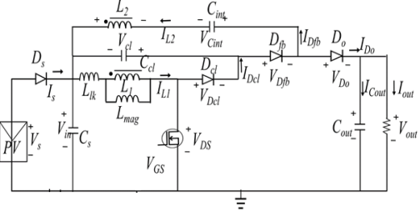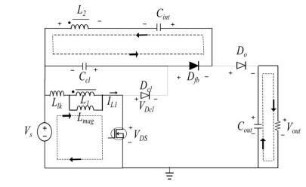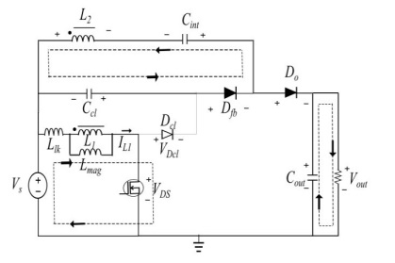
Figure 1. Novel converter (boost dc-dc) Mode I , Mode II operation of the novel converter
Where in L₁ and L₂ are inductances (primary and secondary) of a connected inductor. Passive clamp recovery of L₁ is denoted by C_{cl} and D_{cl}. The output capacitor is C_{out}, and the output diode is D_{o}. V_{out} is the voltage across the load. On secondary side, the buffer capacitor C_{int} and diode D_{fb} are connected.
Gain ratio (n) is given by n = VL2/VL1 (1)
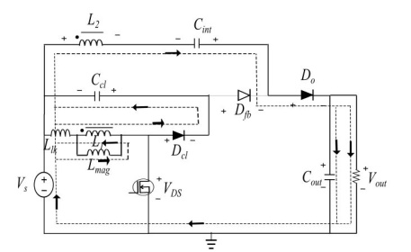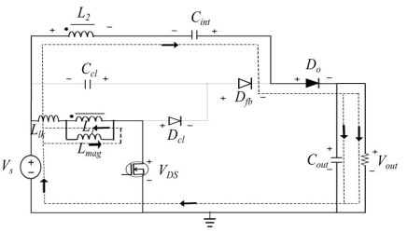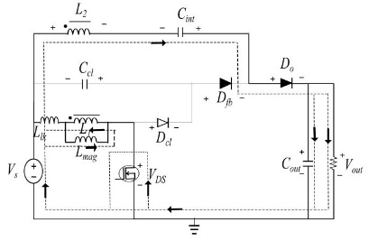
Figure 2 . Mode III Mode IV and Mode V operation of the novel converter (boost dc-dc)
In mode-I, as in Fig 1, MOSFET switch is kept on, current passes by means of switch and coupled inductor primary winding (L₁), energizing coupled inductor’s magnetizing inductance (L_{mag}). D_{cl} and D_{o} are reverse biased in this mode, while D_{fb} is forward biased. L₂ and C_{cl} charges the intermediate capacitor C_{int} through D_{fb}. D_{fb} switches off when the voltage across C_{int} equals the sum of the voltages across L₂ and C_{cl}.
In mode-II, as shown in Fig 1 ,the magnetizing current flowing through the primary inductor L₁ charges the switch parasitic capacitance. The feedback diode D_{fb} remains in forward bias, current flows through supply, inductance (magnetizing) and parasitic capacitance of MOSFET switch.
Diodes D_{cl} and Do become forward biased in mode-III. D_{fb} is reverse biased. The primary side coupled inductor (L1) leakage energy is collected through D_{cl}. and stored in the C_{cl}. Furthermore, as illustrated in Fig 2. Mode-IV begins after the leakage energy from coupled inductor L₁ has been fully recovered. While diode D_{cl} gets reverse biased, diode D_{o} remains forward biased. Current flows from input to the load side through inductor L₂, intermediate capacitor C_{int}, and then to the load .
Mode-V as seen in Fig 2, the magnetizing current energizes the leakage inductor, while the switch parasitic capacitance discharges. Diodes, D_{cl} and D_{fb}, both are reverse biased. When the output diode D_{o} gets reverse biased and current direction through inductor L₂ reverses, this mode ceases shown below inFig2.
The converter's mathematical analysis is required in order to design the components that would be employed in its construction. All of the converter's components are considered to be ideal.
During switch on state:
$V_{L1}=V_{S}$ (1)
$V_{L2} =V_{Cint}-V_{Ccl}$ (2)
As per gain ratio, $V_{L2}=nV_{S}$

During switch off state:
$V_{L1\left(off\right)}=-V_{Ccl}$ (3)
Applying KVL in mode 3 gives $V_{L2}=V_{S}+V_{Cint} –V_{out}$ (4)

By substituting V_{Cint} from (3),(4),
$$V_{L2}=V_{S}+nV_{S}+V_{Ccl}-V_{out}$$
$V_{L2}=V_{S} + nV_{S} –V_{L1\left(off\right)} – V_{out}$ (5)
From gain ratio, $V_{L1}=\frac{V_{L2}}{n}$ (6)
By substituting (6) into (7),
$$V_{L1\left(off\right)}=\frac{(V_{s}-V_{L1\left(off\right)}+nV_{s}-V_{out})}{n}$$
$=\frac{(V_{s}+nV_{s}-V_{out})}{(n+1)}$ (7)
Voltage gain:
Across primary inductor L1, on applying voltage-second balance, we get:
$$V_{L1\left(on\right)}. d+V_{L1\left(off\right)}.\left(1-d\right)=0$$
Substituting (2) and (8) in above equation, we get
$$V_{s}.d+ \frac{\left(V_{s}+nV_{s}-V_{out}\right)}{\left(n+1\right)}\left(1-d\right)=0$$
$$\frac{V_{out}}{V_{s}}= \frac{n+1}{1-d} (8)$$
Where d = duty ratio, n= gain ratio
A turns ratio is chosen for an input and output voltage requirement, and the duty ratio be computed using equation (9).
The magnetizing inductance value $L_{mag}= \frac{1}{2}*\frac{V_{s}*d}{∆I_{mag}*f_{s}}$ (9)
The minimum value of the clamp capacitor $C_{cl}= \frac{I_{mag}*d_{lk}}{∆V_{ccl}*f_{s}}$ (10)
The minimum value of the energy storage capacitor
$C_{int}= \frac{I_{mag}*d}{n*∆V_{cint}*f_{s}}$ (11)
The minimum value of the output capacitor
$C_{out}= \frac{I_{out}*d}{∆V_{o}*f_{s}}$ (12)
The minimum required value of output capacitance
$C_{out\left(min\right)}= \frac{∆I_{o}*xT_{s}}{0.01V_{o}}$ (13)
Where T_{s} hold-up time corresponding to load transient of $∆I_{o}$.

For V_{s} = 35V,V_{out} = 350V,n=4 :

From equation (8), $\frac{V_{out}}{V_{s}}= \frac{(n+1)}{(1-d)}$ ,We get d = 0.5
From equation (9), $L_{mag}> \frac{1}{2}*\frac{V_{s}*d}{∆I_{mag}*f_{s}}$, We get, $L_{mag}>48μH$
From equation (10),$C{}_{cl}= \frac{I_{mag}*d_{lk}}{∆V_{ccl}*f_{s}}$we get C_{cl} = 1µF
From equation (11),$C_{int}= \frac{I_{mag}*d}{n*∆V_{cint}*f_{s}}$we get C_{int} = 47µF
From equation (12),$C_{out}= \frac{I_{out}*d}{∆V_{out}*f_{s}}$ we get C_{out} = 180µF

TABLE 1 CONVERTER SPECIFICATIONS

Source dc voltage | 35V
Output voltage | 350V
Coupled inductor turns ratio | 4
Switching frequency | 50kHz
Coupled inductor | Magnetizing inductance  L_{mag} = 50$μ$H
Clamp capacitor | 1µF
Intermediate capacitor | 47 µF
Output capacitor | 180µF
With converter parameters as per Table 1, voltages across and current through capacitors, diodes and inductance are obtained as:
Reverse voltage across switch S is $V_{DS}= \frac{V_{s}}{(1-d)}$=70V,Reverse voltage across D_{cl} is $V_{dcl}= \frac{V_{s}}{(1-d)}$= 70V,Peak current through D_{cl} is $I_{dcl}= \frac{V_{ccl}*d_{lk}}{L_{1}*f_{s}}$ = 5.6A,Peak current through L_{mag} is $I_{Lmag}= \frac{V_{s}}{L_{mag}}*dT_{s}$ = 7A,Peak current through L₁ is $I_{L1}= \frac{n}{2}*I_{Lmag}$ = 14A,Reverse voltage across D_{fb} is $V_{dfb}=2nV_{s}$ = 280V
Peak current through D_{fb} is $I_{dfb}= \frac{\left(V_{cint}-V_{ccl}\right)*d}{n*L_{2}*f_{s}}$= 2.25A,Reverse voltage across D_{o} is $V_{do}= \frac{n}{\left(1-d\right)}V_{s}$ = 280V
Peak current through D_{o} is $I_{do}= \frac{\left(V_{out}-V_{ccl}-V_{s}\right)*(1-d-d_{l}k)}{n*L_{2}*f_{s}}$ = 1.5A,Voltage across C_{cl} is $V_{ccl}= \frac{d}{1-d}V_{s}$ = 35V
Voltage across C_{int} is $V_{cint}= \frac{d\left(1-n\right)+n}{(1-d)}V_{s}$ =175V.
The operation of the novel converter is compared with boost converter in terms of parameters given as per Table 2.But in practical application circuits, the inductor in conventional boost converter will not be perfectly inductive with zero internal resistance due to which the maximum operating duty ratio of the traditional boost converter will be restricted to (0.4-0.6). As a result, we can't operate at 0.9 duty cycle practically, and thus can't obtain large voltage gain using the traditional converter. The switch drop and switching losses obtained are high. So it causes high loss switching. Hence it is clear that the novel topology is superior in performance.
- GRID SYNCHRONIZATION
The following Fig 3 depict the complete block diagram of the system with synchronization and resistive load.[12].The grid current is sensed and converted into two orthogonal signals$I_{α}$,$I_{β}$ [14-18] by introducing a transport delay of 90°. $I_{α}=A \sin\left(ωt+ϕ\right) I_{β}=A \sin\left(ωt+ϕ-\frac{π}{2}\right)$
The signals are transformed to dq reference frame to get corresponding current signals by using parks transformation.$I_{dq}=\left[\begin{matrix}I_{d} \\ I_{q}\end{matrix}\right]=T I_{αβ}=\left[\begin{matrix}\sin{ωt} & -\cos{ωt} \\ \cos{ωt} & \sin{ωt}\end{matrix}\right]\left[\begin{matrix}I_{α} \\ I_{β}\end{matrix}\right]$
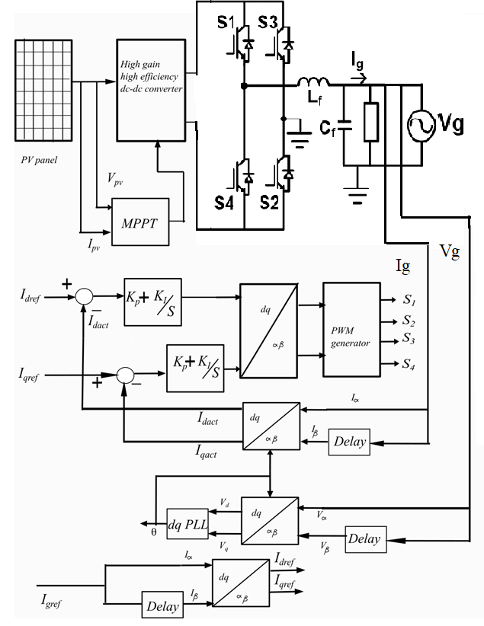

Figure 3. Proposed control scheme for management of power flow of a grid connected PV system

The grid voltage V_{g} is given as input to phase locked loop to get corresponding phase angle.
The actual current signals are compared with current signals obtained from the grid reference current [14-18]. The obtained errors are minimized using proportional-integral controllers. The output signals are transformed to stationary frame using inverse parks transform shown below.

$$I_{αβ}=\left[\begin{matrix}I_{α} \\ I_{β}\end{matrix}\right]=T^{-1}I_{dq}=\left[\begin{matrix}\sin{ωt} & \cos{ωt} \\ \cos{ωt} & -\sin{ωt} \end{matrix}\right]\left[\begin{matrix}I_{d} \\ I_{q}\end{matrix}\right]$$

The above output generates the required reference wave to the PWM generator and compared with carrier wave and generates the switching pulses and thus controls the output voltage of the full bridge inverter.

4. RESULTS AND DISCUSSION

The converter is analyzed in simulation with MATLAB/Simulink environment.
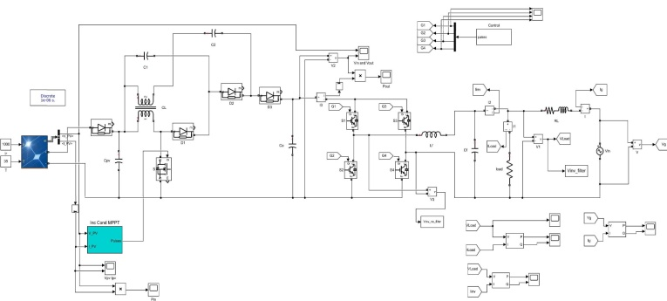

Figure 4. Simulation model of the overall system
The above Figure 4 shows the complete simulation model of the system with detailed descripted parameters in Table 3
TABLE 3 VALUES OF SIMULATION
Parameters | Their Values
Switching frequency | 5kHz
Couple inductor turns ratio | 4
Filter inductance | 1mH
Filter capacitor | 5 µF
AC peak voltage | 324V
Resistive load active power | 500W
Resistive load reactive power | 0 VAR
Module peak power | 240W
Open circuit module voltage(V_{oc}) | 51V
Short circuit module current(I_{sc}) | 6.3A
MPP voltage of module(V_{mp}) | 42.8V
MPP current of module(i_{mp}) | 5.6A
Peak power of array (P_{mp}) | 1200W
Open circuit array voltage(V_{oc}) | 51V
Short-circuit array current(I_{sc}) | 31.5A
MPP voltage of array(V_{mp}) | 42.8V
MPP current of array(I_{mp}) | 28.03A

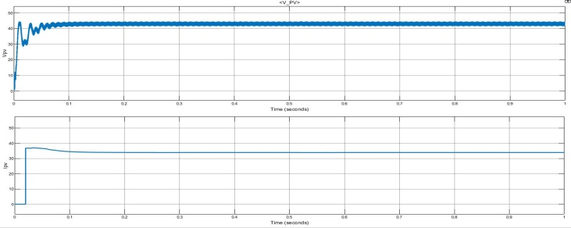

Figure 5. PV voltage current waveforms
The waveforms of current and voltage supplied by the PV array is shown in above Figure 5.
Outputs of switch voltage, Magnetizing current, voltage through diode and voltages of clamped capacitors during various operational modes are shown in Figure 6, Figure7 and Figure8

Efficiency at full load is obtained as 94% shown in Figure 9 below.

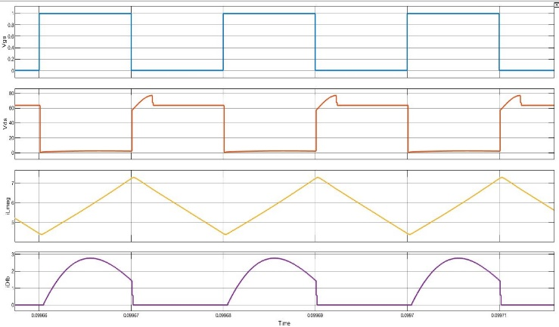 | 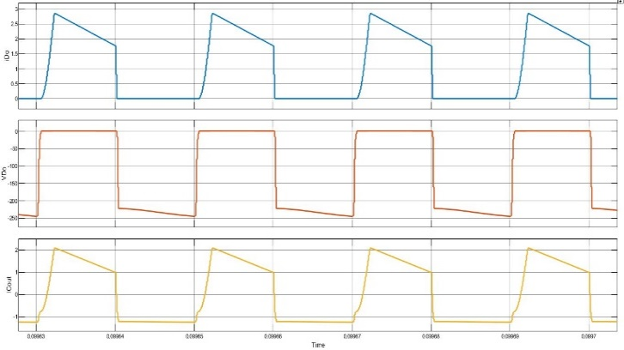
Figure 6. Waveforms of (a) Gate to switch voltage (b) Switch voltage (c) Magnetizing current (d) Current through feedback diode | Figure 7. Waveforms of (a) Current through output diode (b) Voltage across output diode (c) Current through output capacitor
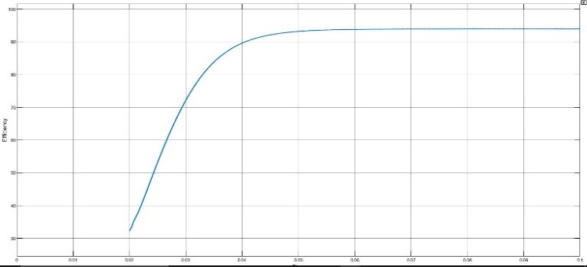
Figure 8. Waveforms of (a) Voltage of clamp diode Figure 9. Efficiency of novel dc-dc converter
(b) Voltage of intermediate capacitor
(c) Voltage of clamp capacitor

Design of LC filter
Filter inductance is designed based on limiting ripple in load current to 20 % of the rated current.
$L=\frac{V_{dc}}{4f_{sw}∆I_{ppmax}}$ = 1mH
Under rated condition, the reactive power that can be absorbed must be restricted to 5% of rated power, therefore filter capacitance is calculated accordingly.
$$Q=\frac{V^{2}}{X_{c}}=V^{2}.2πfC$$
$C=5$ µF

TABLE 4 THD BEFORE AND AFTER LC FILTER
 | THD
Before filter | 52.08%
After filter | 4.62%

By employing the filter, square wave output wave of inverter is converted to nearly sinusoidal signal and higher order harmonics are eliminated. THD obtained is 4.62%, FFT analysis is presented below in Fig 10 and Figure 11.
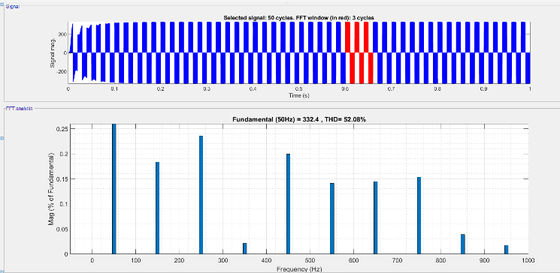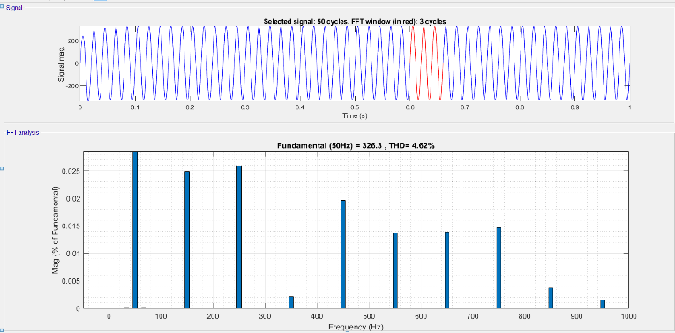
Figure 10. THD of voltage waveform without Figure 11. THD of voltage waveform with LC filter
LC filter

The system is tested during both light load and overload conditions. During light load conditions, the excess power output form the inverter is fed to grid and hence the grid power appears as negative in the waveform. During overload conditions, the inverter supplies a portion of the load's required power, while the grid supplies the remaining active power, as indicated below in Figure18, Figure 12 and Figure 13.

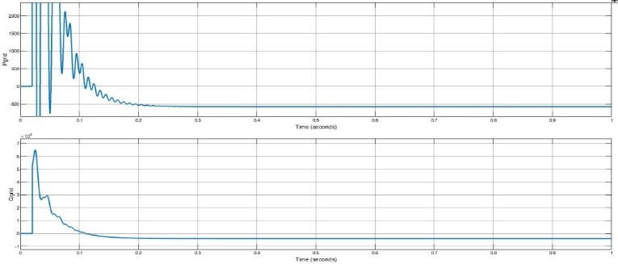 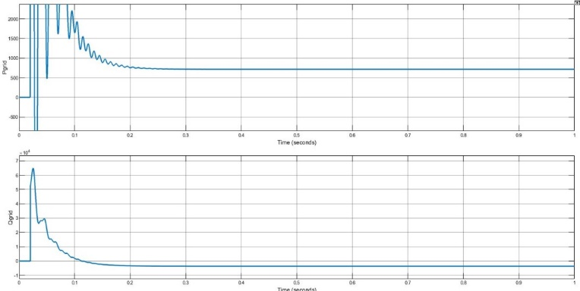Figure 12. Power injected to grid (Light load conditions) Figure 13.Power injected by grid to load(Over load
Conditions)
5. CONCLUSION
Novel converter with large gain implemented for low and medium-voltage source applications. High gain is obtained at lower duty cycles with minimum switching is obtained. The efficiency of dc-dc converter at full load is obtained as 94 %. Output voltage, diode currents and voltages, capacitor voltages are calculated. The converter is fed to a single phase full bridge inverter, which is then connected to the grid. The system is synchronized to grid by using d-q axis current control. The switching pulses to inverter are obtained from pulse generator based on d-q axis control. Waveforms of Output voltages and power of R load with and without LC filter are observed at light load and overload conditions and THD is seen. PV-Source with Incremental Conductance Method is used as input to novel high gain boost converter using d-q axis Controller and all required characteristics are observed. The proposed converter's performance is verified in a simulation environment, and the findings are presented.

REFERENCES

[1] J. H. Lee, T. J. Liang and J. F. Chen, " Isolated Coupled-Inductor-Integrated DC–DC Converter with Non dissipative Snubber for
Solar Energy Applications," IEEE Trans. Ind. Electron., vol. 61, no. 7, pp.3337-3348, July 2014.
[2] M. Prudente, L. L. Pfitscher, G. Emmendoerfer, E. F. Romaneli and R.Gules, "Voltage Multiplier Cells Applied to Non-Isolated
DC–DC Converters," IEEE Trans. Power Electron.,vol. 23, no. 2, pp. 871-887,Mar. 2008.
[3] P. Xuewei and A. K. Rathore, " Novel Bidirectional Snubberless Naturally Commutated Soft-Switching Current-Fed Full-Bridge
Isolated DC/DC Converter for Fuel Cell Vehicles," IEEE Trans Ind. Electron., vol. 61, no. 5, pp. 2307-2315, May 2014.
[4] F. Witulski, “Introduction to Modeling of Transformers and Coupled Inductors,” IEEE Trans.Power Electronics, vol. 10, no. 3,
May 1995.
[5] J. Xu, “Modeling and analysis of switching DC-DC converter with coupled-inductor,” IEEE CICC, pp. 717-720, May 1991.
[6] F. S. Garcia, J. A. Pomilio and G. Spiazzi, "Modeling and Control Design of the Interleaved Double Dual Boost Converter," IEEE
Trans.Ind. Electron., vol. 60, no. 8, pp. 3283-3290, Aug. 2013 .
[7] A. D. Dwivedi, G. Srivastava, S. Dhar, and R. Singh, “A decentralized privacy-preserving healthcare blockchain for IoT,” Sensors, vol. 19, no. 2, pp. 1–17, 2019, doi: 10.3390/s19020326.
[8] K. C. Tseng and C. C. Huang, "High Step-Up High-Efficiency Interleaved Converter With Voltage Multiplier Module for
Renewable Energy System," IEEE Trans. Ind. Electron., vol. 61, no. 3, pp.1311-1319, Mar. 2014.
[9] S. Lee, P. Kim and S. Choi, “High step-up soft-switched converters using voltage multiplier cells,” IEEE Trans. Power Electron.,
vol. 28,no. 7, pp. 3379-3387, Jul. 2013
[10] Y. P. Hsieh, J. F. Chen, T. J. Liang and L. S. Yang, "Novel High Step-Up DC-DC Converter for Distributed Generation System,"
IEEE Trans. Ind. Electron., vol. 60, no. 4, pp. 1473-1482, April 2013.
[11] M. Das and V. Agarwal, "A novel, high efficiency, high gain, front end DC-DC converter for low input voltage solar photovoltaic
applications," IEEE IECON,pp.5744-5749, Oct. 2012
[12] B.Sirisha, Akshay Kapil Gajoju, “A Grid interconnected five level inverter for voltage synchronization using SRF controller and
SVPWM with photo voltaic application,International Journal of Research and Analytical Reviews, vol 8,.Issue 3,July 2021.
[13] M. Das and V. Agarwal, “Design and Analysis of a HighEfficiency DC– DC Converter With Soft Switching Capability for
Renewable Energy Applications Requiring High Voltage Gain,” IEEE Trans. Ind. Electr, vol. 63, no. 5, may 2016.
[14] B. Crowhurst, E.F.El-Saadany, L.El.Chaar and L.A. Lamont,“Single-Phase Grid-Tie Inverter Control Using DQ Transform for
Active and Reactive Load Power Compensation,”IEEE International Conference on Power and Energy (PECon2010), Nov 29Dec
1, 2010.
[15] R. Zhang, M. Cardinal, P. Szczesny, and M. Dame, “A grid Simulator with Control of Single-Phase Power Converters in D-Q
Rotating Frame,” Power Electronics Specialists Conference,Vol. 3, pp. 1431-1436, 2002.
[16] B. Shitole, H. M. Suryawanshi, , G. G. Talapur, Shelas Sathyan, M. S. Ballal,V. B Borghate, M. R. Ramteke and M. A.
Chaudhari,“Grid Interfaced Distributed Generation System with Modified Current Control Loop Using Adaptive
Synchronization Technique,” IEEE Transactions On Industrial Informatics, Jan 2017.
[17] Akansha Hota, Sujit Kumar ,Bhuyan,Prakash Kumar Hota,“ Modeling & Simulation of Photovoltaic System Connected to Grid
using Matlab,” ICREISG, February 2020.
[18] Iwan Setiawan , Mochammad Facta , Hermawan , Trias Andromeda, Mauridhi Hery Purnomo, Taufik,“Sinusoidal Current
Control Strategies for Single Phase Grid-Connected Renewable Power Generation Systems,” 7th Int. Conf. on Information Tech.,
Computer, and Electrical Engineering ICITACEE),2020.

BIOGRAPHIES OF AUTHORS

 | B. Sirisha She holds a B.E. in Electrical Engineering from Osmania University, M. Tech Power Eelectronics from JNTUH in 2003, and a Ph.D. degree from Osmania University 2018. She has over 16 years of experience in research and teaching and is currently employed as an Associate Professor in Electrical Department, Engineering College, Osmania University, Hyderabad, INDIA. She has published various articles in international and national journal publications and conferences. Multilevel Inverters, Power Electronics and Drives, Renewable Energy Applications and Special Electrical Machines are among her research interests. Osmania University awarded her a Ph.D. in the field of multilevel inverters.
 | S.Akhilesh He holds a B.E. in Electrical Engineering from Osmania University.He is currently persuing M.E. in Industrial Drives and Control from University College of Engineering (A), Osmania University, Hyderabad, Telangana, India.

