Diabetes tracking panel: an on-line information system to registration and management

Dixon Salcedo¹, Albeiro Cortes², Edgardo Sanchez-Montero³, Carlos Henriquez⁴, Leidy Martes⁵
¹Computer Science and Electronics Department, Universidad de la Costa, Barranquilla, Colombia
²Electronic Engineering Department, Universidad SurColombiana, Neiva, Colombia
³Humanities Department, Universidad de la Costa, Barranquilla, Colombia
⁴System Engineering Program, Universidad Autónoma del Caribe, Barranquilla, Colombia
⁵System Engineering Program, Universidad de la Costa, Barranquilla, Colombia

Article Info |  | ABSTRACT (10 PT)
Article history:  Received month dd, yyyy  Revised month dd, yyyy  Accepted month dd, yyyy |  | Online hospital information systems enable health care providers to ensure the integrity and readability of patient information and make it available at any point of care. Although nowadays there are great technological advances; in Colombia, the impact on the health sector has been low. As a result, there is an increasing deficiency in cities with less access to new technologies. Therefore, it is necessary for the government and health care providers to join efforts to expand the use of information technologies in the health area to improve the overall quality of the service provided.  Therefore, this project implements an information system to optimize the management the diabetes tracking panel tests in Huila's hospitals to improve the organization of results; and thus, make access timelier and more efficient. The designed information system is based on the HL7-FHIR standard (Health Level 7 - Fast Healthcare Interoperability Resources). As a result, we designed and implemented a system that uses technologies such as Java, MySQL, Java, CSS3, HTML5, among others. Finally, we concluded that the proposed information system can minimize execution times and facilitate the management of the comprehensive metabolic panel tests by the team of medical assistants when a patient's results have been elaborated.
Keywords:
Diabetes tracking System
Health care
HL7-FHIR
Information system
Web services
This is an open access article under the CC BY-SA license.

Corresponding Author:
Phakkharawat Sittiprapaporn
Neuropsychological Research Laboratory, Department of Anti-Aging and Regenerative Science
School of Anti-Aging and Regenerative Medicine, Mae Fah Luang University
Bangkok, Thailand
Email: wichian.sit@mfu.ac.th

- INTRODUCTION
Diabetes is a chronic disease in which the body cannot regulate the amount of sugar in the blood. Insulin is a hormone produced by the pancreas to control blood sugar. Diabetes can be caused by too little insulin production, insulin resistance or both [1]–[4].
On the other hand, to understand diabetes, it is important to first understand the normal process by which food is transformed and used by the body for energy. Also, when food is digested, several things happen that are shown below:
- A sugar called glucose enters the bloodstream. Glucose is a source of energy for the body.
- An organ called the pancreas makes insulin. The role of insulin is to move glucose from the bloodstream into muscle, fat, and liver cells, where it can be stored or used for energy.
On the other hand, people with diabetes have high blood sugar levels because their body cannot move the sugar from the blood into the muscle and fat cells to burn or store it as energy, and because the liver makes too much glucose and secretes it into the blood. There are three reasons for this:
- The pancreas does not produce enough insulin.
- Cells do not respond normally to insulin.
- Both above reasons.
It is important to explain that there are two main types of diabetes; the causes and risk factors are different for each type [5]–[8]:
Type 1 diabetes: it can occur at any age, but is most often diagnosed in children, adolescents, or young adults. It can occur at any age, but is most often diagnosed in children, adolescents, or young adults. In this disease, the body produces little or no insulin, and it occurs because the cells in the pancreas that produce insulin stop working .
Type 2 diabetes: more common than Type 1, it usually occurs in adulthood, but due to high rates of obesity, children and adolescents are now being diagnosed with this disease. Also, some people with type 2 diabetes do not know they have the disease. Therefore, with type 2 diabetes, the body is resistant to insulin and does not use it as effectively as it should.
On the other hand, there are other causes of diabetes, and some people cannot be classified as type 1 or 2. Additionally, in prenatal diabetes, high blood sugar occurs at any time during pregnancy in a woman who does not have diabetes.
Finally, it is important to add that at the hereditary level, if a parent, brother, or sister has diabetes, you may be more likely to have the disease.

1.1. Symptoms of diabetes
In general, some symptoms of diabetes, begin when a person has high blood sugar, they may have a variety of symptoms, for example [9]: blurred vision, excessive thirst, fatigue, frequent urination, Hunger, Weight loss. Also, Type 2 diabetes develops slowly; and some people with high blood sugar levels have no symptoms. On the other hand, the symptoms of Type 1 diabetes develop in a short period of time. People can be very sick by the time they are diagnosed.

1.2 Tests and examinations
A urine test may show high levels of blood sugar. But a urine test alone does not diagnose diabetes. Your health care provider may suspect that you have diabetes if your blood sugar level is more than 200 mg/dl (11.1 mmol/L). To confirm the diagnosis, one or more of the following tests should be done.

1.3. Blood tests
Fasting blood glucose. Diabetes is diagnosed if the fasting glucose level is greater than 126 mg/dl (7.0 mmol/L) on two different tests. Levels between 100 and 126 mg/dl (5.5 and 7.0 mmol/L) are called impaired fasting glucose or pre-diabetes. These levels are risk factors for type 2 diabetes.
On the other hand, as computer systems evolved, information systems appeared that were capable of presenting reports related to the health of each patient, statistics on the data obtained from the examinations carried out, as well as the medicines and treatments formulated by the doctors. Examples of these systems are Care2x (Open-Source Hospital Information System), first published in 2002 by Elpidio Latorilla, and the Mexican Government's Hospital Management Information System (SIGHO), which began only in 2005 [10]. The technology mentioned above is currently being implemented in the Department of Huila, so this work can be considered an initial contribution to innovation in the area.
In relation to the above, this article presents the design and implementation of an information system for recording, organizing, and analyzing the results of diabetes tracking panel tests in hospitals of the Department of Huila. Likewise, the main objective of the work is to create a (Hospital Information System) that allows to store the data of patients, medical personnel, and laboratory personnel so that they can register, consult, or authorize the results of the diabetes tracking panel tests. Therefore, the data can be fed into the Hospital's local area network as well as from any remote computer or device (Smart phone or Tablet) connected through the Internet. It is also important to note that the design of the HIS follows the guidelines of the HL7-FHIR standard, which is the most widely used worldwide, ensuring easy interoperability (compatibility and data migration) with other hospital information systems using the same standard.

- RELATED WORKS
In the world there are many diseases; however, diabetes is a disease with which clinical aspects are related to: cardiovascular accidents [11], Cerebral [12], [13], and today it is associated with mortality generated by COVID-19 [14]-[16]. Therefore, it is important to prevent, diagnose and treat diabetes [17], [18].

In relation to the above, several solutions have been developed based on technological solutions, which address different aspects of the diagnosis and treatment of diabetes. In [19], the authors created something they call "Dital Twin", which allows to personalize food consumption in people with genetic predisposition to diabetes; that based on neural networks can create a food model for each person. Also, in [20]a digital platform based on "Self-Management" is introduced, which helps patients with diabetes to monitor the disease. The platform has been co-designed and co-developed jointly by patients and physicians, based on the principles of design science (DSRM).
Moreover, authors have used disease prediction and classification techniques for diabetes. For example, researchers presented a paper that has mixed two learning algorithms (Ada Boost and Random Forest) for feature selection, which used the "Decision Tree" classifier to classify healthy and diabetic people. Also, they performed a statistical analysis that showed that the proposed method effectively detected diabetes and can be implemented in e-healthcare environments [21]. Likewise, an integrated approach of Farthest First (FF) clustering algorithm and Sequential Minimal Optimization (SMO) classifier to diagnose Diabetes mellitus (DM) is presented in [22]. This work used a dataset of 768 diabetic patient samples taken from Pima Indians Dataset; where, the results showed that the proposed integrated approach achieves a classification accuracy of 99.4% to predict DM. Finally, there are other research using Data Mining and Machine learning techniques to do classification and prediction of diabetes disease [23]-[25].
Finally, the different efforts of the research community to design and implement technological solutions to improve the processes to prevent, diagnose, and treat diabetes are evident. However, many solutions are tailor-made for specific contexts; therefore, it is necessary to have access to a scalable, multiplatform, and customizable tool that can be implemented in any context of the clinical area for the disease.

- METHODOLOGY
Developing develop the SIH, different stages were made, such as Design, implementation and start-up which was done through tests to the platform.

2.1. General design of the platform
Initially, Figure 1 presents the design of the general scheme of the described system that is proposed. This design has a MySQL database where the data is stored, the Web Server that delivers the pages carrying out the control of the platform, and the Clients that request the connection; the Web Clients can request the server to send pages from any device with a Web browser and Internet connection such as desktop computers, laptops, tablets, or smartphones.
In the stages of the project development process, first the database is designed taking the variables and records necessary for the proper functioning of the system; then the control and service of the web pages through the server is defined along with the visual design of the pages that are delivered. The system considers the HL7-FHIR standard for sending medical information, so that tools like MirthConnet can access the information using their connection protocols based on the standard.

2.1.1. The HL7-FHIR standard
HL7-FHIR (Health Level 7 - Fast Healthcare Interoperability Resources) is a standard that describes the "resources", data formats and elements for the exchange of electronic health records (EHR). The standard was created by the international health standards organization HL7. One of the goals of HL7-FHIR is to facilitate interoperability between different health care systems, to make it easy to provide health care information to health care providers and individuals on a wide variety of devices, from computers to tablets to cell phones, and to allow third-party application developers to develop medical applications that can be easily integrated with existing information systems. HL7-FHIR is relatively easy to implement because it uses a modern web-based technology suite, including RESTful, HTML and cascading style sheets (CSS) for user interface integration, a choice of JSON or XML for data representation and OAuth for authorization [26].
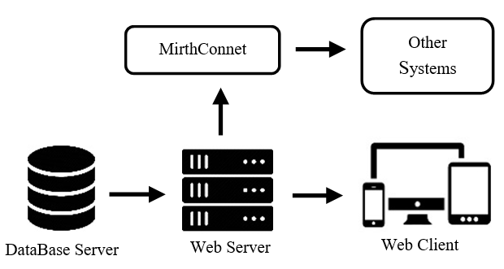
Figure 1. Interoperability system diagram

However, the interoperability with information systems that use different technology to represent data, such as XML or others, can be achieved through a management tool for integrating multiple health information systems, such as MirthConnect. It is important to emphasize that this work is part of a more ambitious project for the Department of Huila, which aims to systematize the entire health area, so that interoperability between different health information systems must be guaranteed.
Additionally, the JSON standard was used for data representation; allowing interoperability and portability with other information systems using this same technology for the exchange of EHRs will be simple and guaranteed. However, interoperability with information systems that use a different technology to represent the data, such as XML or others, can be achieved through a management tool for integrating multiple health information systems, such as MirthConnect. It is important to emphasize that this work is part of a more ambitious project for the Department of Huila, which aims to systematize the entire health area, so that interoperability between different health information systems must be guaranteed like these implementations [27], [28].

2.2. Development technologies
Several free software tools of the OpenSource type (like JAVA) were used for the development of the SIH [29], which are described below:

2.2.1. Development environment
Spring Tool Suite: version: 3.8.4. RELEASE, Build Id: 201703310825, Platform: Eclipse Neon.3 (4.6.3), JavaSE-1.8 (jre1.8.0_121)
Database: MySQL Workbench 6.3.8 build 1228 CE (64 bits) Community, TCP port for database is MySQL:3306
Application server: Apache Tomcat 8.5.14.

2.2.2. Programming languages
To implement the information system, software development tools were used, such as:
HTML5: organizes the parameters for tagging the structure of the HTML page, CSS3 builds the appearance of the page for an interesting visual style and JS allows the construction of page functions on the client to avoid loading on the server.
JAVA SPRING: Spring is an open-source application development framework and control inversion container for the Java platform. It is used to control pages and develop application services.
Bootstrap v4.0.0-alpha.6: framework that facilitates web design adaptable to different devices using responsive design.
Font Awesome: this library contains a compilation of icons to give more visual style to the pages.
javax.mail version 1.4.7: allows the sending of mail messages from the server to users. It is used to send an email to the user when requesting a password recovery.
Mysql conector version 5.1.39: library for controlling connections to the MySQL database from java.
HTML, CSS, and JS: to the handling of view and script functions on the client. HTML5 organizes the parameters for the tagging of the HTML page structure, CSS3 builds the page appearance for interesting visual styling and JS allows the construction of page functions on the client to avoid server load.
JAVA SPRING: Spring is an open-source application development framework and investment control container for the Java platform. It is used for page control and development of application services.

2.3. Implementation

2.3.1 Database server
MySQL is the most popular open-source database over the world, making it a reliable and secure option as this developed solution, this DataBase system was used in recent works in [30], [31]. In addition, it has features such as high scalability, ease of use, high performance among others, making it the ideal choice for information system needs.
Initially, the table that stores information about users is defined. Also, then a session table, and finally another one that stores the information corresponding to the tests of the diabetes tracking panel. Therefore, in Figure 2, the database diagram described above can be presented. Consequently, for the User and Exam tables, the fields are constructed in JSON format using the HL7 standard. Below is a description of the fields of each implemented table:
User: stores the information corresponding to the users of the platform.
Roles: table of many to many relationships between the user table and the role table that contains the user roles.
role: Table containing the platform's user roles, the fields in this table are:
ADMIN: role for the administrator.
PATIENT: role for the patient
PERSONAL: role for staff.
LAB: role for lab technician
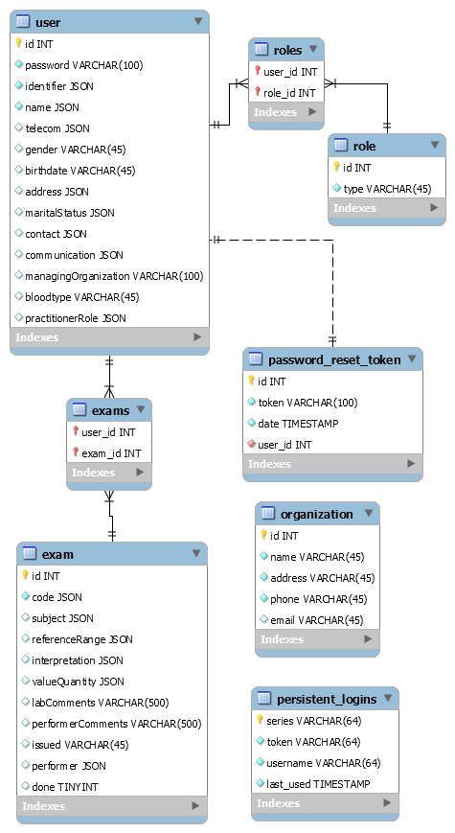
exams: multi-to-many relationships table between the user table and the exam table containing the user's exams.

Figure 2. Database Diagram

Exam: stores the information corresponding to the medical tests of the liver profile.
organization: table stored by the service provider.
persisten_logins: table that stores the sessions that are remembered in the browser.
According to the HL7 standard to fully describe the exam and its result the ReferenceRange, Interpretation and ValeQuantity fields should be included in the exam table. Therefore, the following is how it was implemented in this solution:
ReferenceRange: defines the reference range of the variable, this field is represented by the following variables. For the minimum value of the range: low-code: reference code of the variable, low-unit: unit of measure, low-value: measurement value, low-system: reference information of the variable. Also, for the maximum value of the range: high-code: variable reference code, high-unit: unit of measure, high-value: measurement value, high-system: reference information of the variable.
Interpretation: interpretation of the measured variable, this field is represented by the following variables: coding-code: reference code of the measurement status, coding-system: reference information of the variable, coding- display: measurement status description.
ValeQuantity: defines the measured value of the test variable. This field is represented by the following variables: code: variable reference code, unit: measurement unit, value: measured value of the variable, system: reference information of the variable.

2.3.2. Web Platform
The web platform allows users to perform functions for handling the information registered in the system, the Figure 3 shown the home page screen. The SIH allows four types of users, and they are defined below:
Administrator: it is registered through the website. It has the function of registering, modifying, or eliminating the other users of the platform.
Personal: he can see his basic information and modify his data, he also has access to the patient's data, which allows him to authorize the exams of the diabetes tracking panel and consult the history of exams.
Patient: you can see your personal information and modify your data. The platform allows you to consult the history of exams that were performed.
Lab technician: you can see your personal information, modify your data and the data of the entity that provides the laboratory services. The platform allows you to register the values given during the medical examination when it is authorized.

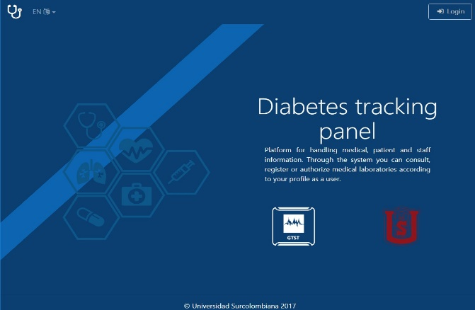
Figure 3. Home page view
In addition, the login system allows users to log in with their personal identification number and password; the platform can remember the user session and retrieve their password if they do not remember it, see Figure 4. Additionally, the platform supports English and Spanish languages.

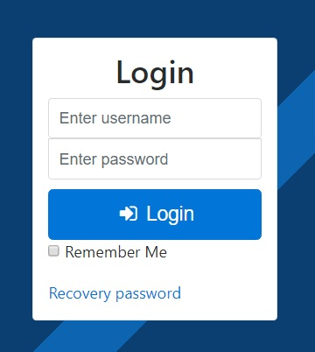
Figure 4. Login screen view.

Users can perform functions that are specific to each profile, in the Figure 5 we shown a platform view: Administrators can add, update, or remove any type of user, Medical staff users can view patient information and authorize tests, Patients can review their personal information and authorized tests, Labs are performed by labs that are authorized by medical staff.
In the same way, each user can update their personal information from the platform. Therefore, you must go to the administrator if you want to change the user's identity card number.
Figures 6(a) and 6(b) contains all the information that is stored for the user. The ID number and user roles can only be updated by the administrator, the other data can be updated from the platform by the user himself.

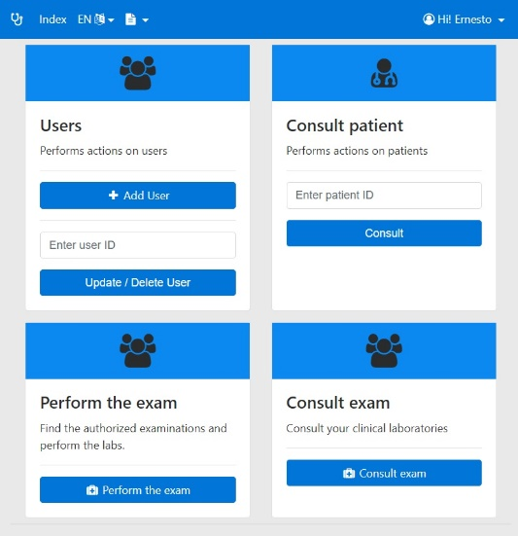
Figure 5. User profile home page.

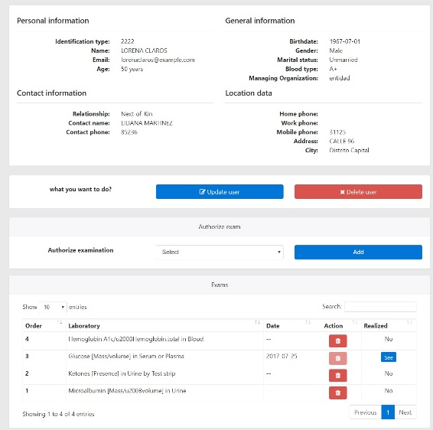
Figure 7. General user information.

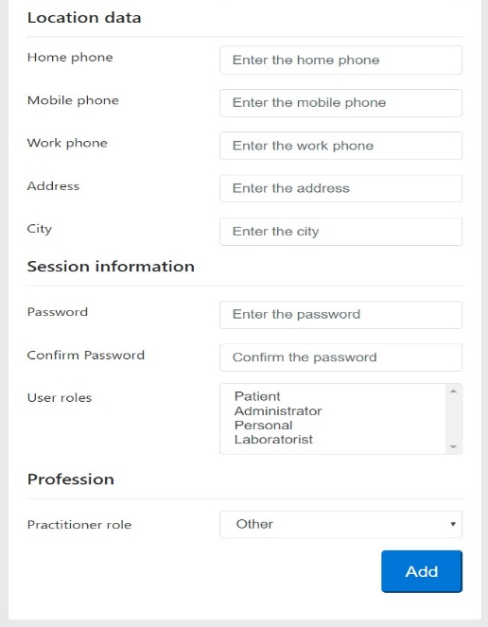
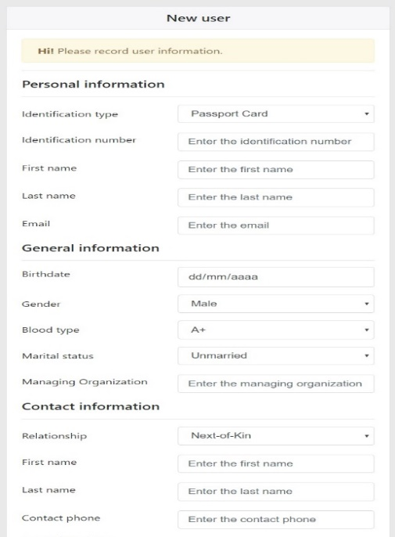

Figure 6(a). User form Figure 6(b). User form

Likewise, the identity card number and user roles can only be updated by the administrator, the other data can be updated from the platform by the user himself, see Figure 7.
In addition, a doctor can authorize the different tests and to do a consultation with his user. Then, after the test is authorized, the doctor can withdraw the authorization if it has not been carried out by the laboratory, see Figure 8.
Finally, the tests performed by the laboratory may be quantitative if a variable is measured or descriptive if only the presence of the compound in the sample needs to be determined.

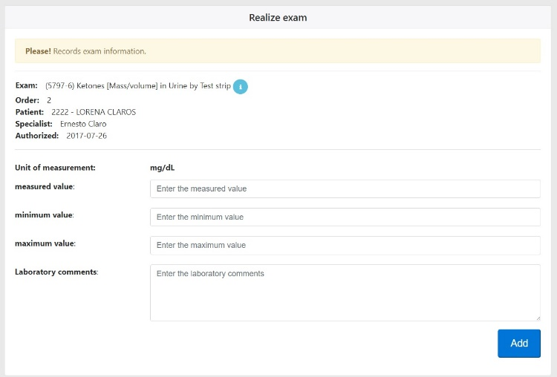
Figure 8. Quantitative test form.

- RESULTS
In general, the SIH developed allows patients, doctors, auxiliary personnel, and laboratory staff to enter information for the platform's interoperability.
On the other hand, each user role has different functions according to its profile. First the medical staff must authorize the tests to the patient; these authorized tests are waiting to be performed by the laboratory users. Therefore, if the test has not been performed, the medical staff can cancel the order issued. Similarly, when the laboratory staff performs the exam, they enter the data and the information is available for consultation by the staff or the patients, thus completing the process.
In addition, the platform allows the management the highest number of exams respect to the diabetes tracking panel (10, max value), and they are shown below:
1. Glucose [Mass/volume] in Capillary blood by Glucometer.
2. Glucose – lab.
3. Hours after meal [Time].
4. Hemoglobin A1c/Hemoglobin.total in Blood.
5. Glucose mean value [Mass/volume] in Blood Estimated from glycated hemoglobin.
6. Microalbumin [Mass/volume] in Urine.
7. Ketones [Presence] in Urine by Test strip.
8. Glucose [Mass/volume] in Urine by Test strip.
9. Calorie intake total 24 hour.
10. Date of last eye examination.
Another contribution of the implemented system is the data query because it facilitates patients and medical staff can see the results of the tests by accessing the profile of each patient, the user profile shows a table at the bottom of the page with the laboratories performed.

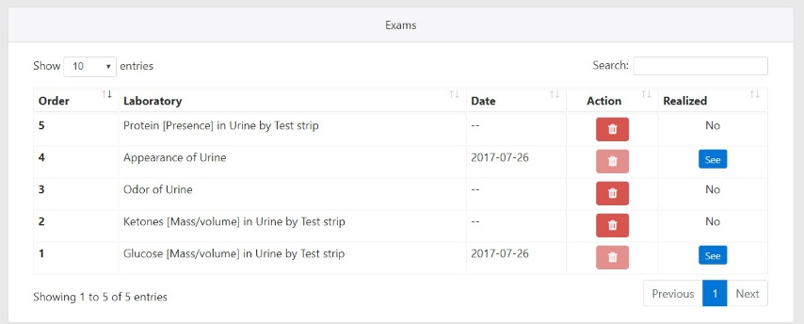
Figure 9. Patient information results

Consequently, in Figure 10, you can see the laboratory order made, which details the descriptive data of the test performed; and shows the type of laboratory, the range of measurement, the measured value, the unit of measurement, and the comments about the laboratory. Likewise, for non-quantitative examinations, the comments of the laboratory technician and the doctor about the presence of a chemical compound are shown.

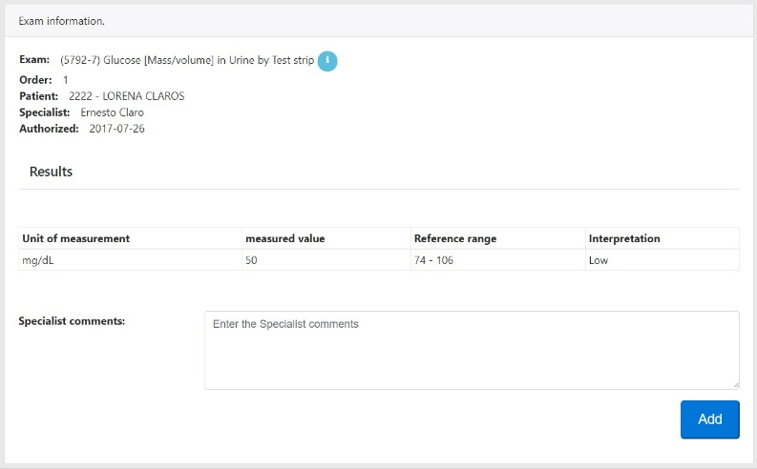
Figure 10. Test information

Besides this, the interconnection of the HIS with other information systems is ruled out, once it has been implemented, the HIS goes into operation, is enabled to communicate with any other health information system that supports the HL7-FHIR standard and packages the data using the JSON standard. This can be easily achieved by establishing channels between this system and any other system that meets the above requirement and by using Mirth Connect or a similar tool. Systems that package their data using XML or other technologies can also be supported with minor adaptations.
Finally, to consult additional information about the SIH; and also the project code, you can consult the following address: https://github.com/albecor/Medical_DiabetesTracking, where the following files can be found:
Database/EERDatabase.mwb: modelo de la base de datos.
Database/ScriptDatabase.sql: archivo script de la base de datos.
Javadoc/: contiene la documentación del API del proyecto
Research Project/: contiene el archivo de información de la investigación del proyecto.
User Manual/: contiene el manual del usuario de la aplicación web.
Web Application/medical_diabetes_tracking/: archivo de proyecto de la aplicación.
Web Application/medical_metabolic.war: archivo de despliegue de la aplicación para el servidor Tomcat.

- CONCLUSIONS
The implemented information system allows optimizing the communication between the agents involved in the authorization, execution, and publication of the tests for a patient in Huila's hospitals, reducing the execution time and facilitating the work of the medical staff when choosing treatments according to the specific condition of each patient. Consequently, the use of information technology must be intensified, through the development of projects that provide solutions to many of the problems or needs that afflict the Colombian health system.
It is important to emphasize that the information system presented in this work makes it possible to guarantee the integrity and readability of patient information and makes it possible for the information to be available to any entity (Patient, Medical Nurses, among others), at the time it is needed, regardless of where it is located, and independent of the institution providing health services that needs it.
Finally, it should be noted that according to the World Health Organization - WHO, if better information is available, better decisions will be made and the population will be able to have better health; this is what justifies the need for more robust HIS for Huila's hospitals.

ACKNOWLEDGEMENTS (10 PT)
We thank the Universidad Surcolombiana for allowing and support the development of this project.

REFERENCES
[1] I. Kojta, M. Chacińska, and A. Błachnio-Zabielska, “Obesity, Bioactive Lipids, and Adipose Tissue Inflammation in Insulin Resistance,” Nutrients 2020, Vol. 12, Page 1305, vol. 12, no. 5, p. 1305, May 2020, doi: 10.3390/NU12051305.
[2] W. Ling, Y. Huang, Y. M. Huang, R. R. Fan, Y. Sui, and H. L. Zhao, “Global trend of diabetes mortality attributed to vascular complications, 2000–2016,” Cardiovascular Diabetology, vol. 19, no. 1, Dec. 2020, doi: 10.1186/S12933-020-01159-5.
[3] K. Nørgaard, “Telemedicine Consultations and Diabetes Technology During COVID-19,” Journal of Diabetes Science and Technology, vol. 14, no. 4, pp. 767–768, Jul. 2020, doi: 10.1177/1932296820929378.
[4] Y. Zhou, J. Chi, W. Lv, and Y. Wang, “Obesity and diabetes as high-risk factors for severe coronavirus disease 2019 (Covid-19),” Diabetes/Metabolism Research and Reviews, vol. 37, no. 2, Feb. 2021, doi: 10.1002/DMRR.3377.
[5] M. J. Redondo et al., “The clinical consequences of heterogeneity within and between different diabetes types,” Diabetologia, vol. 63, no. 10, pp. 2040–2048, Oct. 2020, doi: 10.1007/S00125-020-05211-7.
[6] E. Abuelgasim, S. Shah, … B. A.-R. in, and undefined 2021, “Clinical overview of diabetes mellitus as a risk factor for cardiovascular death,” rcm.imrpress.com, 2021, Accessed: Dec. 05, 2021. [Online]. Available: https://rcm.imrpress.com/EN/Y2021/V22/I2/301
[7] E. Ahlqvist, R. Prasad, L. G.- Diabetes, and undefined 2020, “Subtypes of type 2 diabetes determined from clinical parameters,” Am Diabetes Assoc, 2020, doi: 10.2337/dbi20-0001.
[8] J. Wong, G. M.-C. J. of Diabetes, and undefined 2020, “Efficacy of depression management in an integrated psychiatric-diabetes education clinic for comorbid depression and diabetes mellitus types 1 and 2,” Elsevier, 2020, Accessed: Dec. 05, 2021. [Online]. Available: https://www.sciencedirect.com/science/article/pii/S1499267120301258?casa_token=1yi2PUrHAPwAAAAA:AWCWq1d6tXK_dGuil5Tx1P_8Km0tpX-D1a5FqL8roRYBzBJy0r9RbsHAaqPC2Lri-dDbyBBFMfvB
[9] Standards of medical care in diabetes, “8. Obesity Management for the Treatment of Type 2 Diabetes: Standards of Medical Care in Diabetes—2019 | Enhanced Reader,” 2019.
[10] NextGen Healthcare, “Healthcare Integration Engine | Mirth® Connect by NextGen Healthcare,” 2018. https://www.nextgen.com/products-and-services/integration-engine (accessed Dec. 05, 2021).
[11] A. Avogaro, F. Barillà, F. Cavalot, A. C.- Nutrition, undefined Metabolism, and undefined 2021, “Cardiovascular risk management in type 2 diabetes mellitus: A joint position paper of the Italian Cardiology (SIC) and Italian Diabetes (SID) Societies,” Elsevier, 2021, Accessed: Dec. 05, 2021. [Online]. Available: https://www.sciencedirect.com/science/article/pii/S0939475321001009?casa_token=FGcz2n3iikQAAAAA:sxrboIHdSyeAEF-jbEeiA06ZFoqd8FlM_n4Hk4z7NUVzh-LgIUiBcDJ9BVuzHmQgTNjFPAYRYutt
[12] C.-H. Tseng, “Metformin and Risk of Malignant Brain Tumors in Patients with Type 2 Diabetes Mellitus. Biomolecules 2021, 11, 1226,” mdpi.com, 2021, doi: 10.3390/biom11081226.
[13] O. Rozanska, … A. U.-I. journal of, and undefined 2020, “Brain-derived neurotrophic factor and diabetes,” mdpi.com, doi: 10.3390/ijms21030841.
[14] Z. T. Bloomgarden and C. T. Zachary Bloomgarden, “Diabetes and COVID‐19,” covid-19.conacyt.mx, 2020, doi: 10.1056/NEJMoa2001017.
[15] S. Peric and T. M. Stulnig, “Diabetes and COVID-19: Disease—Management—People,” Wiener Klinische Wochenschrift, vol. 132, no. 13–14, pp. 356–361, Jul. 2020, doi: 10.1007/S00508-020-01672-3.
[16] Z. hong Wu, Y. Tang, and Q. Cheng, “Diabetes increases the mortality of patients with COVID-19: a meta-analysis,” Acta Diabetologica, vol. 58, no. 2, pp. 139–144, Feb. 2021, doi: 10.1007/S00592-020-01546-0.
[17] A. Mohammadinejad, M. Heydari, R. Kazemi Oskuee, and M. Rezayi, “A Critical Systematic Review of Developing Aptasensors for Diagnosis and Detection of Diabetes Biomarkers,” Critical Reviews in Analytical Chemistry, 2021, doi: 10.1080/10408347.2021.1919986.
[18] B. A. Lipsky et al., “Guidelines on the diagnosis and treatment of foot infection in persons with diabetes (IWGDF 2019 update),” Wiley Online Library, vol. 36, no. S1, Mar. 2020, doi: 10.1002/dmrr.3280.
[19] A. Vaskovsky, … M. C.-2020 4th S., and undefined 2020, “Creation of digital twins of neural network technology of personalization of food products for diabetics,” ieeexplore.ieee.org, 2020, Accessed: Dec. 05, 2021. [Online]. Available: https://ieeexplore.ieee.org/abstract/document/9216776/
[20] S. Joachim, P. Prakash Jayaraman, A. Rahim, M. Forkan, A. Morshed, and N. Wickramasinghe, “Design and Development of a Diabetes Self-Management Platform: A Case for Responsible Information System Development,” scholarspace.manoa.hawaii.edu, 2021, Accessed: Dec. 05, 2021. [Online]. Available: https://scholarspace.manoa.hawaii.edu/handle/10125/71075
[21] A. U. Haq et al., “Intelligent machine learning approach for effective recognition of diabetes in E-healthcare using clinical data,” mdpi.com, vol. 20, 2020, doi: 10.3390/s20092649.
[22] R. Devi, A. Bai, N. N.-O. Medicine, and undefined 2020, “A novel hybrid approach for diagnosing diabetes mellitus using farthest first and support vector machine algorithms,” Elsevier, 2020, Accessed: Dec. 05, 2021. [Online]. Available: https://www.sciencedirect.com/science/article/pii/S2451847619300727?casa_token=c3RF_p0TWIkAAAAA:jIRBGSl112DbxBBIARXMWUc9Ux0vkMlTcVOGs06e1FNa8iO7S8b2kwqr_tesifI2wGLFveZIvmdU
[23] Md. Maniruzzaman, Md. J. Rahman, B. Ahammed, and Md. M. Abedin, “Classification and prediction of diabetes disease using machine learning paradigm,” Health Information Science and Systems, vol. 8, no. 1, Dec. 2020, doi: 10.1007/S13755-019-0095-Z.
[24] M. Shuja et al., “Effective prediction of type ii diabetes mellitus using data mining classifiers and SMOTE,” Springer, pp. 195–211, 2020, doi: 10.1007/978-981-15-0222-4_17.
[25] T. Nibareke and J. Laassiri, “Using Big Data-machine learning models for diabetes prediction and flight delays analytics,” Journal of Big Data, vol. 7, no. 1, Dec. 2020, doi: 10.1186/S40537-020-00355-0.
[26] FHIR, “Index - FHIR v4.0.1,” 2017. https://www.hl7.org/fhir/ (accessed Dec. 05, 2021).
[27] A. C. Cabezas, … D. S.-A. J. of, and undefined 2020, “Information system to management comprehensive metabolic panel tests in hospitals of Huila-Colombia department,” repositorio.cuc.edu.co, vol. 15, no. 20, 2020, Accessed: Dec. 05, 2021. [Online]. Available: https://repositorio.cuc.edu.co/handle/11323/7809
[28] A. C. Cabezas, … D. S.-A. J. of, and undefined 2020, “Renal function panel: an information system for results tests management at the Huila department,” repositorio.cuc.edu.co, vol. 15, no. 19, 2020, Accessed: Dec. 05, 2021. [Online]. Available: https://repositorio.cuc.edu.co/handle/11323/7808
[29] E. F. Ruiz-Ledesma, R. Palma-Orozco, E. Acosta-Gonzaga, E. Fabiola, R. Ledesma, and I. P. Nacional, “Framework proposal for adaptive mobile intelligent agents,” Bulletin of Electrical Engineering and Informatics, vol. 10, no. 5, pp. 2759–2770, Oct. 2021, doi: 10.11591/eei.v10i5.2841.
[30] P. A. David Narváez, A. Cortés Cabezas, and D. Salcedo, “Design and implementation of an uv radiation monitoring system to the Neiva-Huila municipality,” 2019, Accessed: Dec. 05, 2021. [Online]. Available: https://repositorio.cuc.edu.co/handle/11323/5827
[31] D. Suárez, J. Solano, R. B. Martinez, M. A.- CESTA, and undefined 2020, “Sistema Inteligente para para la gestión automática de un generador eléctrico basado en la arquitectura del IoT,” repositorio.cuc.edu.co, 2020, Accessed: Dec. 05, 2021. [Online]. Available: https://repositorio.cuc.edu.co/handle/11323/8721

BIOGRAPHIES OF AUTHORS

 | Dixon Salcedo  Ph.D. in Engineering with emphasis in Telecommunications from the Universidad Pontificia Bolivariana, Medellin, Colombia. Additionally, he holds a M.Sc. in Free Software, with emphasis in Computer Networks and Systems Administration, from the Universidad Autónoma de Bucaramanga - Colombia, and is a Systems Engineer by profession (from the Universidad Autónoma del Caribe - Barranquilla). Currently, he is a full-time professor of the professional training program in Systems Engineering, attached to the Department of Computer Science and Electronics, and is a member of the Software and Network Engineering Research Group of the Universidad de la Costa-CUC, Barranquilla, Colombia. His research interests are in the field of quality of service in Internet networks, traffic engineering, computer networks and next generation protocols, and related topics with telecommunications, software development, Internet of Things, and AI. He can be contacted at email: dsalcedo2@cuc.edu.co.
 | Albeiro Cortés is an Associate Professor at Electronic Engineering Department, Universidad SurColombiana, Neiva, Colombia. where she has been a faculty member since 2004. He is M.Sc. in Electrical & Computer and completed his Ph.D. in Engineering from the University of South Florida. Her research interests are primarily in wireless communications and networks, also he works currently in software development based in open-soruce platform. He can be contacted at email: albecor@usco.edu.co.
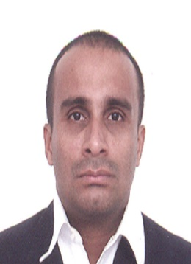 | Carlos Henriquez is a Titular Professor at the Department of System Engineering, Autonomous University of the Caribbean, Barranquilla, where he has been a faculty member since 2004. Systems Engineer, Specialist in pedagogical studies, master’s in software engineering and PhD in Systems and Computer Engineering. Senior Researcher before Minciencias. His research interests are primarily in: machine learning, natural language processing and sentiment analysis. Editor of the scientific journal Prospectiva. Leader of the research group Intelligent systems and new categories (SINT) categorized A. Director of software projects as consultant and professor. Consultant and instructor in JAVA technology (J2EE, J2SE, JavaCard, Android). He can be contacted at email: carlos.henriquez@uac.edu.co.

