Indonesian Automatic Short Answer Grading System

Heinrich Reagan Salim, Chintya De, Nicholas Daniel Pratamaputra, Derwin Suhartono
Department of Computer Science, BINUS University, West Jakarta, DKI Jakarta 11480 Indonesia

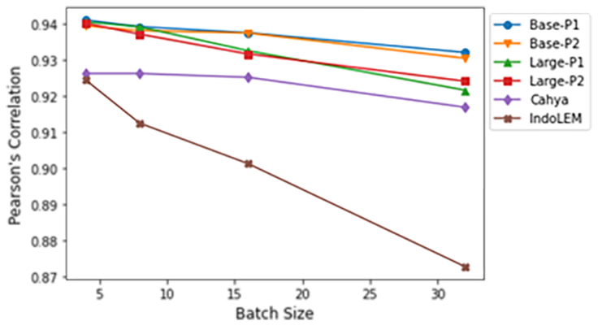
Figure 1. The effect of batch size on the average Pearson's Correlation of BERT model using Basic Programming data set

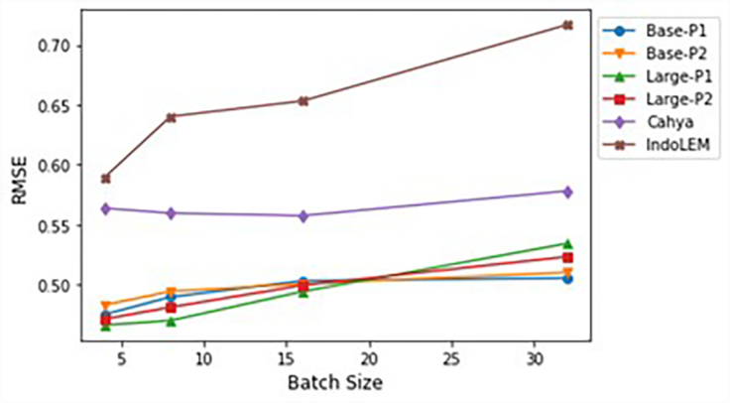
Figure 2. The effect of batch size on the average RMSE of BERT model using Basic Programming data set

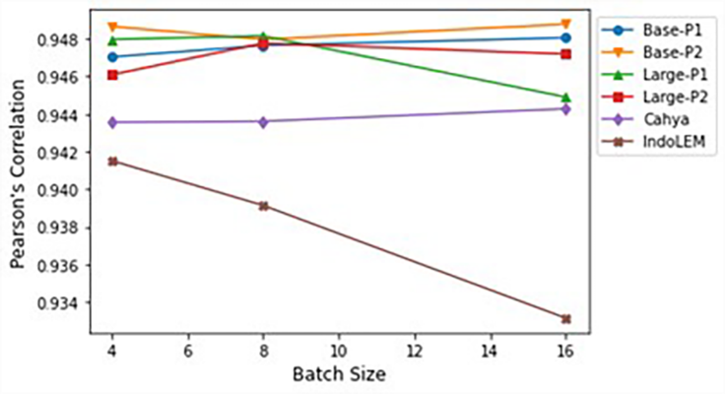
Figure 3. The effect of batch size on the average Pearson's Correlation of BERT model using Rahutomo data set

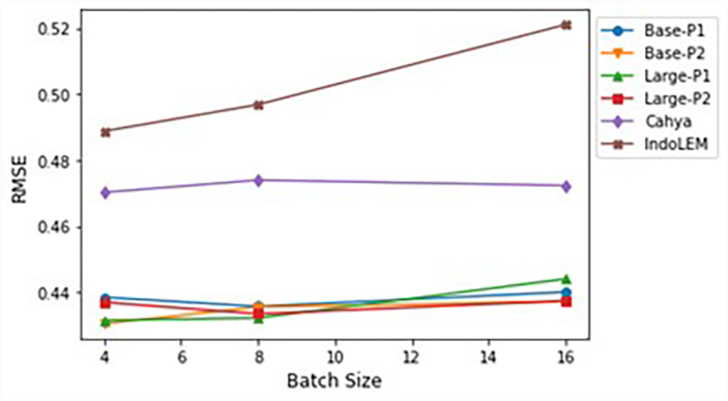
Figure 4. The effect of batch size on the average RMSE of BERT model using Rahutomo data set

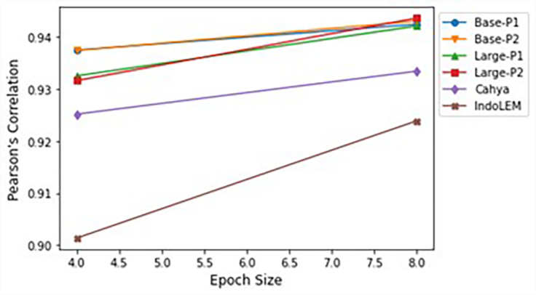
Figure 5. The effect of epoch size on the average Pearson's Correlation of BERT model using Basic Programming data set

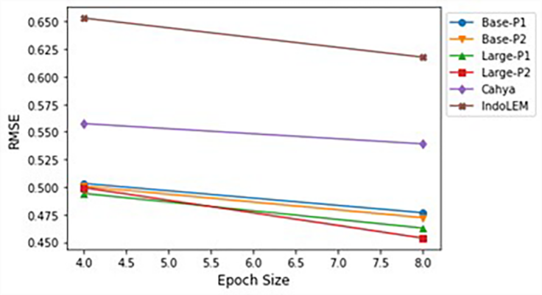
Figure 6. The effect of epoch size on the average RMSE of BERT model using Basic Programming data set

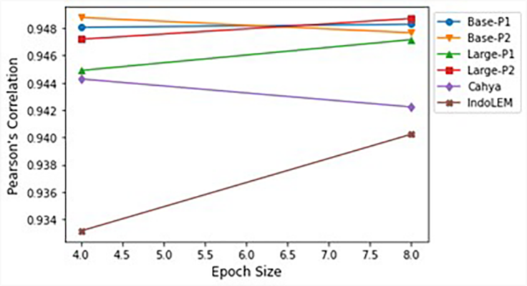
Figure 7. The effect of epoch size on the average Pearson's Correlation of BERT model using Rahutomo data set

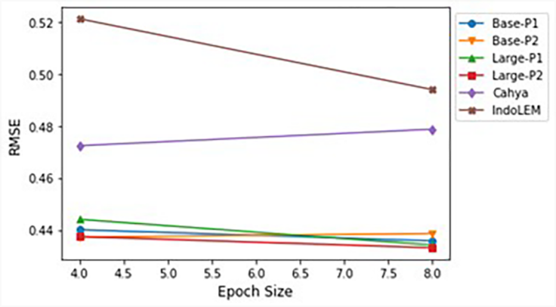
Figure 8. The effect of epoch size on the average RMSE of BERT model using Rahutomo data set

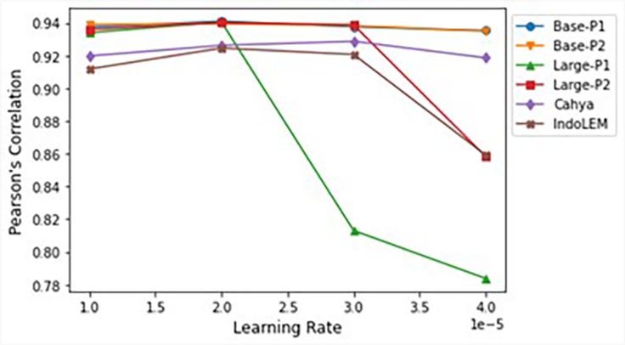
Figure 9. The effect of learning rate on the average Pearson's Correlation of BERT model using Basic Programming data set

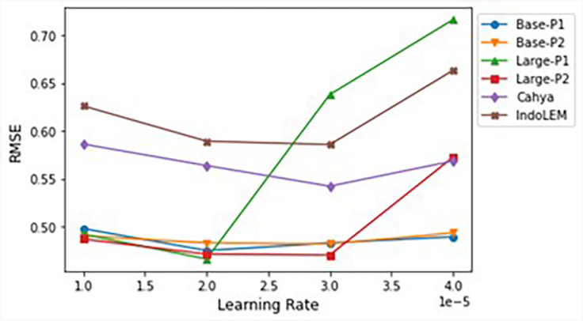
Figure 10. The effect of learning rate on the average RMSE of BERT model using Basic Programming data set

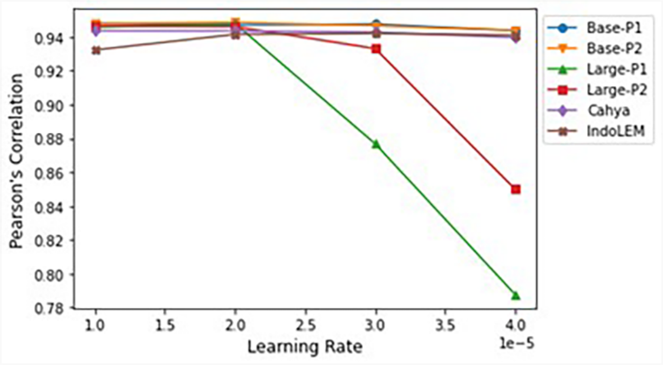
Figure 11. The effect of learning rate on the average Pearson's Correlation of BERT model using Rahutomo data set

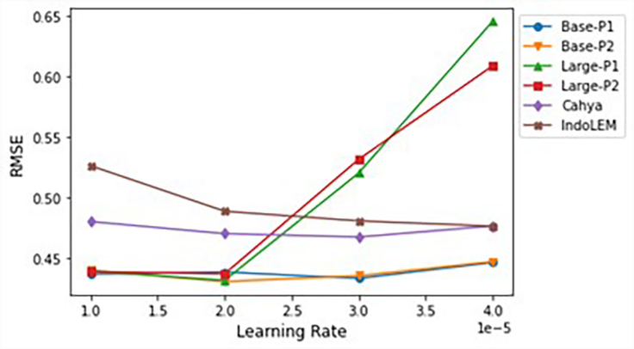
Figure 12. The effect of learning rate on the average RMSE of BERT model using Rahutomo data set

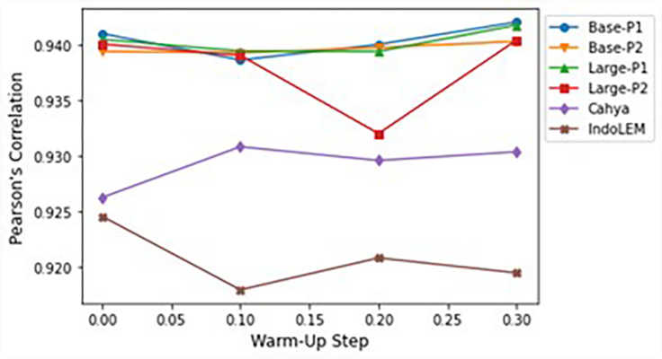
Figure 13. The effect of warm-up step on the average Pearson's Correlation of BERT model using Basic Programming data set

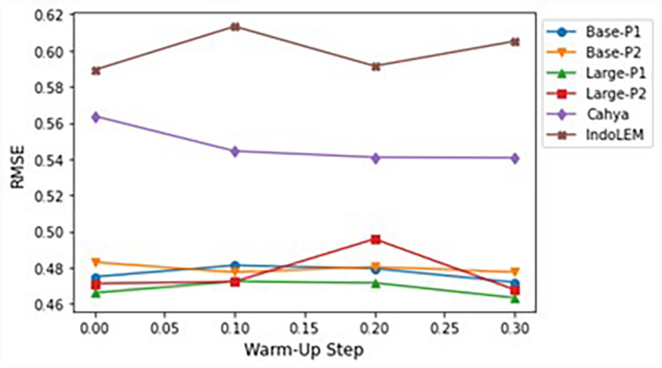
Figure 14. The effect of warm-up step on the average RMSE of BERT model using Basic Programming data set

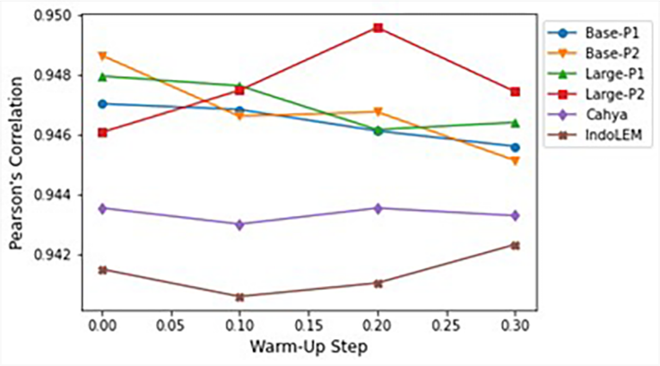
Figure 15. The effect of warm-up step on the average Pearson's Correlation of BERT model using Rahutomo data set

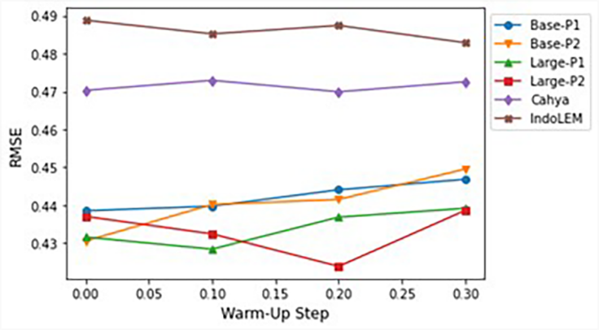
Figure 16. The effect of warm-up step on the average RMSE of BERT model using Rahutomo data set

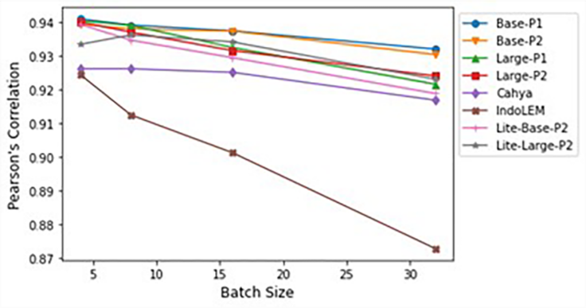
Figure 17. The effect of batch size on the average Pearson's Correlation of ALBERT model using Basic Programming data set

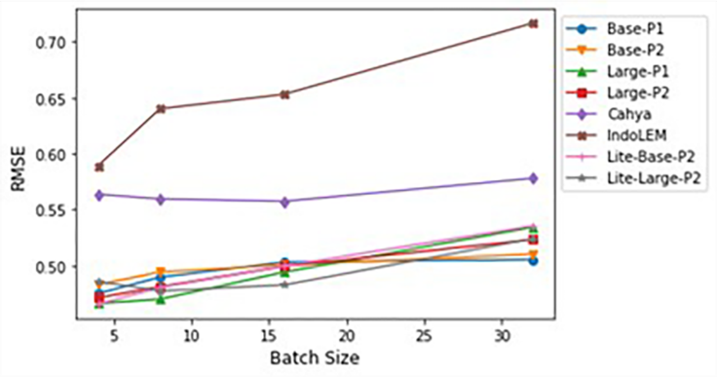
Figure 18. The effect of batch size on the average RMSE of ALBERT model using Basic Programming data set

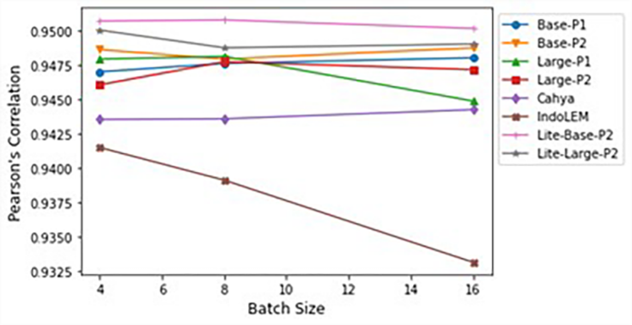
Figure 19. The effect of batch size on the average Pearson's Correlation of ALBERT model using Rahutomo data set

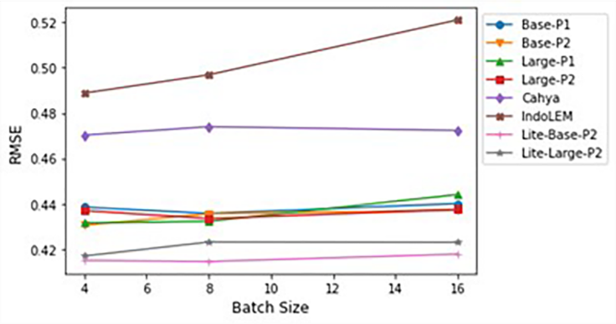
Figure 20. The effect of batch size on the average RMSE of ALBERT model using Rahutomo data set

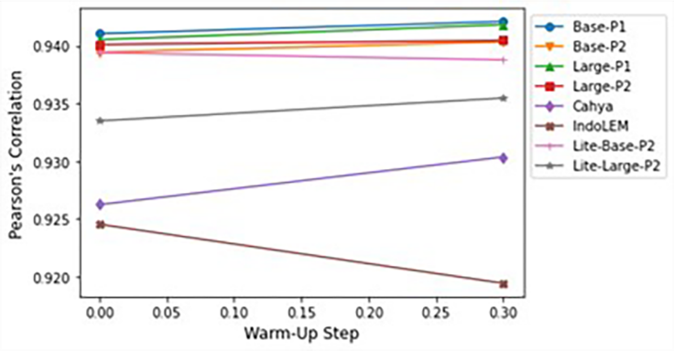
Figure 21. The effect of warm-up step on the average Pearson's Correlation of ALBERT model using Basic Programming data set

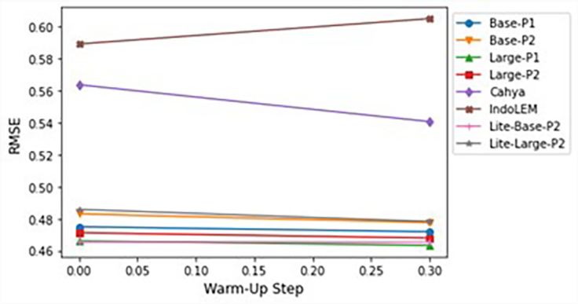
Figure 22. The effect of warm-up step on the average RMSE of ALBERT model using Basic Programming data set

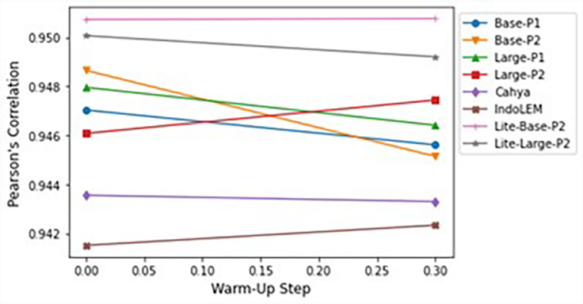
Figure 23. The effect of warm-up step on the average Pearson's Correlation of ALBERT model using Rahutomo data set

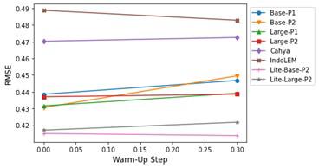
Figure 24. The effect of warm-up step on the average RMSE of ALBERT model using Rahutomo data set

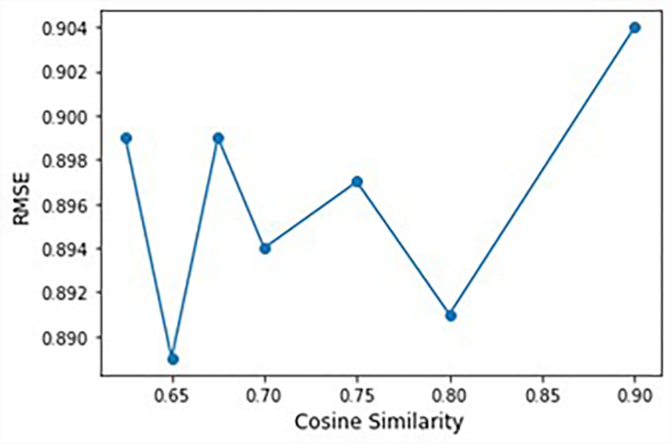
Figure 25. The effect of minimum cosine similarity score on the average RMSE of ridge regression model using Basic Programming data set

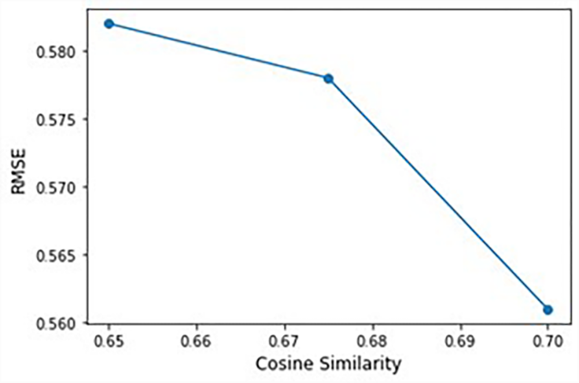
Figure 26. The effect of minimum cosine similarity score on the average RMSE of ridge regression model using Rahutomo data set

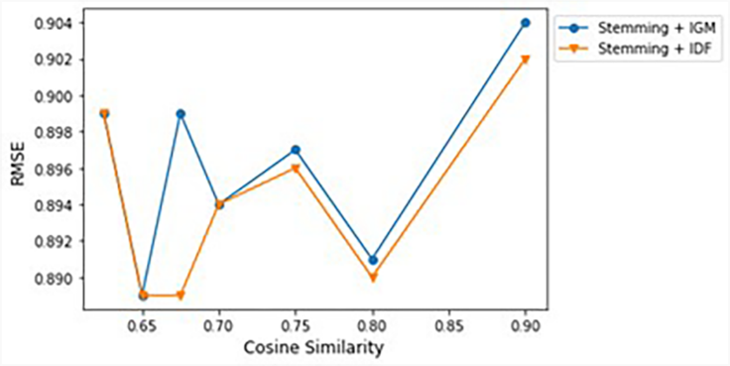
Figure 27. The effect of term weighting scheme on the average RMSE of ridge regression model using Basic Programming data set

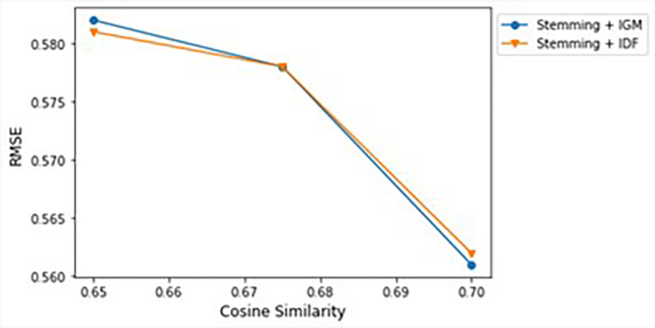
Figure 28. The effect of term weighting scheme on the average RMSE of ridge regression model using Rahutomo data set

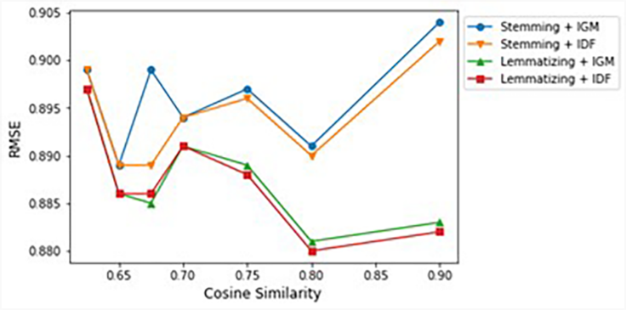
Figure 29. The effect of text preprocessing module on the average RMSE of ridge regression model using Basic Programming data set

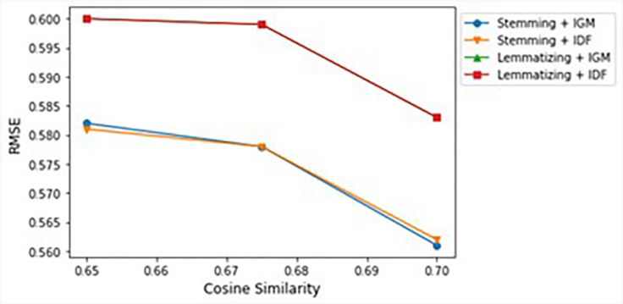
Figure 30. The effect of text preprocessing module on the average RMSE of ridge regression model using Rahutomo data set

Table 1. Questions and reference answers in the Basic Programming data set
No. | Question | Reference Answer | Source
1 | Apa yang dimaksud dengan variabel? | Variabel adalah nama yang merujuk lokasi pada memori yang digunakan untuk menyimpan suatu nilai dengan tipe data tertentu. | Reference [19]
2 | Apa yang dimaksud dengan tipe data array? | Tipe data array adalah tipe data yang menampung banyak nilai dengan tipe data yang sama pada lokasi memori yang berurutan. | Reference [20]
3 | Apa perbedaan antara tipe data integer dan float? | Integer adalah tipe data untuk menampung bilangan bulat, sedangkan float adalah tipe data untuk menampung bilangan desimal. | Reference [19]  Reference [20]
4 | Apa yang dimaksud dengan algoritma? | Algoritma adalah urutan langkah-langkah untuk menyelesaikan sebuah masalah yang disusun secara logis dan sistematis. | Reference [21]
5 | Mengapa perlu membuat pseudocode terlebih dahulu sebelum memulai coding? | Agar lebih mudah memahami dan menggambarkan algoritma program untuk mengubahnya menjadi bahasa pemrograman tertentu. | Reference [21]

Table 2. Questions and keywords in the Basic Programming data set
No. | Reference Answer | Keyword
1 | Variabel adalah nama yang merujuk lokasi pada memori yang digunakan untuk menyimpan suatu nilai dengan tipe data tertentu. | - Nama  - Lokasi  - Menyimpan  - Nilai  - Tipe data tertentu
2 | Tipe data array adalah tipe data yang menampung banyak nilai dengan tipe data yang sama pada lokasi memori yang berurutan. | - Lokasi memori  - Berurutan  - Menampung  - Banyak nilai  - Tipe data sama
3 | Integer adalah tipe data untuk menampung bilangan bulat, sedangkan float adalah tipe data untuk menampung bilangan desimal. | - Menampung  - Integer/ bilangan bulat  - Float/ bilangan desimal
4 | Algoritma adalah urutan langkah-langkah untuk menyelesaikan sebuah masalah yang disusun secara logis dan sistematis. | - Urutan  - Langkah-langkah  - Menyelesaikan  - Masalah  - Logis
5 | Agar lebih mudah memahami dan menggambarkan algoritma program untuk mengubahnya menjadi bahasa pemrograman tertentu. | - Lebih mudah  - Menggambarkan  - Algoritma  - Mengubah  - Bahasa pemrograman

Table 3. Scoring rubric for the Basic Programming data set
Score | Criteria  (All Except Question #3) | Criteria  (Question #3 Only)
5 | The respondent's answer has the same five keywords as the reference answer. | The respondent's answer has the same three keywords as the reference answer.
4 | The respondent's answer has the same four keywords as the reference answer. | The respondent's answer has the second and third keywords as the reference answer.
3 | The respondent's answer has the same three keywords as the reference answer. | The respondent's answer has the first and second or the second and third keywords as the reference answer.
2 | The respondent's answer has the same two keywords as the reference answer. | The respondent's answer has the second or third keywords as the reference answer.
1 | The respondent's answer has the same one keyword as the reference answer. | The respondent's answer has the first keywords as the reference answer.
0 | The respondent's answer is empty or irrelevant to the reference answer. | The respondent's answer is empty or irrelevant to the reference answer.

Table 4. BERT-based model experiment scenario with the Basic Programming and Rahutomo data sets
No. | Model | Batch  (b) |  |  |  | Epoch  (e) |  |  | Fold  (f) |  |  | Learning Rate  (lr) |  |  |  | Warm-Up Step  (ws)
No. | Model | 4 | 8 | 16 | 32 |  | 4 | 8 |  | 5 | 10 | 1e-5 | 2e-5 | 3e-5 | 4e-5 | 0 | 0.1 | 0.2 | 0.3
1 | Base-P1  Base-P2  Large-P1  Large-P2  Cahya  IndoLEM | ✓ |  |  |  |  | ✓ |  |  |  | ✓ |  | ✓ |  |  | ✓
2 | Base-P1  Base-P2  Large-P1  Large-P2  Cahya  IndoLEM |  | ✓ |  |  |  | ✓ |  |  |  | ✓ |  | ✓ |  |  | ✓
3 | Base-P1  Base-P2  Large-P1  Large-P2  Cahya  IndoLEM |  |  | ✓ |  |  | ✓ |  |  |  | ✓ |  | ✓ |  |  | ✓
4 | Base-P1  Base-P2  Large-P1  Large-P2  Cahya  IndoLEM |  |  |  | ✓ª |  | ✓ |  |  |  | ✓ |  | ✓ |  |  | ✓
5 | Base-P1  Base-P2  Large-P1  Large-P2  Cahya  IndoLEM |  |  | ✓ |  |  |  | ✓ |  |  | ✓ |  | ✓ |  |  | ✓
6 | Base-P1  Base-P2  Large-P1  Large-P2  Cahya  IndoLEM |  |  | ✓ |  |  | ✓ |  |  | ✓ |  |  | ✓ |  |  | ✓
7 | Base-P1  Base-P2  Large-P1  Large-P2  Cahya  IndoLEM | ✓ |  |  |  |  | ✓ |  |  |  | ✓ | ✓ |  |  |  | ✓
8 | Base-P1  Base-P2  Large-P1  Large-P2  Cahya  IndoLEM | ✓ |  |  |  |  | ✓ |  |  |  | ✓ |  |  | ✓ |  | ✓
9 | Base-P1  Base-P2  Large-P1  Large-P2  Cahya  IndoLEM | ✓ |  |  |  |  | ✓ |  |  |  | ✓ |  |  |  | ✓ | ✓
10 | Base-P1  Base-P2  Large-P1  Large-P2  Cahya  IndoLEM | ✓ |  |  |  |  | ✓ |  |  |  | ✓ |  | ✓ |  |  |  | ✓
11 | Base-P1  Base-P2  Large-P1  Large-P2  Cahya  IndoLEM | ✓ |  |  |  |  | ✓ |  |  |  | ✓ |  | ✓ |  |  |  |  | ✓
12 | Base-P1  Base-P2  Large-P1  Large-P2  Cahya  IndoLEM | ✓ |  |  |  |  | ✓ |  |  |  | ✓ |  | ✓ |  |  |  |  |  | ✓
13 | Lite-Base-P2  &  Lite-Large-P2 | ✓ |  |  |  |  | ✓ |  |  |  | ✓ |  | ✓ |  |  | ✓
14 | Lite-Base-P2  &  Lite-Large-P2 |  | ✓ |  |  |  | ✓ |  |  |  | ✓ |  | ✓ |  |  | ✓
15 | Lite-Base-P2  &  Lite-Large-P2 |  |  | ✓ |  |  | ✓ |  |  |  | ✓ |  | ✓ |  |  | ✓
16 | Lite-Base-P2  &  Lite-Large-P2 |  |  |  | ✓ª |  | ✓ |  |  |  | ✓ |  | ✓ |  |  | ✓
17 | Lite-Base-P2  &  Lite-Large-P2 | ✓ |  |  |  |  | ✓ |  |  |  | ✓ |  | ✓ |  |  |  |  |  | ✓

Table 5. Ridge regression model experiment scenario with the Basic Programming data sets
No. | Minimum Cosine Similarity Score |  |  |  |  |  |  | ppdbSim |  | Term Weighting |  | Text Preprocessing
No. | 0.625 | 0.65 | 0.675 | 0.7 | 0.75 | 0.8 | 0.9 | Cosine Similarity | 0.9 | TF-IGM | TF-IDF | Stemming | Lemmatization
1 | ✓ |  |  |  |  |  |  |  | ✓ | ✓ |  | ✓
2 |  | ✓ |  |  |  |  |  |  | ✓ | ✓ |  | ✓
3 |  |  | ✓ |  |  |  |  |  | ✓ | ✓ |  | ✓
4 |  |  |  | ✓ |  |  |  |  | ✓ | ✓ |  | ✓
5 |  |  |  |  | ✓ |  |  |  | ✓ | ✓ |  | ✓
6 |  |  |  |  |  | ✓ |  |  | ✓ | ✓ |  | ✓
7 |  |  |  |  |  |  | ✓ |  | ✓ | ✓ |  | ✓
8 |  |  |  |  |  |  |  | ✓ |  | ✓ |  | ✓
9 | ✓ |  |  |  |  |  |  |  | ✓ |  | ✓ | ✓
10 |  | ✓ |  |  |  |  |  |  | ✓ |  | ✓ | ✓
11 |  |  | ✓ |  |  |  |  |  | ✓ |  | ✓ | ✓
12 |  |  |  | ✓ |  |  |  |  | ✓ |  | ✓ | ✓
13 |  |  |  |  | ✓ |  |  |  | ✓ |  | ✓ | ✓
14 |  |  |  |  |  | ✓ |  |  | ✓ |  | ✓ | ✓
15 |  |  |  |  |  |  | ✓ |  | ✓ |  | ✓ | ✓
16 |  |  |  |  |  |  |  | ✓ |  |  | ✓ | ✓
17 | ✓ |  |  |  |  |  |  |  | ✓ | ✓ |  |  | ✓
18 |  | ✓ |  |  |  |  |  |  | ✓ | ✓ |  |  | ✓
19 |  |  | ✓ |  |  |  |  |  | ✓ | ✓ |  |  | ✓
20 |  |  |  | ✓ |  |  |  |  | ✓ | ✓ |  |  | ✓
21 |  |  |  |  | ✓ |  |  |  | ✓ | ✓ |  |  | ✓
22 |  |  |  |  |  | ✓ |  |  | ✓ | ✓ |  |  | ✓
23 |  |  |  |  |  |  | ✓ |  | ✓ | ✓ |  |  | ✓
24 |  |  |  |  |  |  |  | ✓ |  | ✓ |  |  | ✓
25 | ✓ |  |  |  |  |  |  |  | ✓ |  | ✓ |  | ✓
26 |  | ✓ |  |  |  |  |  |  | ✓ |  | ✓ |  | ✓
27 |  |  | ✓ |  |  |  |  |  | ✓ |  | ✓ |  | ✓
28 |  |  |  | ✓ |  |  |  |  | ✓ |  | ✓ |  | ✓
29 |  |  |  |  | ✓ |  |  |  | ✓ |  | ✓ |  | ✓
30 |  |  |  |  |  | ✓ |  |  | ✓ |  | ✓ |  | ✓
31 |  |  |  |  |  |  | ✓ |  | ✓ |  | ✓ |  | ✓
32 |  |  |  |  |  |  |  | ✓ |  |  | ✓ |  | ✓

Table 6. Ridge regression model experiment scenario with the Rahutomo data sets
No. | Minimum Cosine Similarity Score |  |  |  |  |  |  | ppdbSim |  | Term Weighting |  | Text Preprocessing
No. | 0.625 | 0.65 | 0.675 | 0.7 | 0.75 | 0.8 | 0.9 | Cosine Similarity | 0.9 | TF-IGM | TF-IDF | Stemming | Lemmatization
1 |  | ✓ |  |  |  |  |  |  | ✓ | ✓ |  | ✓
2 |  |  | ✓ |  |  |  |  |  | ✓ | ✓ |  | ✓
3 |  |  |  | ✓ |  |  |  |  | ✓ | ✓ |  | ✓
4 |  |  |  |  |  |  |  | ✓ |  | ✓ |  | ✓
5 |  | ✓ |  |  |  |  |  |  | ✓ |  | ✓ | ✓
6 |  |  | ✓ |  |  |  |  |  | ✓ |  | ✓ | ✓
7 |  |  |  | ✓ |  |  |  |  | ✓ |  | ✓ | ✓
8 |  |  |  |  |  |  |  | ✓ |  |  | ✓ | ✓
9 |  | ✓ |  |  |  |  |  |  | ✓ | ✓ |  |  | ✓
10 |  |  | ✓ |  |  |  |  |  | ✓ | ✓ |  |  | ✓
11 |  |  |  | ✓ |  |  |  |  | ✓ | ✓ |  |  | ✓
12 |  |  |  |  |  |  |  | ✓ |  | ✓ |  |  | ✓
13 |  | ✓ |  |  |  |  |  |  | ✓ |  | ✓ |  | ✓
14 |  |  | ✓ |  |  |  |  |  | ✓ |  | ✓ |  | ✓
15 |  |  |  | ✓ |  |  |  |  | ✓ |  | ✓ |  | ✓
16 |  |  |  |  |  |  |  | ✓ |  |  | ✓ |  | ✓

Table 7. The effect of paraphrase similarity score (ppdbSim) on the average RMSE of ridge regression model using Basic Programming data set
Term Weighting Scheme | ppdbSim | Minimum Cosine Similarity | RMSE
TF-IGM | 0.9 | 0.65 | 0.889
TF-IGM | 0.9 | 0.9 | 0.904
TF-IGM | Cosine similarity | - | 0.904
TF-IDF | 0.9 | 0.675 | 0.889
TF-IDF | 0.9 | 0.9 | 0.902
TF-IDF | Cosine similarity | - | 0.903

Table 8. The effect of paraphrase similarity score (ppdbSim) on the average RMSE of ridge regression model using Rahutomo data set
Term Weighting Scheme | ppdbSim | Minimum Cosine Similarity | RMSE
TF-IGM | 0.9 | 0.675 | 0.582
TF-IGM | 0.9 | 0.7 | 0.561
TF-IGM | Cosine similarity | - | 0.538
TF-IDF | 0.9 | 0.65 | 0.581
TF-IDF | 0.9 | 0.7 | 0.562
TF-IDF | Cosine similarity | - | 0.539

Table 9. The effect of text preprocessing module on the average RMSE of ridge regression model using Basic Programming data set
Text Preprocessing Module | Term Weighting Scheme | RMSE
Stemming | IGM | 0.904
Stemming | IDF | 0.903
Lemmatization | IGM | 0.883
Lemmatization | IDF | 0.882

Table 10. The effect of text preprocessing module on the average RMSE of ridge regression model using Rahutomo data set
Text Preprocessing Module | Term Weighting Scheme | RMSE
Stemming | IGM | 0.538
Stemming | IDF | 0.539
Lemmatization | IGM | 0.562
Lemmatization | IDF | 0.562

