Fabrication of (Polymer Blend- Magnesium Oxide) Nanoparticle and Studying their Optical Properties For Optoelectronic Applications
¹Alaa J. Kadham, ³Dalal Hassan, ² Najlaa Mohammad and ²Ahmed Hashim
¹AL-Qasim Green University , College of Agriculture, Department of Soil and Water, Iraq.
²University of Babylon, College of Education of Pure Science, Department of Physics, Iraq
ahmed_taay@yahoo.com

Abstract
Nanocomposites used in many optical devices applications. This aims to preparation of new type of polymer and study their optical properties. The polyvinyl pyrrolidone -carboxymethyl cellulose blend and magnesium oxide nanocomposites have been fabricated. The nanocomposites are prepared for different concentrations of polymer blend and magnesium oxide nanoparticles. The optical properties of nanocomposites were studied. The experimental results showed that the absorbance, absorption coefficient, refractive index, extinction coefficient, real and imaginary parts of dielectric constant and optical conductivity of (PVP-CMC) blend are increased with increase of the MgO nanoparticles concentration. The transmittance and energy band gap are decreased with increase of the MgO nanoparticles concentration. The nanocomposites have high absorbance in UV region which may be used for radiation shielding application.
Keywords: blend, transmittance, polyvinyl pyrrolidone, magnesium oxide, nanocomposites.

Introduction
Polymeric materials have attracted the scientific and technological researchers, because of their wide applications. This is mainly due to the lightweight, good mechanical strength, optical properties and makes them to be multifunctional materials. In recent years, studies of electrical and optical properties of the polymer have attracted much attention in view of their application in electronic and optical devices. The optical absorption spectra of polymers provide essential information about the band structure and the energy gap in crystalline, semi-crystalline, and non-crystalline polymers. The electrical and optical properties of polymers can be suitably modified by the addition of dopants. Moreover, these polymers are traditionally considered as an excellent host material. The field of polymer additives has attracted strong interest in today’s materials research, in view of this it is very important to note that the dopant modifies the structure of the polymer and hence its properties. Since, the change in polymer properties are mainly depends on the nature of the dopant and the way in which it interacts with the polymer, as it achieve impressive enhancements of the polymer properties as compared with the pure polymers. The development of nano science and nano technology has allowed us to create new nano-sized materials having unique electronic and optical properties quite different from those of their bulk state. In various electronic and optical devices the size-dependent properties of the nano materials were used [1]. Preparation of nanocomposites based on blends is a recent and promising trend in the nanocomposites science. Mixing of two or more polymers to develop new polymeric materials with improved properties is usually cheaper and less time-consuming than a realization of new polymer chemistry. However, the intrinsic properties of the basic polymers may not be sufficient to meet some specific requirements of new developing industries. In a nanocomposites system, a small amount from the nano-additives could improve the overall performance of the polymeric materials. This is owing to the small size, the large specific area, quantum confinement effects, and the strong interfacial interaction of the nanomaterials [2]. The impressive widespread of the use of composite materials at present could be explained, among other arguments, by the possibility to predict the composite’s properties, on the basis of the volumetric content and the corresponding properties of the matrix and the reinforcement. In fact, the user can get a new material that is tailored by his demands. Measurements of the electrical properties of polymers are one of the most convenient and sensitive methods for studying polymer structure. A filled polymer differs substantially from the free one in a wide range of properties. The presence of filler affects both the electrical, as well as, mechanical properties. In most of their industrial applications, elastomers are used ascomposite materials [3,4]. In addition, they are used as conducting adhesives in electronics packaging flip-chips, cold solders, switching devices, static charge dissipating materials, and devices for surge protection [5,6]. Polymeric composites have high strength and stiffness, light weight, and high corrosion resistance [7]. The studies of metal oxide nanoparticles/Polymer nanocomposites are generating increasing interest due to their potential applications in household electronics, recording heads, memory and microwave devices. The addition of inorganic nanoparticles to polymers allows the modification of the polymer physical properties as well as the implementation of new features in the polymer matrix. With decreasing particle size, the ratio of surface/ volume increases, so that surface properties become crucial. Smaller the particles are, more important will be the surface properties, thereby influencing interfacial properties, agglomeration behavior, and also the physical properties of the particles. The intensity of these properties changes depending upon the nature, composition, concentration and size of the nanoparticles. Nanocomposites on base of semiconductor nanoparticles and polymer matrix are prospective materials for application in optoelectronics, for creation of luminescentmaterials, sensor electronics…. etc. Introducing semiconductor nanoparticles into polymer matrix volume changes physicochemical properties of the system. The properties of the obtained structures depend on a semi- conductor particle type, dimensions of particles. Furthermore, the physicochemical properties of the system will be under influence of the effects of interaction of nanoparticles with polymer matrix, interphase phenolmena in polymer-nanoparticle. Formation of nanocomposites can be performed by the different ways. Technology of obtaining nanocomposites can influence on distribution of nanoparticles in a polymer matrix volume, dimensions of nanoparticles and etc. All these factors may lead to change in physicochemical properties of the system [8].

Materials and Method
Nanocomposites films were prepared by using: polyvinyl pyrrolidone -carboxymethyl cellulose blend and magnesium oxide nanoparticles as additive. The polymer blend was fabricated with different concentrations of PVP (22 wt.%) and CMC (78 wt.%), The MgO nanoparticles added to polymer blend by different concentrations are (0,2,4 and 6) wt.%. nanoparticles by using casting technique. The optical properties of nanocomposites were measured by using UV/1800/ Shimadzu in range of wavelength (220-800) nm. The absorption coefficient (α) of a nanocomposite is given by [9]:
α=2.303A/t ………. (1)
Where A: is the absorbance of sample and t: the sample thickness in cm. The non-direct transition model for amorphous semiconductors is determined by [9]:
Where B is a constant, hυ is the photon energy , E_{g} is the optical energy band gap, r=2,or3 for allowed and forbidden indirect transition.
The refractive index (n) can be calculated by using the equation [10]:
n= (1+R^{1/2})/ (1-R^{1/2} ) ……… (3)
The extinction coefficient (k) is given by using the equation [10]:
K=αλ/4π ………… (4)
The real and imaginary parts of dielectric constant (ε₁ and ε₂) can be calculated by using equations [11]:
ε₁=n²-k² (real part) …..... (5)
ε₂=2nk (imaginary part) …… (6)
The optical conductivity is calculated by using the equation [12]:

Results and Discussion
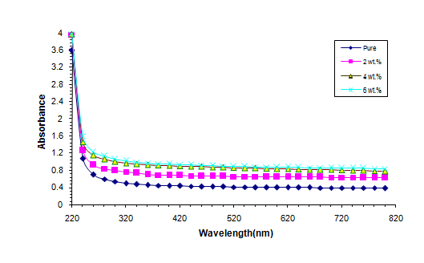
The effect of magnesium oxide nanoparticle on optical absorbance and transmittance of (PVP-CMC) blend are shown in figure 1 and 2. As shown in figures, the absorbance of polymer blend increases and the transmittance decreases with increase the MgO nanoparticle concentrations which may be related to increase the number of charges carries inside nanocomposite. This is similar with the results of researcher [2]

Figure 1: effect of magnesium oxide nanoparticle on optical absorbance of (PVP-CMC) blend.
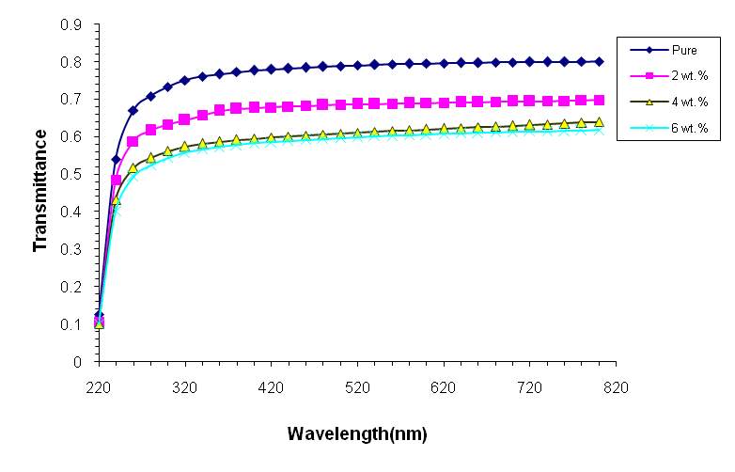

Figure 2: effect of magnesium oxide nanoparticle on optical transmittance of (PVP-CMC) blend.
The variation of absorption coefficient with photon energy for different concentrations of MgO nanoparticle is presented in figure 3. The gradient of the absorption coefficient is from high photon energy to low photon energy. This means that the possibility of electron transition is little, because the energy is not sufficient to move the electron from the valence band to the conduction band (hυ < Eg). It was observed that at high energy, absorption is great and the forbidden energy gap is less which indicates the large probability of electronic transitions [9].
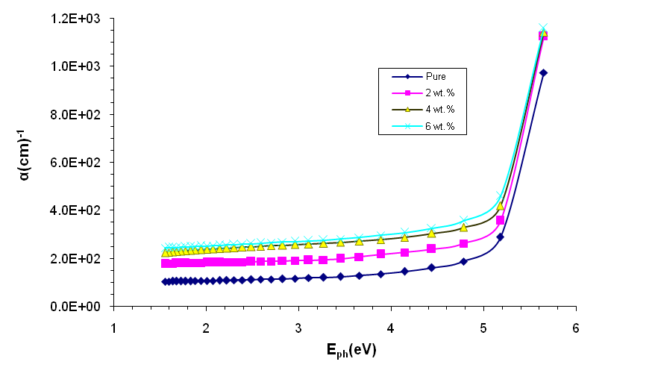

Figure 3: variation of absorption coefficient with photon energy of nanocomposites.
The band gap of the films was estimated using the fundamental absorption, which corresponds to electron excitation from the valence band to conduction band. The band gap E_{g} is the value of optical energy gap between the valence band and the conduction band. The optical energy band gap E_{g} for allowed and forbidden indirect transition are shown in figures (4 and 5). The energy band gap of allowed and forbidden indirect transition decreases with increase the MgO nanoparticle concentrations. The gradual decrease in the value of E_{g} by increasing MgO nanoparticle concentration may be attributed due to the formation of chemical bonding between polymer chains and MgO nanoparticle responsible for the generation of localized states. The reduction in energy gap value in (PVP-CMC) after embedding MgO nanoparticle make them efficient materials for optoelectronic devices. This is because of the fact that such devices require the band gap tenability[1].
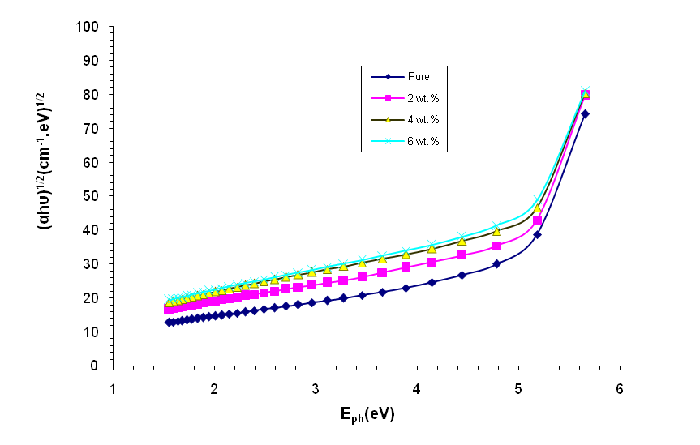

Figure 4: optical energy band gap E_{g} for allowed indirect transition of nanocomposites.

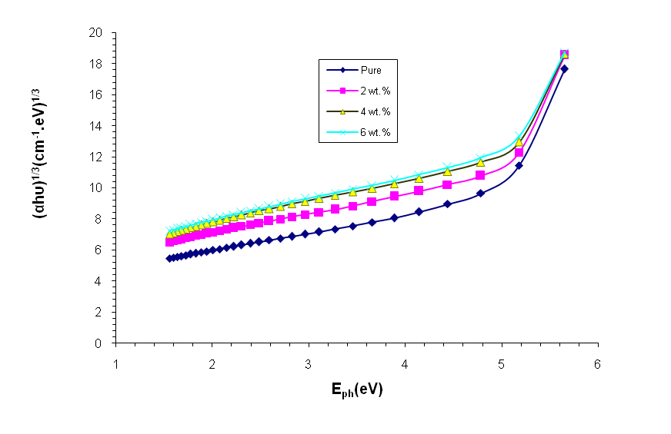
Figure 5: optical energy band gap E_{g} for forbidden indirect transition of nanocomposites.

Figures 6 and 7 show the variation of refractive index and extinction coefficient with photon wavelength for different concentration of MgO nanoparticle. From the figures, it can seen the refractive index and extinction coefficient are increased with increase the MgO nanoparticle concentration which may be attributed to increase of the density of nanocomposite and absorption coefficient [13].
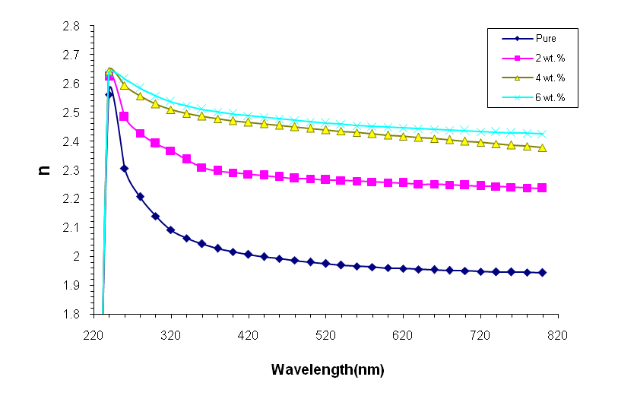

Figures 6: variation of refractive index with photon wavelength for different concentration of MgO nanoparticle.
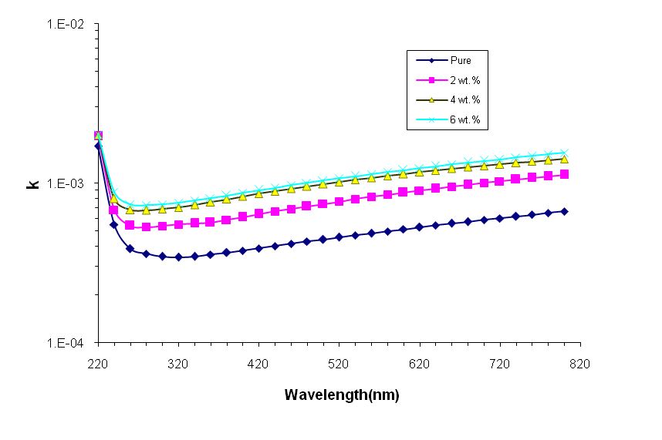
Figures 7: variation of extinction coefficient with photon wavelength for different concentration of MgO nanoparticle.

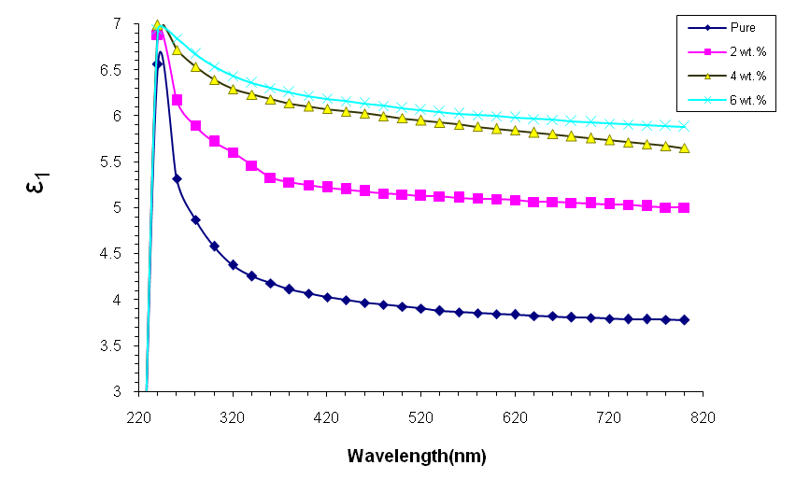
The variation of real and imaginary parts of dielectric constant with photon wavelength are shown in figures (8 and 9). The real and imaginary parts of dielectric constant are increased with the increase of MgO nanoparticle concentration. The increase of real and imaginary parts of dielectric constant with MgO nanoparticle concentration due to the increase of refractive index and extinction coefficient [13].

Figure 8: variation of real part of dielectric constant with photon wavelength.
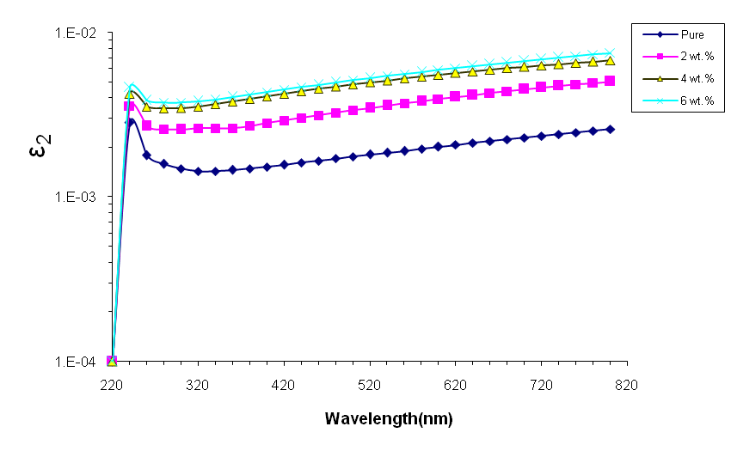
Figure 9: variation of imaginary part of dielectric constant with photon wavelength.

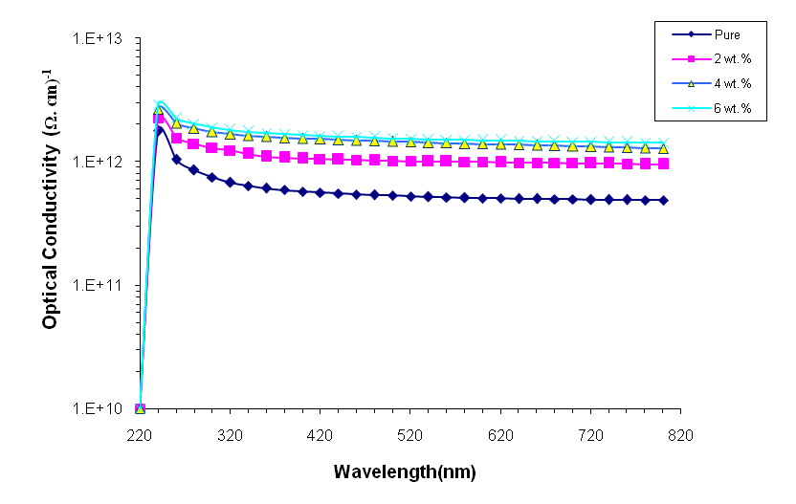
Figure 10 shows the variation of optical conductivity of (PVP-CMC-MgO) nanocomposite with photon energy. From the figure, the optical conductivity increases with the increase of weight percentages of MgO nanoparticle, this behavior attributed to increase of refractive index and absorption coefficient. This is similar with the results of researcher [14]
Figure 10: variation of optical conductivity of (PVP-CMC-MgO) nanocomposites with photon energy.

Conclusions
- The absorbance of (PVP-CMC) blend increases and the transmittance decreases with increase of the MgO nanoparticles concentrations. The (PVP-CMC-MgO) nanocomposites have high absorbance in the UV-region.
- The energy band gap of polymer blend decreases increases with increase of the MgO nanoparticles concentrations.
- The absorption coefficient, refractive index, extinction coefficient, real and imaginary parts of dielectric constant and optical conductivity of polymer blend are increased with increase of the MgO nanoparticles concentrations

References
[1] D. Hegazy, M. Eid and M. Madani, "Effect of Ni Nano particles on Thermal, Optical and Electrical Behaviour of Irradiated PVA/AAc Films", Arab Journal of Nuclear Science and Applications, Vol.47, No. 1, PP.41-52, (2014).
[2] A. M. El Sayed and W. M. Morsi, " α-Fe₂O₃ /(PVA + PEG) Nanocomposite Films; Synthesis, Optical, and Dielectric Characterizations", Journal of Materials Science, Vol.49, PP.5378–5387, (2014).
[3] Bahaa H. Rabee and Ahmed Hashim, Dielectric properties of (PS-BaSO₄.5H₂O) composites, European Journal of Social Sciences, Vol. 32, No.3, pp. 316-320, (2012).
[4] Alaa J. Kadham Algidsawi, Hayder J. Kadham, Algidsawi, Ahmed Hashim, Ghaleb abd al-wahab ali, The dielectric properties of (PVC-Zn) composites, Australian Journal of Basic and Applied Sciences, Vol.5, No.11, pp.1463-1465, (2011).
[5] Bahaa Hussien, Ahmed Hashim, Alaa Jewad, Electrical properties of polyvinylchloride - Zinc composite, European Journal of Social Sciences, Vol. 32, No.3, pp. 225-229, (2012).
[6] Z. Al-Ramadhan, Ahmed Hashim and Alaa J. Kadham Algidsawi, The D.C electrical properties of (PVC-Al₂O₃) composites , AIP Conference Proceedings, Vol. 1400, No.1, (2011).
[7] Ahmed Hashim, Alaa J. Kadham Algidsawi, Hayder Abduljalil, Shaymaa Hadi, Mechanical properties of (PVA-CoNO₃, BaSO₄.5H₂O) composites, European Journal of Scientific Research, Vol. 65, No. 2, pp.163-167, (2011).
[8] Ibrahim R. Agool, Kadhim J. Kadhim, Ahmed Hashim, Preparation of (polyvinyl alcohol–polyethylene glycol– polyvinyl pyrrolidinone–titanium oxide nanoparticles) nanocomposites: electrical properties for energy storage and release, International Journal of Plastics Technology, Vol.20, No. 1, PP. 121–127, (2016).
[9] V. Sangawar and M. Golchha, "Evolution of the optical properties of Polystyrene thin films filled with Zinc Oxide nanoparticles", International Journal of Scientific & Engineering Research, Vol. 4, Issue 6, (2013).
[10] Shaymaa Hadi, Ahmed Hashim and Alaa Jewad, Optical properties of (PVA-LiF) composites, Australian Journal of Basic and Applied Sciences, Vol.5, No.9, pp. 2192-2195, (2011).
[11] Farhan Lafta Rashid, Ahmed Hashim, Majeed Ali Habeeb, Saba R. Salman , Hind Ahmed, Preparation of PS-PMMA copolymer and study the effect of sodium fluoride on its optical properties, Journal of Engineering and Applied Sciences, Vol.8 , No.5, PP. 137-139, (2013).
[12] M. H. Hassouni, K. A. Mishjil, S. Chiad and N. F. Habubi, "Effect of Gamma Irradiation on the Optical Properties of Mg doped CdO Thin films deposited by Spray Pyrolysis", International Letters of Chemistry, Physics and Astronomy, Vol. 11, PP. 26-37, (2013).
[13] Bahaa H. Rabee, Ahmed Hashim, Synthesis and characterization of carbon nanotubes -polystyrene composites , European Journal of Scientific Research, Vol. 60, No. 2, pp. 247-254 , (2011).
[14] M. Venkatarayappa, S. Kilarkaje, A. Prasad and D. Hundekal, Refractive Index and Dispersive Energy of NiSO₄ Doped Poly (Ethylene Oxide) Films, Journal of Materials Science and Engineering A, Vol.1, PP.964-973, (2011).

