WiFi-Friendly Building to Enable WiFi Signal Indoor

Suherman
Electrical Engineering Department
Universitas Sumatera Utara
e-mail: suherman@usu.ac.id

Abstrak
Jaringan 802.11 (jaringan wireless fidelity (WiFi)) telah menjadi infrastruktur akses internet yang utama di rumah-rumah dan bangunan. Selain masalah penempatan access point, arsitektur bangunan turut mempengaruhi penyebaran sinyal WiFi. Meskipun instalasi WiFi pada gedung-gedung sudah umum, namun tampaknya arsitektur bangunan belum mempertimbangkan WiFi-friendliness dalam perencanaan. Pada kenyataannya, semakin bersahabat arsitektur bangunan terhadap sinyal WiFi, semakin efisien infrastruktur jaringan 802.11. Tulisan ini memperkenalkan istilah WiFi-friedly building dengan mempertimbangkan propagasi sinyal WiFi, pengaruh halangan juga dengan mengajukan perangkat ornament-attaced reflector dan struktur hole-in-the-wall untuk meningkatkan distribusi sinyal WiFi. Hasil eksperimen menunjukkan bahwa material penghalang yang terbuat dari beton meredam sinyal WiFi paling besar, diikuti oleh logam dan kayu. Material pemantul dapat meningkatkan penerimaan sinyal WiFi, sebagai contoh, ornament-attached reflector yang diimplementasikan dapat meningkatkan penerimaan sinyal WiFi sampai 6.56dBm. Sementara struktur hole-in-the-wall berhasil meningkatkan sinyal WiFi sampai 2.3 dBm..

Kata kunci: WiFi-Friendly Building, 802.11, Ornament-attached Reflector, hole-in-the-wall structure

Abstract
The 802.11 networks (wireless fidelity (WiFi) networks) have been the main wireless internet access infrastructure within houses and buildings. Besides access point placement, building architectures contribute to the WiFi signal spreading. Even dough WiFi installation in buildings becomes prevalent; the building architectures still do not take WiFi-friendliness into considerations. In fact, the more friendly the building to WiFi signal, the more efficient the 802.11 based wireless infrastructure. This paper introduces the term of WiFi-friedly building by considering signal propagations, the obstacle impact, as well as proposing ornament-attaced reflector and hole-in-the-wall structure to improve WiFi signal distribution. Experiment results show that obstacle materials made of concrete reducing WiFi signal the most, following by metal and wood. Reflecting materials are able to improve the received signal level, for instance, theimplemented ornament-attached reflector is able to improve the received signal up 6.56 dBm. Further, the hole-in-the-wall structure is successfully increasing WiFi signal up to 2.3 dBm.

Keywords: WiFi-Friendly Building, 802.11, Ornament-attached Reflector, hole-in-the-wall structure

1. Introduction
Internet access has been available in houses and offices as the access network technologies adanced. The internet networks within buildings are shared among cable and wireless networks. The 802.11 wireless local area network (WLAN) or Wireless Fidelity (WiFi) is the common technologies providing wireless internet access within buildings. This is due to the its sufficient mobility and the connection speed compared to the existing cable and mobile networks. As mobile computer and mobile phone application are becoming popular, users in houses and offices tend to choose WLAN when available.
Even dough WLAN demand in buildings is part of building necesties; the integration of wireless network requirement is not yet included in building design. The consideration is just limited on how the cabling infrastructure provided. In fact, wireless signal propagation always faces indoor propagation problems.
On the other hand, there is an empty gap on scientific publication in discussing how to design buildings that are friendly to WiFi signal. The WLAN and building relationship generally are shared in the following topics:
- How to locate the access point optimally within the building to cover are as much as possible. The access point placement can either based on propagation analysis and model [1], user density traces [2], the overall Euclidian distance [3] or interferences possibilities [4].
- Location based services that ar talking about how to find a terminal by analyzing the received access point signals. This is often referred to as indoor localization [5-8].
- Home automation services using internet connections [9].
Meanwhile, materials used in buildings mostly absorbs WiFi signal that make the access point placement inefficient as the transmitted signal blocked, absorbed, dispersed or reflected back by the wall and building structures. Isolative materials, such as concrete absorb and disperse the WiFi signal, while conductive materials such as metal reflect WiFi signal. The characteristics of those materials are approximated by using conductivity and complex permittivity parameter. The more conductive materials, the more reflective to radio signals. The more permittive a material, the more absorbing to radio signals. Table 1 shows the examples of permittivity and conductivity of some materials exist on buildings.

Table 1 Permittivity and conductivity of some material
Material. | Relative Permittivity | Conductivity (S/m) | Frequency (GHz)
Concrete | 5.31 | 0.0326 | 1-100
Brick | 3.75 | 0.038 | 1-10
Plaster board | 2.94 | 0.0116 | 1-100
Wood | 1.99 | 0.0047 | 0.001-100
Glass | 6.27 | 0.0043 | 0.1-100
Ceiling board | 1.50 | 0.0005 | 1-100
Metal | 1 | 10 | 1-100

Indoor propagations as the main problems for WiFi networks have been studied and modeled in some mathematical expressions. Deterministic model relies only on mathematical expressions, such as free space loss model, log distance path loss model, and log normal shadowing model. A more sophisticated model uses a complex approach such as impulse response [10] and statistic dispersion [11]. The modeling is performed only for a specific frequency band.
This paper introduces the term of WiFi-friendly building by reminding that the building structure is the major challenge on indoor signal propagation, mainly caused by signal losses caused by the obstacles. This paper also introduces that the properties within the buildings may assists signal spreadings so that building is friendlier to WiFi signal. At the end of this paper, a simple though-hole application on the wall may increase WiFi signal in other wall side.

2. Research Method
In order to introduce the needs of WiFi-friendly building, research methods are designed to show that:
- obstacles reduce WiFi signal
- reflector on certain position increases the received signal
- reflector can be inserted in building properties or ornaments
- A small hole-in-the-wall structure may eliminate signal blocking.

2.1 The Obstacle Impact
In order to show obstacle impact to WiFi signal propagation, a measurement device is assemblied by using ESP8266. ESP8266 is a system on a chip (SOC) integrated circuit that can work as an access point as well as a client of the 802.11 network. ESP8266 can work either with microcontroller or stand alone. In order to examine the impact of obstacle to WiFi signal, an experiement is set up as shown in Figure 1a. Figure 1b is for assessing the impact of the reflector on the received signal.

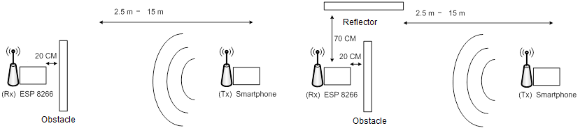

(a) Obstacle experiment (b) Reflector Experiment
Figure 1. Experiment set up for obstacle and reflector impact

A smart phone is turned on to broadcast WiFi signal that will be blocked by an obstacle, separated 2.5m to 15 m from a smart phone and 20 cm from the receiver. WEMOS D1 ESP8266-E12 is applied as a WiFi signal receptor. Obstacles are made of concrete, wood and metal while reflector is metal. Sample of the obstacles are shown in Figure 2.

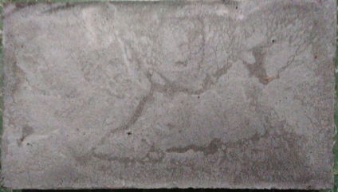  - Concrete | 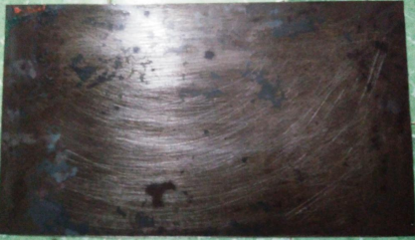  (b) Metal | 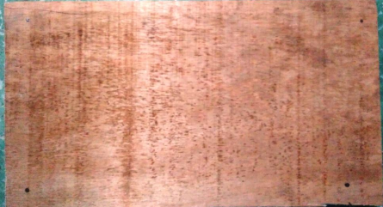  - Wood
Figure 2. Sample of the obstacle materials

2.2 An Ornament-attaced Reflector
Properties within the building such as painting, foto frames and statu can be used as signal spreaders, rather than obstacles. As an example, this paper utilizes a painting frame mounted in the wall as the reflector. An aluminium sheet is attached behind the painting. This ornament-attached reflector is employed to increase WiFi signal on the second floor. The access point is placed on the first floor. Figure 3 shows the sketch of the experiment. There are three points for the reflector positioning: position 1, position 2 and position 3.

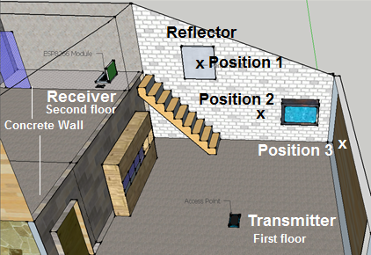
Figure 3. Sample of the obstacle materials
2.3 A hole-in-the-wall Structure
Building wall is the main obstacle within the building. Some rooms are isolated from WiFi signal as there is no way signal getting trhough. In this case, a hole-in-the-wall structure is designed to help signal passing through the wall. Figure 4 shows the designed structure.
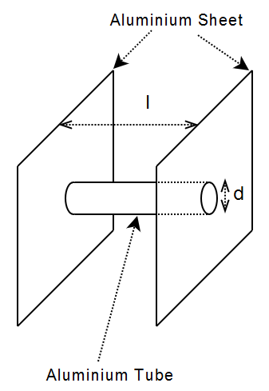
Figure 4. A hole-in-the-wall structure

The hole is made of an aluminium tube with diameter d and length l, attached to two sheets aluminium. This structure is embedded to the wall so that concrete filled the area between the two aluminium sheets. The hole is expected to pass WiFi signal. An experiment is set to measure the impact of the hole-in-the-wall structure as shown in Figure 5.
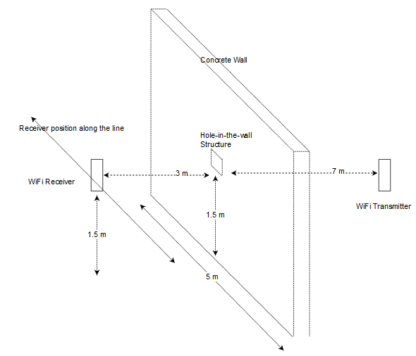
Figure 5. A hole-in-the-wall experiment

3. Results and Analysis
3.1. Obstacle Impact to WiFi Signal
The results of experiment on Figure 1 are shown in Figure 6. Data shown in Figure 6 is based on the average of 30 times measurements. The average signal level decreases as distance between transmitter and receiver increases. The concrete obstacle absorbs signal the most producing the average signal level of -66.27 dBm. Metal is following by producing signal level of -64.23 dBm. Wood is the less absorbing material, the average received signal is - 58.9 dBm.
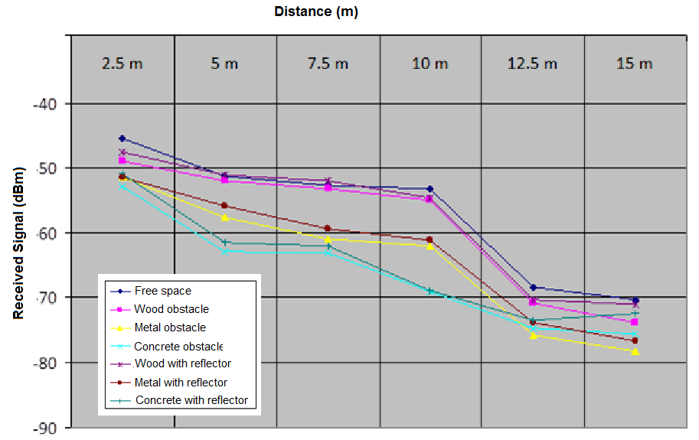

Figure 6.Signal Reductions due to Propagation and Obstacle

3.2. Reflector Impact to WiFi Signal
A metal reflector placement as depicted in Figure 1b has been successfully reduce the signal absorption and increase received signal level. Signal level increases 1.14 dBm in average. The received signal for concrete obstacle is -64.74 dBm, metal obstacle is -63.27 dBm and wood obstacle is -58.17 dBm. The plots are also shown in Figure 6.

3.3. Impact of Ornament-attached Reflector
Figure 7 shows the exact locations of the ornament-attached reflector and the results are plotted in Figure 8.

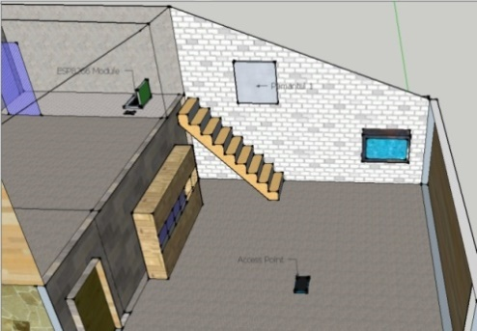  Position 1 | 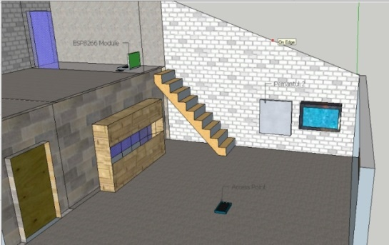  Position 2
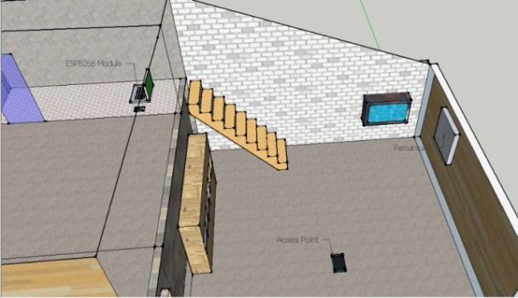
- Position 3
Figure 7. Reflector position

The concrete wall blocks the received signal on the second floor. The only way signal gets through is by reflection through the door. Without additional reflector, the average received signal on the second floor is -68.69 dBm transforming the painting frame on the wall to be a reflector causes increments of received signals. There is 4.03 dBm increments in average. Reflector in position 1 increases 3.39 dBm, position 2 increases 6.56 dBm and position 3 increase 2.14 dBm. Position 2 results the best increment. Theses increments are plotted in Figure 8.
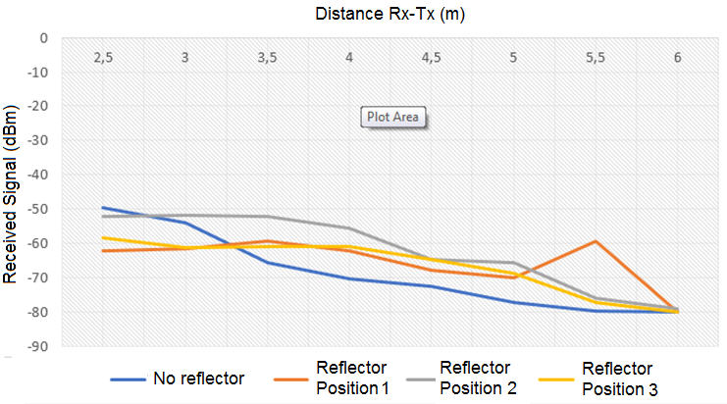

Figure 8.Signal Reductions due to Propagation and Obstacle

The increment on received signal can be approximated by using the propagation model, for instant the ITU-R model where the losses occurred between the access point and the receiver can be calculated directly using using Equation 1 with d be distance, n is number of floor and L_{f} is losses factor, and L_{f} is floor losses [12].
$L_{ITU-R}=20\log_{10}f+N.\log_{10}d+L_{f}\left(n\right)-28$ [1]

If the transmitted power of access point known, then the effective isotropic radiated power (EIRP) is:
𝐸𝐼𝑅𝑃 =𝑝𝑜𝑤𝑒𝑟 𝑡𝑟𝑎𝑛𝑠𝑚𝑖𝑡𝑡𝑒𝑑 (𝐴𝑃)–𝑐𝑎𝑏𝑙𝑒 𝑙𝑜𝑠𝑠 +𝐺𝑇𝑥 [2]
And the received signal strength indication (RSSI) in receiver is:
𝑅𝑆𝑆𝐼_{no-reflector} =𝐸𝐼𝑅𝑃 –𝑝𝑎𝑡ℎ 𝑙𝑜𝑠𝑠 +𝐺𝑅𝑥 − 𝐿𝑅𝑥 [3]
This RSSI _{no-reflector} is the received power without reflector. In order to calculated the RSSI _{with-reflector} the power increment should be calculated by considering losses from transmitter to reflector. The losses as the link is direct can be calculated using free space loss formula:
$L_{FSL}=20\log_{10}f+N.\log_{10}d+92.45$ [4]

The reflected power, $P_{0}^{r}$ is calculated by using the following formula
$P_{0}^{r}=Γ.P_{0}^{I}$ [5]

Since the first medium is air and the second one is aluminium, then:
$$n_{1}=\sqrt{\frac{μ_{1}}{ϵ_{1}}}=\sqrt{\frac{1,26×{10}^{-6}}{8,85×{10}^{-12}}}=126,83$$
$$n_{2}=\sqrt{\frac{μ_{2}}{ϵ_{2}}}=\sqrt{\frac{1,256×{10}^{-6}}{1,115×{10}^{-9}}}=33,56$$
$$Γ=\frac{E_{0}^{r}}{E_{0}^{I}}=\frac{P_{0}^{r}}{P_{0}^{I}}=\frac{n_{1}+n_{2}}{n_{1}-n_{2}}=1,71$$

If it is assumed that the reflected power directed to the receiver, then the power increment or RSSI_{increment} is:
RSSI_{increment} = Prec=$P_{0}^{I}$-Loss_{ref-rec} [5]
The total received power with reflector is:
𝑅𝑆𝑆𝐼_{with-reflector} = 𝑅𝑆𝑆𝐼_{no-reflector}+ 𝑅𝑆𝑆𝐼_{increment} [6]

The 𝑅𝑆𝑆𝐼_{with-reflector} may vary depending on the reflected power by the reflector. 𝑅𝑆𝑆𝐼_{with-reflector} could be smaller than 𝑅𝑆𝑆𝐼_{no-reflector} if reflection causes the opposite phase signal.

3.4. Impact of The Hole-in-the-wall Structure
Figure 9 shows the exact locations of the ornament-attached reflector and the results are plotted in Figure 8. The hole-in-the-wall structure is able to improve signal level about 2.3 dBm in average.

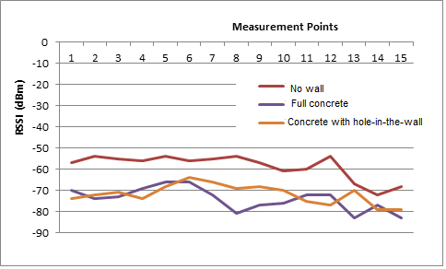
Figure 9. Impact of the hole-in-the-wall structure

When radio signal propagates through a small hole, the transmitted signal combined with the induced surface signal diffracted forward the hole as shown in Figure 10. This occurred if the hole is sub wavelength or much smaller then λ [13].
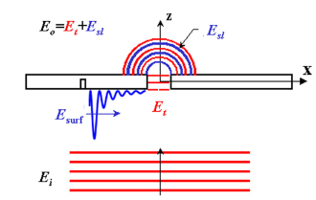
Figure 10. Small hole diffraction [13]

The forwarded signal power is [13]:
$P_{0}^{o}=\frac{64}{27π} k^{4}a^{6}S_{i}$ [7]

Where a is radius of the hole, k is propagation parameter (2*π/λ) and S_{i} is the flux given by:
$S_{i}=0.5 c∈_{0}E_{i}^{2}$ [8]

Since the hole-in-the-wall structure is isolated by the concrete and the hole is not smaller then λ, then output electric field transmitted through the hole is not E₀=E_{t}+E_{si} [13], but E₀= E_{si.} In order to increase higher signal level, size of l in Figure 4 should be as thin as possible. But it will reduce the objective the wall exists for.

4. Conclusion
This paper has introduced the WiFi-friendly building idea that enables the 802.11 signal propagating indoor efficiently. The study has proven that concrete materials that dominate the building materials absorb WiFi sinal the most. However, reflectors in certain positions are able to increase WiFi signal. For instance, ornament-attached reflector is able to improve WiFi signal up to 6.56 dBm. Further, a small hole-in-the-wall structure within the wall is able to increase signal in other side by 2.3 dBm in average.
By transforming the building properties as well as building structure, WiFi signal indoor can be boosted in certain level. Future works may explore more on building properties that may help its friendliness to WiFi signal.

References
- Gu Y, Ren F, and Li J. PAWS: Passive Human Activity Recognition Based on WiFi Ambient Signals. IEEE Internet of Things Journal. 2016; 3(5), 796-805.
- Bulut E, Szymanski B. K. WiFi access point deployment for efficient mobile data offloading. ACM SIGMOBILE Mobile Computing and Communications Review. 2013; 17(1), 71-78.
- Lee G. 3D coverage location modeling of Wi-Fi access point placement in indoor environment. Computers, Environment and Urban Systems. 2015; 54, 326-335.
- Farsi A, Achir N, Boussetta, K. WLAN planning: Separate and joint optimization of both access point placement and channel assignment. Annuals of telecommunications-annales des telecommunications. 2015; 70(5-6), 263-274.
- Varzandian, S, Zakeri H, Ozgoli S. Locating WiFi access points in indoor environments using non-monotonic signal propagation model. IEEE Asian Control Conference (ASCC). 2013; pp. 1-5.
- Ma R, Guo Q, Hu C, Xue J. An improved WiFi indoor positioning algorithm by weighted fusion. Sensors. 2015; 15(9), 21824-21843.
- Retscher G, Moser E, Vredeveld D, Heberling D, Pamp J. Performance and accuracy test of a WiFi indoor positioning system. Journal of Applied Geodesy jag. 2007; 1(2), 103-110.
- Barcelo-Arroyo F, Martin-Escalona I, Ciurana-Adell M. Positioning Terminals in Mobile Computing Networks.Mobile Computing. 2013; 11.
- Sangogboye F C, Droegehorn O, Porras J. Analyzing the Payback Time of Investments in Building Automation. In Sustainable Ecological Engineering Design. 2016; pp. 367-381.
- Rappaport T S, Seidel S Y, Takamizawa K. Statistical channel impulse response models for factory and open plan building radio communication system design. IEEE Trans. Communication. 1999; 39(5), pp.794-807.
- Hashemi H. The indoor radio propagation channel. Proceedings of the IEEE. 1993; 81(7), 943-968.
- Rec. ITU-R P.2040-1, ITU-R Recommendation, Vol.1, P Series, ITU, Geneva, 2015.
- Weiner J. The physics of light transmission through subwavelength apertures and aperture arrays. Reports on progress in physics. 2009; 72(6), 064401.

